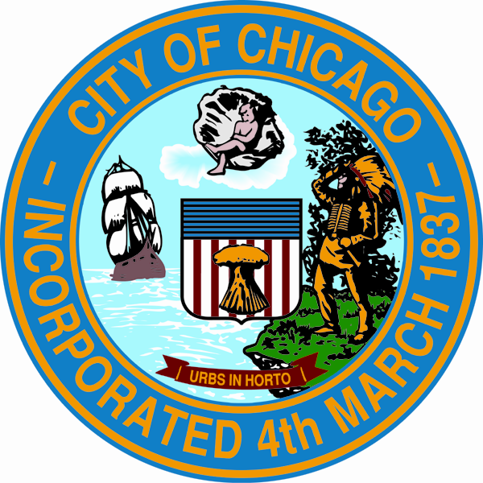

City of Chicago Special Service Area (SSA) Application
NOTE: This application is for SSAs applying to begin service in calendar year 2025. This form is to be submitted only as part of the formal application package submitted to DPD by June 14, 2024. It is not to be submitted as part of the 2025 Feasibility Study on December 1, 2023..

- Applicant name:

- Applicant legal status:

- Special services to be provided:
Customer attraction, public way aesthetics, sustainability and public places, economic/business development, and safety programs. These special services shall be in addition to services provided to and by the City of Chicago generally.

- Boundaries of the proposed Special Service Area:

- Estimated amount of funding required:

  - Initial year budget estimate:

  - Annual budget estimate for subsequent years:

- Stated need for the proposed Special Service Area:

- Local support for the proposed Special Service Area:

Signature of owner of record of property within the proposed Special Service Area (SSA):

A. Printed name of owner of record in proposed SSA

B. Printed name and Title of Authorized Signatory
(Complete only if the owner of record listed in Item A above is a legal entity and not a natural person)

C. Property Index Number (PIN) in proposed SSA for owner of record listed in Item A above

D. Property street address in proposed SSA for owner of record listed in Item A above

________________________________________________ _____________
E. Signature of owner of record listed in Item A or B above Date

F. Attach documentation confirming:
1. The taxpayer of record owns the property associated with PIN listed above, and
2. If the taxpayer of record is not an individual, the signatory is authorized to sign on behalf of
taxpayer of record entity.

