EXHIBIT C
Sample PSA

Specification Number:
Contract PO Number:
Supplier Number:

~~SAMPLE~~
PROFESSIONAL SERVICES AGREEMENT (“PSA”)

BETWEEN

THE CITY OF CHICAGO
Committee on Finance

and

AUDITOR

City-Wide Comprehensive Annual Financial Report RFP

LORI LIGHTFOOT
MAYOR COMMITTEE ON FINANCE

PROFESSIONAL SERVICES AGREEMENT

TABLE OF CONTENTS

ARTICLE 1. DEFINITIONS 3
1.1 Definitions 3
1.2 Interpretation 3
1.3 Order of Precedence 4
1.4 Incorporation of Exhibits 4
ARTICLE 2. DUTIES AND RESPONSIBILITIES OF CONTRACTOR 5
2.1 Scope of Services 5
2.2 Deliverables 5
2.3 Standard of Performance 5
2.4 Personnel 6
2.5 Minority and Women's Business Enterprises Commitment 7
2.6 Insurance 7
2.7 Indemnification 7
2.8 Ownership of Documents 8
2.9 Copyright Ownership 8
2.10 Records and Audits 9
2.11 Confidentiality 11
2.12 Assignments and Subcontracts 12
ARTICLE 3. DURATION OF AGREEMENT 13
3.1 Term of Performance 13
3.2 Timeliness of Performance 13
ARTICLE 4. COMPENSATION 13
4.1 Basis of Payment 13
4.2 Method of Payment 13
4.3 Funding 14
4.4 Non-Appropriation 14
ARTICLE 5. Intentionally Deleted 14
ARTICLE 6. COMPLIANCE WITH ALL LAWS 14
6.1 Compliance with All Laws Generally 14
6.2 Nondiscrimination 15
6.3 Inspector General 16
6.4 MacBride Ordinance 16
6.5 Business Relationships with Elected Officials 16
6.6 Wages 17
6.7 Environmental Warranties and Representations 18
6.8 Prohibition on Certain Contributions 19
6.9 Firms Owned or Operated by Individuals with Disabilities 20
6.10 Ineligibility to do Business with City 20
6.11 Duty to Report Corrupt or Unlawful Activity 20
6.12 Policy Prohibiting Sexual Harassment 20
6.13 Policy on Non-Disclosure of Salary History 21
6.14 Deemed Inclusion 22
ARTICLE 7. SPECIAL CONDITIONS 22
7.1 Warranties and Representations 22
7.2 Ethics 23
7.3 Joint and Several Liability 23
7.4 Business Documents 24
7.5 Conflicts of Interest 24
7.6 Non-Liability of Public Officials 25
7.7 EDS / Certification Regarding Suspension and Debarment 25
ARTICLE 8. EVENTS OF DEFAULT, REMEDIES, TERMINATION, SUSPENSION AND RIGHT TO OFFSET 25
8.1 Events of Default Defined 25
8.2 Remedies 26
8.3 Early Termination 28
8.4 Suspension 28
8.5 Right to Offset 29
ARTICLE 9. GENERAL CONDITIONS 29
9.1 Entire Agreement 29
9.2 Counterparts 30
9.3 Amendments 30
9.4 Governing Law and Jurisdiction 30
9.5 Severability 31
9.6 Assigns 31
9.7 Cooperation 31
9.8 Waiver 31
9.9 Independent Auditor 32
ARTICLE 10. NOTICES 33
ARTICLE 11. AUTHORITY 34
Signature Execution Page 35
EXHIBIT 1 SCOPE OF SERVICES AND TIME LIMITS FOR PERFORMANCE 36
EXHIBIT 2 -SCHEDULE OF COMPENSATION 37
EXHIBIT 3 SPECIAL CONDITIONS REGARDING MBE/WBE COMMITMENT 38
EXHIBIT 4 -ECONOMIC DISCLOSURE STATEMENT AND AFFIDAVIT - 72 -
EXHIBIT 5 INSURANCE REQUIREMENTS AND EVIDENCE OF INSURANCE - 73 -
EXHIBIT 6 BUSINESS ASSOCIATE AGREEMENT - 74 -
BUSINESS ASSOCIATE AGREEMENT - 75 -
EXHIBIT 7 LIST OF KEY PERSONNEL - 80 -
EXHIBIT 8 SEXUAL HARASSMENT POLICY AFFIDAVIT (SECTION 2-92-612) - 81 -
EXHIBIT 9 CONTRACTOR’S RESPONSE TO REQUEST FOR PROPOSALS - 82 -
EXHIBIT 10 CONTRACTOR’S RESPONSE TO ORAL PRESENTATION - 83 -
EXHIBIT 11 DATA PROTECTION REQUIREMENTS FOR CONTRACTORS, VENDORS AND THIRD PARTIES - 84 -
EXHIBIT 12 CITY OF CHICAGO IDENTIY PROTECTION POLICY - 89 -

AGREEMENT

This Agreement is entered into as of the _________ day of ____________, _____ ("Effective Date") by and between __________________ ("Auditor"), and the City of Chicago, a municipal corporation and home rule unit of local government existing under the Constitution of the State of Illinois, acting through its Committee on Finance ("City"), at Chicago, Illinois. The City and Auditor agree as follows:

TERMS AND CONDITIONS

ARTICLE 1. DEFINITIONS

1.1 Definitions

The following words and phrases have the following meanings for purposes of this Agreement:

"Additional Services" means those services which are within the general scope of Services of this Agreement, but beyond the description of services required under Section 2.1, and all services reasonably necessary to complete the Additional Services to the standards of performance required by this Agreement. Any Additional Services requested by the Committee on Finance require the approval of the City in a written amendment under Section 9.3 of this Agreement before Auditor is obligated to perform those Additional Services and before the City becomes obligated to pay for those Additional Services.

"Agreement" means this Professional Services Agreement, including all exhibits attached to it and incorporated in it by reference, and all amendments, modifications or revisions made in accordance with its terms.

"Chief Procurement Officer" means the Chief Procurement Officer of the City and any representative duly authorized in writing to act on his behalf.

"Commissioner" means the chief executive of the Committee on Finance and any representative authorized in writing to act on the Committee on Finance’s behalf.

"Services" means, collectively, the services, duties and responsibilities described in Article 2 and Exhibit 1 of this Agreement and any and all work necessary to complete them or carry them out fully and to the standard of performance required in this Agreement.

"Subcontractor" means any person or entity with whom Auditor contracts to provide any part of the Services, including subcontractors and subconsultants of any tier, suppliers and materials providers, whether or not in privity with Auditor.

1.2 Interpretation

(a) The term "include" (in all its forms) means "include, without limitation" unless the context clearly states otherwise.

(b) All references in this Agreement to Articles, Sections or Exhibits, unless otherwise expressed or indicated are to the Articles, Sections or Exhibits of this Agreement.

(c) Words importing persons include firms, associations, partnerships, trusts, corporations and other legal entities, including public bodies, as well as natural persons.

(d) Any headings preceding the text of the Articles and Sections of this Agreement, and any table of contents or marginal notes appended to it, are solely for convenience or reference and do not constitute a part of this Agreement, nor do they affect the meaning, construction or effect of this Agreement.

(e) Words importing the singular include the plural and vice versa. Words of the masculine gender include the correlative words of the feminine and neuter genders.

(f) All references to a number of days mean calendar days, unless indicated otherwise.

1.3 Order of Precedence

The order of precedence of the component Agreement parts will be as follows:
- If funded by the Federal Government, terms required by the Federal Government, whether set out in this document (Exhibit 8), or otherwise.
- Exhibit 1 Scope of Services and Time Limits for Performance
- All other parts of this Agreement.
Provided, however, in the event of an inconsistency between terms set out among different component parts of the Agreement, or terms set out within an Agreement part, notwithstanding the order of precedence noted above, the term that is most favorable to the City controls, unless expressly stated otherwise.

1.4 Incorporation of Exhibits

The following attached Exhibits are made a part of this Agreement:

Exhibit 1 Scope of Services and Time Limits for Performance
Exhibit 2 Schedule of Compensation
Exhibit 3 Special Conditions Regarding MBE/WBE Commitment
Exhibit 4 Economic Disclosure Statement and Affidavit
Exhibit 5 Insurance Requirements and Evidence of Insurance
Exhibit 6 Business Associate Agreement
Exhibit 7 List of Key Personnel
Exhibit 8 Sexual Harassment Policy Affidavit (Section 2-92-612)
Exhibit 9 Auditor’s Response to Request for Proposals
Exhibit 10 Auditor’s Response to Oral Presentation
Exhibit 11 Data Protection Requirements for Contractors/Auditors, Vendors and Third Parties
Exhibit 12 City of Chicago Identity Protection Policy

ARTICLE 2. DUTIES AND RESPONSIBILITIES OF AUDITOR

2.1 Scope of Services

This description of Services is intended to be general in nature and is neither a complete description of Auditor's Services nor a limitation on the Services that Auditor is to provide under this Agreement. Auditor must provide the Services in accordance with the standards of performance set forth in Section 2.3. The Services that Auditor must provide are described in Exhibit 1, Scope of Services and Time Limits for Performance.

The Auditor has advised the City that it can fulfill and satisfy City’s requirements for the Services as are described in this Agreement, and has set forth various representations as to its credentials, experience, and ability to do so in Auditor’s Proposal, dated ________, to the City’s Request for Proposals for City-Wide Comprehensive Annual Financial Report, Specification No. 1211514, and certain other related documents, attached hereto as Exhibit 10 for the purpose of incorporating such representations and the description of the activities and services that Auditor would perform in fulfilling City’s requirements.

2.2 Deliverables

In carrying out its Services, Auditor must prepare or provide to the City various Deliverables. "Deliverables" include work product, such as written reviews, recommendations, reports and analyses, produced by Auditor for the City.

The City may reject Deliverables that do not include relevant information or data, or do not include all documents or other materials specified in this Agreement or reasonably necessary for the purpose for which the City made this Agreement or for which the City intends to use the Deliverables. If the City determines that Auditor has failed to comply with the foregoing standards, it has 30 days from the discovery to notify Auditor of its failure. If Auditor does not correct the failure, if it is possible to do so, within 30 days after receipt of notice from the City specifying the failure, then the City, by written notice, may treat the failure as a default of this Agreement under Section 8.1 Events of Default Defined.

Partial or incomplete Deliverables may be accepted for review only when required for a specific and well-defined purpose for the benefit of the City and when consented to in advance by the City. Such Deliverables will not be considered as satisfying the requirements of this Agreement and partial or incomplete Deliverables in no way relieve Auditor of its obligations under this Agreement.

2.3 Standard of Performance

Auditor must perform all Services required of it under this Agreement with that degree of skill, care and diligence normally shown by a contractor performing services of a scope and purpose and magnitude comparable with the nature of the Services to be provided under this Agreement. Auditor acknowledges that it is entrusted with or has access to valuable and confidential information and records of the City and with respect to that information, Auditor agrees to be held to the standard of care of a fiduciary. Any review, approval, acceptance of Services or Deliverables or payment for any of the Services by the City does not relieve Auditor of its responsibility for the professional skill and care and technical accuracy of its Services and Deliverables. This provision in no way limits the City's rights against Auditor under this Agreement, at law or in equity.

Auditor must be appropriately licensed to perform the Services, if required by law, and must ensure that all Services that require the exercise of professional skills or judgment are accomplished by professionals qualified and competent in the applicable discipline and appropriately licensed as may be required by law. Auditor must provide copies of any such licenses. Auditor remains responsible for the professional and technical accuracy of all Services or Deliverables furnished, whether by Auditor or its Subcontractors or others on its behalf. All Deliverables must be prepared in a form and content satisfactory to the Committee on Finance and delivered in a timely manner consistent with the requirements of this Agreement.

If Auditor fails to comply with the foregoing standards, Auditor must, at the City’s option, perform again, at its own expense, all Services required to be re-performed as a direct or indirect result of that failure, unless the reason is failure to have and maintain required licensure. See subsection 8.1 (b)(ii) regarding failure to comply with licensure requirements.

2.4 Personnel

(a) Adequate Staffing

Auditor must, upon receiving a fully executed copy of this Agreement, assign and maintain during the term of this Agreement and any extension of it an adequate staff of competent personnel that is fully equipped, licensed as appropriate, available as needed, qualified and assigned exclusively to perform the Services. The level of staffing may be revised from time to time by notice in writing from Auditor to the City and with prior written consent of the City.

(b) Key Personnel

Auditor must not reassign or replace Key Personnel without the written consent of the City. "Key Personnel" means those job titles and the persons assigned to those positions in accordance with the provisions of this Section 2.4(b). The Committee on Finance may at any time in writing notify Auditor that the City will no longer accept performance of Services under this Agreement by one or more Key Personnel listed. Upon that notice Auditor must immediately suspend the key person or persons from performing Services under this Agreement and must replace him or them in accordance with the terms of this Agreement. Auditor must include among its staff the Key Personnel and positions as identified in Exhibit 7 List of Key Personnel.

(c) Salaries and Wages

Auditor and Subcontractors must pay all salaries and wages due all employees performing Services under this Agreement unconditionally and at least once a month without deduction or rebate on any account, except only for those payroll deductions that are mandatory by law or are permitted under applicable law and regulations. If in the performance of this Agreement Auditor underpays any such salaries or wages, the Comptroller for the City may withhold, out of payments due to Auditor, an amount sufficient to pay to employees underpaid the difference between the salaries or wages required to be paid under this Agreement and the salaries or wages actually paid these employees for the total number of hours worked. The amounts withheld may be disbursed by the Comptroller for and on account of Auditor to the respective employees to whom they are due. The parties acknowledge that this Section 2.4(c) is solely for the benefit of the City and that it does not grant any third party beneficiary rights.

2.5 Minority and Women's Business Enterprises Commitment

In the performance of this Agreement, including the procurement and lease of materials or equipment, Auditor must abide by the minority and women's business enterprise commitment requirements of the Municipal Code of Chicago (“Municipal Code”), §2-92-420 et seq. (1990), except to the extent waived by the Chief Procurement Officer and the Special Conditions Regarding MBE/WBE Commitment set forth in Exhibit 3. Auditor's completed Schedules C-1 and D-1 in Exhibit 3, evidencing its compliance with this requirement, are a part of this Agreement, upon acceptance by the Comptroller. Auditor must utilize minority and women's business enterprises at the greater of the amounts listed in those Schedules C-1 and D-1 or the percentages listed in them as applied to all payments received from the City.

2.6 Insurance

Auditor must provide and maintain at Auditor's own expense, during the term of this Agreement and any time period following expiration if Auditor is required to return and perform any of the Services or Additional Services under this Agreement, the insurance coverages and requirements specified in Exhibit 5 Insurance Requirements and Evidence of Insurance of this Agreement, insuring all operations related to this Agreement.

2.7 Indemnification

(a) Auditor must defend, indemnify, and hold harmless the City, its officers, representatives, elected and appointed officials, agents and employees from and against any and all Losses, including those related to:

- injury, death or damage of or to any person or property;
- any infringement or violation of any property right (including any patent, trademark or copyright);
- Auditor’s failure to perform or cause to be performed Auditor’s promises and obligations as and when required under this Agreement, including Auditor’s failure to perform its obligations to any Subcontractor;
- the City’s exercise of its rights and remedies under Section 8.2 Remedies of this Agreement; and
- injuries to or death of any employee of Auditor or any Subcontractor under any workers compensation statute.

(b) "Losses" means, individually and collectively, liabilities of every kind, including losses, damages and reasonable costs, payments and expenses (such as, but not limited to, court costs and reasonable attorneys' fees and disbursements), claims, demands, actions, suits, proceedings, judgments or settlements, any or all of which in any way arise out of or relate to Auditor’s breach of this Agreement or to Auditor’s negligent or otherwise wrongful acts or omissions or those of its officers, agents, employees, consultants, Subcontractors or licensees.

(c) At the City Corporation Counsel’s option, Auditor must defend all suits brought upon all such Losses and must pay all costs and expenses incidental to them, but the City has the right, at its option, to participate, at its own cost, in the defense of any suit, without relieving Auditor of any of its obligations under this Agreement. Any settlement must be made only with the prior written consent of the City Corporation Counsel, if the settlement requires any action on the part of the City.

(d) To the extent permissible by law, Auditor waives any limits to the amount of its obligations to defend, indemnify, hold harmless, or contribute to any sums due under any Losses, including any claim by any employee of Auditor that may be subject to the Workers Compensation Act, 820 ILCS 305/1 et seq. or any other related law or judicial decision (such as, Kotecki v. Cyclops Welding Corporation, 146 Ill. 2d 155 (1991)). The City, however, does not waive any limitations it may have on its liability under the Illinois Workers Compensation Act, the Illinois Pension Code, any other statute or judicial decision.

(e) The indemnities in this section survive expiration or termination of this Agreement for matters occurring or arising during the term of this Agreement or as the result of or during Auditor’s performance of Services beyond the term. Auditor acknowledges that the requirements set forth in this section to defend, indemnify, and hold harmless the City are apart from and not limited by the Auditor's duties under this Agreement, including the insurance requirements in Exhibit 5 Insurance Requirements and Evidence of Insurance of this Agreement.

2.8 Ownership of Documents

All Deliverables, data, findings or information in any form prepared, assembled or encountered by or provided to Auditor under this Agreement are property of the City, including, as further described in Section 2.9 Copyright Ownership below, all copyrights inherent in them or their preparation. During performance of its Services, Auditor is responsible for any loss or damage to the Deliverables, data, findings or information while in Auditor's or any Subcontractor's possession. Any such lost or damaged Deliverables, data, findings or information must be restored at the expense of Auditor. If not restorable, Auditor must bear the cost of replacement and of any loss suffered by the City on account of the destruction, as provided in Section 2.7 Indemnification.

2.9 Copyright Ownership

Auditor and the City intend that, to the extent permitted by law, the Deliverables to be produced by Auditor at the City's instance and expense under this Agreement are conclusively deemed "works made for hire" within the meaning and purview of Section 101 of the United States Copyright Act, 17 U.S.C. §101 et seq., and that the City will be the sole copyright owner of the Deliverables and of all aspects, elements and components of them in which copyright can subsist, and of all rights to apply for copyright registration or prosecute any claim of infringement.

To the extent that any Deliverable does not qualify as a "work made for hire," Auditor hereby irrevocably grants, conveys, bargains, sells, assigns, transfers and delivers to the City, its successors and assigns, all right, title and interest in and to the copyrights and all U.S. and foreign copyright registrations, copyright applications and copyright renewals for them, and other intangible, intellectual property embodied in or pertaining to the Deliverables prepared for the City under this Agreement, and all goodwill relating to them, free and clear of any liens, claims or other encumbrances, to the fullest extent permitted by law. Auditor will, and will cause all of its Subcontractors, employees, agents and other persons within its control to, execute all documents and perform all acts that the City may reasonably request in order to assist the City in perfecting its rights in and to the copyrights relating to the Deliverables, at the sole expense of the City. Auditor warrants to the City, its successors and assigns, that on the date of transfer Auditor is the lawful owner of good and marketable title in and to the copyrights for the Deliverables and has the legal rights to fully assign them. Auditor further warrants that it has not assigned and will not assign any copyrights and that it has not granted and will not grant any licenses, exclusive or nonexclusive, to any other party, and that it is not a party to any other agreements or subject to any other restrictions with respect to the Deliverables. Auditor warrants that the Deliverables are complete, entire and comprehensive, and that the Deliverables constitute a work of original authorship.

2.10 Records and Audits

(a) Records
(i) Auditor must deliver or cause to be delivered to the City all documents, including all Deliverables prepared for the City under the terms of this Agreement, promptly in accordance with the time limits prescribed in this Agreement, and if no time limit is specified, then upon reasonable demand for them or upon termination or completion of the Services under this Agreement. If Auditor fails to make such delivery upon demand, then Auditor must pay to the City any damages the City may sustain by reason of Auditor’s failure.

(ii) Auditor must maintain any such records including Deliverables not delivered to the City or demanded by the City for a period that is the longer of (A) 5 years after the final payment made in connection with this Agreement (or, 6 years after the final payment made in connection with this Agreement, with respect to any records that are required to be maintained pursuant to the Auditor’s obligations under Exhibit 6 Business Associate Agreement and the regulations implementing the Health Insurance Portability and Accountability Act of 1996 (HIPAA) and the Health Information Technology for Economic and Clinical Health Act (HITECH), which was part of the American Recovery and Reinvestment Act of 2009, specifically 45 C.F.R. § 164.530(j)), or (B) as directed by the Local Records Act (50 ILCS 205) and relevant records retention schedule. Auditor must not dispose of such records following the expiration of the relevant period without notification of and written approval from the City in accordance with Article 10 Notices.

In addition to the records to be stored by Auditor, all records that are possessed by Auditor in its service to the City to perform a governmental function are public records of the City pursuant to the Illinois Freedom of Information Act (“FOIA”), unless the records are exempt under the Act. FOIA requires that the City produce records in a very short period of time. If the Auditor receives a request from the City to produce records, the Auditor shall do so within 72 hours of the notice.
(b) Audits
(i) Auditor and any of Auditor's Subcontractors must furnish the Committee on Finance with all information that may be requested pertaining to the performance and cost of the Services. Auditor must maintain records showing actual time devoted and costs incurred. Auditor must keep books, documents, papers, records and accounts in connection with the Services open to audit, inspection, copying, abstracting and transcription and must make these records available to the City and any other interested governmental agency, at reasonable times during the performance of its Services.

(ii) To the extent that Auditor conducts any business operations separate and apart from the Services required under this Agreement using, for example, personnel, equipment, supplies or facilities also used in connection with this Agreement, then Auditor must maintain and make similarly available to the City detailed records supporting Auditor's allocation to this Agreement of the costs and expenses attributable to any such shared usages.

(iii) Auditor must maintain its books, records, documents and other evidence and adopt accounting procedures and practices sufficient to reflect properly all costs of whatever nature claimed to have been incurred and anticipated to be incurred for or in connection with the performance of this Agreement. This system of accounting must be in accordance with generally accepted accounting principles and practices, consistently applied throughout.

(iv) No provision in this Agreement granting the City a right of access to records and documents is intended to impair, limit or affect any right of access to such records and documents which the City would have had in the absence of such provisions.

(v) The City may in its sole discretion audit the records of Auditor or its Subcontractors, or both, at any time during the term of this Agreement or within six years after the Agreement ends, in connection with the goods, work, or Services provided under this Agreement. Each calendar year or partial calendar year is considered an “audited period.” If, as a result of any such audit, it is determined that Auditor or any of its Subcontractors has overcharged the City in the audited period, the City will notify Auditor. Auditor must then promptly reimburse the City for any amounts the City has paid Auditor due to the overcharges and also some or all of the cost of the audit, as follows:

- If the audit has revealed overcharges to the City representing less than 5% of the total value, based on the Agreement prices, of the goods, work, or Services provided in the audited period, then the Auditor must reimburse the City for 50% of the cost of the audit and 50% of the cost of each subsequent audit that the City conducts.

B. If, however, the audit has revealed overcharges to the City representing 5% or more of the total value, based on the Agreement prices, of the goods, work, or Services provided in the audited period, then Auditor must reimburse the City for the full cost of the audit and of each subsequent audit.

C. If the audit reveals that the Auditor was not paid the full amount required under the Agreement, the City will pay to the Auditor the sum equal to the amount of the deficiency.

Failure of Auditor to reimburse the City in accordance with subsection A or B above is an event of default under Section 8.1 Events of Default Defined of this Agreement, and Auditor will be liable for all of the City’s costs of collection, including any court costs and attorneys’ fees.

2.11 Confidentiality

(a) All Deliverables and reports, data, findings or information in any form prepared, assembled or encountered by or provided by Auditor under this Agreement are property of the City and are confidential, except as specifically authorized in this Agreement or as may be required by law. Auditor must not allow the Deliverables to be made available to any other individual or organization without the prior written consent of the City. Further, all documents and other information provided to Auditor by the City are confidential and must not be made available to any other individual or organization without the prior written consent of the City. Auditor must implement such measures as may be necessary to ensure that its staff and its Subcontractors are bound by the confidentiality provisions in this Agreement.

(b) Auditor must not issue any publicity news releases or grant press interviews, and except as may be required by law during or after the performance of this Agreement, disseminate any information regarding its Services or the project to which the Services pertain without the prior written consent of the Comptroller.

(c) If Auditor is presented with a request for documents by any administrative agency or with a subpoena duces tecum regarding any records, data or documents which may be in Auditor's possession by reason of this Agreement, Auditor must immediately give notice to the Comptroller and the Corporation Counsel for the City with the understanding that the City will have the opportunity to contest such process by any means available to it before the records, data or documents are submitted to a court or other third party. Auditor, however, is not obligated to withhold the delivery beyond the time ordered by a court or administrative agency, unless the subpoena or request is quashed or the time to produce is otherwise extended.

(d) HIPAA, HITECH, and AIDS Confidentiality Act. To the extent not defined herein the capitalized terms below and in Exhibit 6 Business Associate Agreement will have the same meaning as set forth in the Health Insurance Portability and Accountability Act, the Health Information Technology for Economic and Clinical Health Act, and their implementing regulations (collectively “HIPAA”). See 45 CFR parts 160, 162 and 164. Auditor and all its Subcontractors must comply with HIPAA and all rules and regulations applicable to it or them. Auditor must also comply with the Illinois AIDS Confidentiality Act (410 ILCS 305/1 through 16) and the rules and regulations of the Illinois Department of Public Health promulgated under it. If Auditor fails to comply with the applicable provisions under HIPAA or the Illinois AIDS Confidentiality Act, such failure will constitute an event of default under this Agreement for which no opportunity for cure will be provided.

Additionally, if Auditor is a Business Associate it must comply with all requirements of the HIPAA applicable to Business Associates including the provisions contained in Exhibit 6 Business Associate Agreement.

(f) Illinois Identity Protection Act. In the performance of the Services, Auditor may encounter the social security numbers of individuals, and must therefore comply with the following: (a) Auditor must not engage in any activity that would be prohibited if undertaken by a local government agency under the Identity Protection Act (5 ILCS 179) (“IPA”), and Auditor must protect individuals’ social security numbers consistent with the obligations imposed on a local government agency in the IPA and consistent with the City’s Identity Protection Policy, attached as Exhibit 12, and; (b) Auditor must maintain and comply with throughout the term of any such contract a policy in which Auditor sets forth the means by which Auditor will protect individuals’ social security numbers, such that the City maintains compliance with the IPA (at a minimum, Auditor’s IPA policy must incorporate all of the requirements set forth in Sec. 35(a) of the IPA); and (c) Auditor must tender a copy of its IPA policy to the City within no less than 120 days of the Effective Date of this Agreement, but in any event, prior to the disclosure of an individual’s social security number by City to Auditor.

2.12 Assignments and Subcontracts

(a) Auditor must not assign, delegate or otherwise transfer all or any part of its rights or obligations under this Agreement: (i) unless otherwise provided for elsewhere in this Agreement; or (ii) without the express written consent of the Committee on Finance. The absence of such a provision or written consent voids the attempted assignment, delegation or transfer and is of no effect as to the Services or this Agreement. No approvals given by the Committee on Finance, including approvals for the use of any Subcontractors, operate to relieve Auditor of any of its obligations or liabilities under this Agreement.

(b) All Subcontractors are subject to the prior approval of the Committee on Finance. Approval for the use of any Subcontractor in performance of the Services is conditioned upon performance by the Subcontractor in accordance with the terms and conditions of this Agreement. If any Subcontractor fails to perform the Services in accordance with the terms and conditions of this Agreement to the satisfaction of the Committee on Finance, the City has the absolute right upon written notification to immediately rescind approval and to require the performance of this Agreement by Auditor personally or through any other City-approved Subcontractor. Any approval for the use of Subcontractors in the performance of the Services under this Agreement under no circumstances operates to relieve Auditor of any of its obligations or liabilities under this Agreement.

(c) Auditor, upon entering into any agreement with a Subcontractor, must furnish upon request of the Committee on Finance a copy of its agreement. Auditor must ensure that all subcontracts contain provisions that require the Services be performed in strict accordance with the requirements of this Agreement, provided that the Subcontractors are subject to all the terms of this Agreement and are subject to the approval of the Committee on Finance. If the agreements do not prejudice any of the City's rights under this Agreement, such agreements may contain different provisions that are provided in this Agreement with respect to extensions of schedule, time of completion, payments, guarantees and matters not affecting the quality of the Services.

(d) Auditor must not transfer or assign any funds or claims due or to become due under this Agreement without the prior written approval of the Committee on Finance. The attempted transfer or assignment of any funds, either in whole or in part, or any interest in them, which are due or to become due to Auditor under this Agreement, without such prior written approval, has no effect upon the City.

(e) Under §2-92-245 of the Municipal Code, the Comptroller may make direct payments to Subcontractors for Services performed under this Agreement. Any such payment has the same effect as if the City had paid Auditor that amount directly. Such payment by the City to Auditor's Subcontractor under no circumstances operates to relieve Auditor of any of its obligations or liabilities under this Agreement. This section is solely for the benefit of the City and does not grant any third-party beneficiary rights.

(f) The City reserves the right to assign or otherwise transfer all or any part of its interests under this Agreement to any successor.

ARTICLE 3. DURATION OF AGREEMENT

3.1 Term of Performance

This Agreement takes effect as of the Effective Date, and, except as provided under Section 4.4 Non-Appropriation or Article 8 Events of Default, Remedies, Termination, and Right to Offset, Auditor will commence and execute performance of the Services described in Section A. in Exhibit 1 Scope of Services and Time Limits for Performance, until completion, pursuant to the Schedule of Performance set forth Exhibit 1, Section A. Subsequent to completion of the Services in Exhibit 1, Section A, Auditor will, for a period of three years, provide Services to the City as set forth in Exhibit 1, Section B.

3.2 Timeliness of Performance

(a) Auditor must provide the Services and Deliverables within the time limits required pursuant to the provisions of Section 2.1 Scope of Services and Exhibit 1 Scope of Services and Time Limits for Performance. Further, Auditor acknowledges that TIME IS OF THE ESSENCE and that the failure of Auditor to comply with the required time limits may result in economic or other losses to the City.

(b) Neither Auditor nor Auditor’s agents, employees or Subcontractors are entitled to any damages from the City, nor is any party entitled to be reimbursed by the City, for damages, charges or other losses or expenses incurred by Auditor by reason of delays or hindrances in the performance of the Services, whether or not caused by the City.

ARTICLE 4. COMPENSATION

4.1 Basis of Payment

The City will pay Auditor according to the Schedule of Compensation in the attached Exhibit 2 for the completion of the Services in accordance with this Agreement, including the Standard of Performance in Section 2.3.

4.2 Method of Payment

Auditor must email invoices to the City for line items as outlined in the Schedule of Compensation in Exhibit 2 in arrears, monthly. The invoices must be in such detail as the City requests. The City will process payment within 60 days after receipt of invoices and all supporting documentation necessary for the City to verify the Services provided under this Agreement.

4.3 Funding

The source of funds for payments under this Agreement is fund number ____________________. Payments under this Agreement must not exceed $__________________without a written amendment in accordance with Section 9.3 Amendments. Funding for this Agreement is subject to the availability of funds and their appropriation by the City Council of the City.

4.4 Non-Appropriation

If no funds or insufficient funds are appropriated and budgeted in any fiscal period of the City for payments to be made under this Agreement, then the City will notify Auditor in writing of that occurrence, and this Agreement will terminate on the earlier of the last day of the fiscal period for which sufficient appropriation was made or whenever the funds appropriated for payment under this Agreement are exhausted. Payments for Services completed to the date of notification will be made to Auditor except that no payments will be made or due to Auditor under this Agreement beyond those amounts appropriated and budgeted by the City to fund payments under this Agreement.

ARTICLE 5. Intentionally Deleted

ARTICLE 6. COMPLIANCE WITH ALL LAWS

6.1 Compliance with All Laws Generally

(a) Auditor must observe and comply with all applicable federal, state, county and municipal laws, statutes, ordinances and executive orders, in effect now or later and whether or not they appear in this Agreement, including those set forth in this Article 6 Compliance With All Laws, and Auditor must pay all taxes and obtain all licenses, certificates and other authorizations required by them. Auditor must require all Subcontractors to do so, also. Further, Auditor must execute an Economic Disclosure Statement and Affidavit ("EDS") in the form attached to this Agreement as Exhibit 4 Economic Disclosure Statement and Affidavit.

Notwithstanding acceptance by the City of the EDS, Auditor’s failure in the EDS to include all information required under the Municipal Code renders this Agreement voidable at the option of the City.

Auditor must promptly update its EDS(s) on file with the City whenever any information or response provided in the EDS(s) is no longer complete and accurate. Auditor agrees that Auditor’s failure to maintain current throughout the term and any extensions of the term, the disclosures and information pertaining to ineligibility to do business with the City under Chapter 1-23 of the Municipal Code, as such is required under Sec. 2-154-020, shall constitute an event of default.

(b) Notwithstanding anything in this Agreement to the contrary, references to a statute or law are considered to be a reference to (i) the statute or law as it may be amended from time to time; (ii) all regulations and rules pertaining to or promulgated pursuant to the statute or law; and (iii) all future statutes, laws, regulations, rules and executive orders pertaining to the same or similar subject matter.

6.2 Nondiscrimination

(a) Auditor

Auditor must comply with applicable federal, state, and local laws and related regulations prohibiting discrimination against individuals and groups. If this Agreement is federally funded in whole or in part, additional provisions related to nondiscrimination may be set forth in Exhibit 8 Sexual Harassment Policy Affidavit.

(i) Federal Requirements

Auditor must not engage in unlawful employment practices, such as (1) failing or refusing to hire or discharging any individual, or otherwise discriminating against any individual with respect to compensation or the terms, conditions, or privileges of the individual’s employment, because of the individual's race, color, religion, sex, age, handicap/disability or national origin; or (2) limiting, segregating or classifying Auditor’s employees or applicants for employment in any way that would deprive or tend to deprive any individual of employment opportunities or otherwise adversely affect the individual’s status as an employee, because of the individual's race, color, religion, sex, age, handicap/disability or national origin.

Auditor must comply with, and the procedures Auditor utilizes and the Services Auditor provides under this Agreement must comply with, the Civil Rights Act of 1964, 42 U.S.C. sec. 2000e et seq. (1981), as amended and the Civil Rights Act of 1991, P.L. 102-166. Attention is called to: Exec. Order No. 11246, 30 Fed. Reg. 12,319 (1965), reprinted in 42 U.S.C. 2000e note, as amended by Exec. Order No. 11375, 32 Fed. Reg. 14,303 (1967) and by Exec. Order No. 12086, 43 Fed. Reg. 46,501 (1978); Age Discrimination Act, 42 U.S.C. §6101-6106 (1981); Age Discrimination in Employment Act, 29 U.S.C. §621-34; Rehabilitation Act of 1973, 29 U.S.C. §793-794 (1981); Americans with Disabilities Act, 42 U.S.C. §12101 et seq.; 41 C.F.R. Part 60 et seq. (1990); and all other applicable federal statutes, regulations and other laws.

(ii) State Requirements

Auditor must comply with, and the procedures Auditor utilizes and the Services Auditor provides under this Agreement must comply with, the Illinois Human Rights Act, 775 ILCS 5/1-101 et seq. (1990), as amended and any rules and regulations promulgated in accordance with it, including the Equal Employment Opportunity Clause, 44 Ill. Admin. Code §750 Appendix A. Furthermore, Auditor must comply with the Public Works Employment Discrimination Act, 775 ILCS 10/0.01 et seq. (1990), as amended, and all other applicable state statutes, regulations and other laws.

(iii) City Requirements

Auditor must comply with, and the procedures Auditor utilizes and the Services Auditor provides under this Agreement must comply with, the Chicago Human Rights Ordinance, ch. 2-160, Section 2-160-010 et seq. of the Municipal Code of Chicago (1990), as amended, and all other applicable City ordinances and rules.

(b) Subcontractors

Auditor must incorporate all of this Section 6.2 by reference in all agreements entered into with any suppliers of materials, furnisher of services, Subcontractors of any tier, and labor organizations that furnish skilled, unskilled and craft union skilled labor, or that may provide any such materials, labor or services in connection with this Agreement. Further, Auditor must furnish and must cause each of its Subcontractor(s) to furnish such reports and information as requested by the federal, state, and local agencies charged with enforcing such laws and regulations, including the Chicago Commission on Human Relations.

6.3 Inspector General

It is the duty of any bidder, proposer or Auditor, all Subcontractors, every applicant for certification of eligibility for a City contract or program, and all officers, directors, agents, partners and employees of any bidder, proposer, Auditor, Subcontractor or such applicant to cooperate with the Inspector General in any investigation or hearing undertaken pursuant to Chapter 2-56 of the Municipal Code. Auditor understands and will abide by all provisions of Chapter 2-56 of the Municipal Code. All subcontracts must inform Subcontractors of the provision and require understanding and compliance with it.

6.4 MacBride Ordinance

The City of Chicago through the passage of the MacBride Principles Ordinance seeks to promote fair and equal employment opportunities and labor practices for religious minorities in Northern Ireland and provide a better working environment for all citizens in Northern Ireland.

In accordance with Section 2-92-580 of the Municipal Code of the City of Chicago, if Auditor conducts any business operations in Northern Ireland, the Auditor must make all reasonable and good faith efforts to conduct any business operations in Northern Ireland in accordance with the MacBride Principles for Northern Ireland as defined in Illinois Public Act 85-1390 (1988 Ill. Laws 3220).

The provisions of this Section 6.4 do not apply to contracts for which the City receives funds administered by the United States Department of Transportation, except to the extent Congress has directed that the Department of Transportation not withhold funds from states and localities that choose to implement selective purchasing policies based on agreement to comply with the MacBride Principles for Northern Ireland, or to the extent that such funds are not otherwise withheld by the Department of Transportation.

6.5 Business Relationships with Elected Officials

Pursuant to MCC Sect. 2-156-030(b), it is illegal for any elected official, or any person acting at the direction of such official, to contact either orally or in writing any other City official or employee with respect to any matter involving any person with whom the elected official has any business relationship that creates a financial interest on the part of the official, or the domestic partner or spouse of the official, or from whom or which he has derived any income or compensation during the preceding twelve months or from whom or which he reasonably expects to derive any income or compensation in the following twelve months. In addition, no elected official may participate in any discussion in any City Council committee hearing or in any City Council meeting or vote on any matter involving the person with whom the elected official has any business relationship that creates a financial interest on the part of the official, or the domestic partner or spouse of the official, or from whom or which he has derived any income or compensation during the preceding twelve months or from whom or which he reasonably expects to derive any income or compensation in the following twelve months.

Violation of MCC § 2-156-030 by any elected official with respect to this Agreement will be grounds for termination of this Agreement. The term financial interest is defined as set forth in MCC Chapter 2-156.

6.6 Wages

Auditor must pay the highest of: (a) minimum wage specified by Mayoral Executive Order 2014-1; (b) Chicago Minimum Wage rate specified by MCC Chapter 1-24, or (c) the highest applicable State or Federal minimum wage; each as described below.

- Minimum Wage, Mayoral Executive Order 2014-1
Mayoral Executive Order 2014-1 provides for a fair and adequate Minimum Wage to be paid to employees of City contractors and subcontractors performing work on City contracts. A copy of the Order may be downloaded from the Chicago City Clerk’s website at:

www.chicityclerk.com/legislation-records/journals-and-reports/executive-orders

If this Agreement was advertised on or after October 1, 2014, Auditor must comply with Mayoral Executive Order 2014-1 and any applicable rules issued by the Chief Procurement Officer. As of July 1, 2020, the Minimum Wage to be paid pursuant to the Order is $14.15 per hour. The Minimum Wage must be paid to:

• All employees regularly performing work on City property or at a City jobsite.
• All employees whose regular work entails performing a service for the City under a City contract, including this Agreement.

Beginning on July 1, 2015, and every July 1 thereafter, the hourly wage specified by the Executive Order shall increase in proportion to the increase, if any, in the Consumer Price Index for All Urban Consumers most recently published by the Bureau of Labor Statistics of the United States Department of Labor. Any hourly wage increase shall be rounded up to the nearest multiple of $0.05. Such increase shall remain in effect until any subsequent adjustment is made.

The Minimum Wage is not required to be paid to employees whose work is performed in general support of Contractors’ operations, does not directly relate to the services provided to the City under the contract, and is included in the contract price as overhead, unless that employee's regularly assigned work location is on City property or at a City jobsite. It is also not required to be paid by employers that are 501(c)(3) not-for-profits.

Except as further described, the Minimum Wage is also not required to be paid to categories of employees subject to subsection 4(a)(2), subsection 4(a)(3), subsection 4(d), subsection 4(e), or Section 6 of the Illinois Minimum Wage Law, 820 ILCS 105/1 et seq., in force as of the date of this Agreement or as amended. Nevertheless, the Minimum Wage is required to be paid to those workers described in subsections 4(a)(2)(A) and 4(a)(2)(B) of the Illinois Minimum Wage Law.

Additionally, the Minimum Wage is not required to be paid to employees subject to a collective bargaining agreement that provides for different wages than those required by Mayoral Executive Order 2014-1, if that collective bargaining agreement was in force prior to October 1, 2014 or if that collective bargaining agreement clearly and specifically waives the requirements of the order.

If the payment of a Base Wage pursuant to MCC Sect. 2-92-610 is required for work or services done under this Agreement, and the Minimum Wage is higher than the Base Wage, then the Auditor must pay the Minimum Wage. Likewise, if the payment of a prevailing wage is required and the prevailing wage is higher than the Minimum Wage, then the Auditor must pay the prevailing wage.

Auditor is reminded that they must comply with Municipal Code Chapter 1-24 establishing a Chicago Minimum Wage.

- Not-for-Profit Corporations: If Auditor is a corporation having federal tax-exempt status under Section 501(c)(3) of the Internal Revenue Code and is recognized under Illinois not-for-profit law, then the provisions of subsections (a) through (b) above do not apply.
- Chicago Paid Sick Leave Ordinance
The Paid Sick Leave Ordinance, which was published in the June 22, 2016 Council Journal, pages 27188 – 27197 and codified at MCC 1-24-045, became effective July 1, 2017. Auditor understands that, to the extent that the Ordinance applies to its activities, it must comply with the Ordinance.

6.7 Environmental Warranties and Representations

In accordance with Section 11-4-1600(e) of the Municipal Code of Chicago, Auditor warrants and represents that it, and to the best of its knowledge, its subcontractors have not violated and are not in violation of the following sections of the Code (collectively, the Waste Sections):

7-28-390 Dumping on public way;
7-28-440 Dumping on real estate without permit;
11-4-1410 Disposal in waters prohibited;
11-4-1420 Ballast tank, bilge tank or other discharge;
11-4-1450 Gas manufacturing residue;
11-4-1500 Treatment and disposal of solid or liquid waste;
11-4-1530 Compliance with rules and regulations required;
11-4-1550 Operational requirements; and
11-4-1560 Screening requirements.

During the period while this Agreement is executory, Auditor’s or any Subcontractor’s violation of the Waste Sections, whether or not relating to the performance of this Agreement, constitutes a breach of and an event of default under this Agreement, for which the opportunity to cure, if curable, will be granted only at the sole discretion of the Comptroller. Such breach and default entitles the City to all remedies under the Agreement, at law or in equity.

This section does not limit Auditor’s and its Subcontractors’ duty to comply with all applicable federal, state, county and municipal laws, statutes, ordinances and executive orders, in effect now or later, and whether or not they appear in this Agreement.

Non-compliance with these terms and conditions may be used by the City as grounds for the termination of this Agreement, and may further affect Auditor's eligibility for future contract awards.

6.8 Prohibition on Certain Contributions

No Auditor or any person or entity who directly or indirectly has an ownership or beneficial interest in Auditor of more than 7.5% ("Owners"), spouses and domestic partners of such Owners, Auditor’s Subcontractors, any person or entity who directly or indirectly has an ownership or beneficial interest in any Subcontractor of more than 7.5% ("Sub-owners") and spouses and domestic partners of such Sub-owners (Auditor and all the other preceding classes of persons and entities are together, the "Identified Parties"), shall make a contribution of any amount to the Mayor of the City of Chicago (the "Mayor") or to his political fundraising committee during (i) the bid or other solicitation process for this Agreement or Other Contract, including while this Agreement or Other Contract is executory, (ii) the term of this Agreement or any Other Contract between City and Auditor, and/or (iii) any period in which an extension of this Agreement or Other Contract with the City is being sought or negotiated.

Auditor represents and warrants that since the date of public advertisement of the specification, request for qualifications, request for proposals or request for information (or any combination of those requests) or, if not competitively procured, from the date the City approached the Auditor or the date the Auditor approached the City, as applicable, regarding the formulation of this Agreement, no Identified Parties have made a contribution of any amount to the Mayor or to his political fundraising committee.

Auditor shall not: (a) coerce, compel or intimidate its employees to make a contribution of any amount to the Mayor or to the Mayor’s political fundraising committee; (b) reimburse its employees for a contribution of any amount made to the Mayor or to the Mayor’s political fundraising committee; or (c) bundle or solicit others to bundle contributions to the Mayor or to his political fundraising committee.

The Identified Parties must not engage in any conduct whatsoever designed to intentionally violate this provision or Mayoral Executive Order No. 2011-4 or to entice, direct or solicit others to intentionally violate this provision or Mayoral Executive Order No. 2011-4.

Violation of, non-compliance with, misrepresentation with respect to, or breach of any covenant or warranty under this provision or violation of Mayoral Executive Order No. 2011-4 constitutes a breach and default under this Agreement, and under any Other Contract for which no opportunity to cure will be granted. Such breach and default entitles the City to all remedies (including without limitation termination for default) under this Agreement, under Other Contract, at law and in equity. This provision amends any Other Contract and supersedes any inconsistent provision contained therein.

If Auditor violates this provision or Mayoral Executive Order No. 2011-4 prior to award of the Agreement resulting from this specification, the Comptroller may reject Auditor’s bid.

For purposes of this provision:

"Other Contract" means any agreement entered into between the Auditor and the City that is (i) formed under the authority of MCC Ch. 2-92; (ii) for the purchase, sale or lease of real or personal property; or (iii) for materials, supplies, equipment or services which are approved and/or authorized by the City Council.

"Contribution" means a "political contribution" as defined in MCC Ch. 2-156, as amended.

"Political fundraising committee" means a "political fundraising committee" as defined in MCC Ch. 2-156, as amended.

6.9 Firms Owned or Operated by Individuals with Disabilities

The City encourages contractors to use Subcontractors that are firms owned or operated by individuals with disabilities, as defined by Section 2-92-586 of the Municipal Code of the City of Chicago, where not otherwise prohibited by federal or state law.

6.10 Ineligibility to do Business with City

Failure by the Auditor or any Controlling Person (defined in Section 1-23-010 of the Municipal Code) thereof to maintain eligibility to do business with the City in violation of Section 1-23-030 of the Municipal Code shall render this Agreement voidable or subject to termination, at the option of the Comptroller. Auditor agrees that Auditor's failure to maintain eligibility (or failure by Controlling Persons to maintain eligibility) to do business with the City in violation of Section 1-23-030 of the Municipal Code shall constitute an event of default.

6.11 Duty to Report Corrupt or Unlawful Activity

Pursuant to §2-156-018 of the Municipal Code, it is the duty of the Auditor to report to the Inspector General, directly and without undue delay, any and all information concerning conduct which it knows to involve corrupt activity. “Corrupt Activity” means any conduct set forth in Subparagraph (a)(1), (2) or (3) of §1-23-020 of the Municipal Code. Knowing failure to make such a report will be an event of default under this Agreement. Reports may be made to the Inspector General’s toll free hotline, 866-IG-TIPLINE (866-448-4754).

6.12 Policy Prohibiting Sexual Harassment
(Section 2-92-612 of the Chicago Municipal Code)
For purposes of this section, the following definitions shall apply:
“Contract” means any contract, purchase order, construction project, or other agresement (other than a delegate agency contract or lease of real property or collective bargaining agreement) awarded by the city and whose cost is to be paid from funds belonging to or administered by the city.
“Auditor” means the person to whom a contract is awarded.
“Sexual harassment” means any unwelcome sexual advances or requests for sexual favors or conduct of a sexual nature when (i) submission to such conduct is made either explicitly or implicitly a term or condition of an individual's employment; or (ii) submission to or rejection of such conduct by an individual is used as the basis for any employment decision affecting the individual; or (iii) such conduct has the purpose or effect of substantially interfering with an individual's work performance or creating an intimidating, hostile or offensive working environment.
“Subcontractor” means any person that enters into a contract with a contractor to perform work on a contract.
As a condition of contract award, Auditor shall, as prescribed by the Comptroller, attest by affidavit that Auditor has a written policy prohibiting sexual harassment that shall include, at a minimum, the following information: (i) the illegality of sexual harassment; (ii) the definition of sexual harassment; and (iii) the legal recourse available for victims of sexual harassment. Auditor’s affidavit is included in Exhibit 8 Sexual Harassment Policy Affidavit.
Auditor’s failure to have a written policy prohibiting sexual harassment as provided above shall constitute an event of default. In the event of default, the Comptroller shall notify Auditor of such noncompliance and may, as appropriate: (i) issue Auditor an opportunity to cure consistent with the default provisions in this Agreement; (ii) terminate the contract; or (iii) take any other action consistent with the default provisions in the contract. This section shall not be construed to prohibit the City from prosecuting any person who knowingly makes a false statement of material fact to the city pursuant to Chapter 1-21 of this Code, or from availing itself of any other remedies under contract or law.

6.13 Policy on Non-Disclosure of Salary History
(Section 2-92-385 of the Chicago Municipal Code)
For purposes of this section, the following definitions shall apply:
“Contract” means any agreement or transaction pursuant to which a contractor (i) receives City funds in consideration for services, work or goods provided or rendered, including contracts for legal or other professional services, or (ii) pays the City money in consideration for a license, grant or concession allowing it to conduct a business on City premises, and includes any contracts not awarded or processed by the Department of Procurement Services.
“Auditor” means the person to whom a contract is awarded.
As a condition of contract award, Auditor shall attest by affidavit that Auditor has a policy that conforms to the following requirements:
- Auditor shall not screen job applicants based on their wage or salary history, including by requiring that an applicant’s prior wages, including benefits or other compensation, satisfy minimum or maximum criteria; or by requesting or requiring an applicant to disclose prior wages or salary, either (i) as a condition of being interviewed, (ii) as a condition of continuing to be considered for an offer of employment, (iii) as a condition of an offer of employment or an offer of compensation, or (iv) as a condition of employment; and
- Auditor shall not seek an applicant’s wage or salary history, including benefits or other compensation, from any current or former employer.
Auditor’s affidavit is provided as per Exhibit 4 Economic Disclosure Statement and Affidavit, specifically by Appendix C - Prohibition on Wage & Salary History Screening.
If Auditor violates the above requirements, Auditor may be deemed ineligible to contract with the City; any contract, extension, or renewal thereof awarded in violation of the above requirements may be voidable at the option of the City. Provided, however, that upon a finding of a violation by Auditor, no contract shall be voided, terminated, or revoked without consideration by the Chief Procurement Officer of such action’s impact on the Auditor’s MBE or WBE subcontractors.

6.14 Deemed Inclusion

Provisions required by law, ordinances, rules, regulations, or executive orders to be inserted in this Agreement are deemed inserted in this Agreement whether or not they appear in this Agreement or, upon application by either party, this Agreement will be amended to make the insertion; however, in no event will the failure to insert the provisions before or after this Agreement is signed prevent its enforcement.

ARTICLE 7. SPECIAL CONDITIONS

7.1 Warranties and Representations

In connection with signing and carrying out this Agreement, Auditor:

(a) warrants that Auditor is appropriately licensed under Illinois law to perform the Services required under this Agreement and will perform no Services for which a professional license is required by law and for which Auditor is not appropriately licensed;

(b) warrants it is financially solvent; it and each of its employees, agents and Subcontractors of any tier are competent to perform the Services required under this Agreement; and Auditor is legally authorized to execute and perform or cause to be performed this Agreement under the terms and conditions stated in this Agreement;

(c) warrants that it will not knowingly use the services of any ineligible contractor or Subcontractor for any purpose in the performance of its Services under this Agreement;

(d) warrants that Auditor and its Subcontractors are not in default at the time this Agreement is signed, and have not been deemed by the Chief Procurement Officer or Comptroller to have, within 5 years immediately preceding the Effective Date of this Agreement, been found to be in default on any contract awarded by the City;

(e) represents that it has carefully examined and analyzed the provisions and requirements of this Agreement; it understands the nature of the Services required; from its own analysis it has satisfied itself as to the nature of all things needed for the performance of this Agreement; this Agreement is feasible of performance in accordance with all of its provisions and requirements, and Auditor warrants it can and will perform, or cause to be performed, the Services in strict accordance with the provisions and requirements of this Agreement;

(f) represents that Auditor and, to the best of its knowledge, its Subcontractors are not in violation of the provisions of §2-92-320 of the Municipal Code, and in connection with it, and additionally in connection with the Illinois Criminal Code, 720 ILCS 5/33E as amended, and the Illinois Municipal Code, 65 ILCS 5/11-42.1-1;

(g) acknowledges that any certification, affidavit or acknowledgment made under oath in connection with this Agreement is made under penalty of perjury and, if false, is also cause for termination under Sections 8.2 and 8.3 of this Agreement; and

- warrants and represents that neither Auditor nor an Affiliate of Auditor (as defined below) appears on the Specially Designated Nationals List, the Denied Persons List, the Unverified List, the Entity List, or the Debarred List as maintained by the Office of Foreign Assets Control of the U.S. Department of the Treasury or by the Bureau of Industry and Security of the U.S. Department of Commerce (or their successors), or on any other list of persons or entities with which the City may not do business under any applicable law, rule, regulation, order or judgment. “Affiliate of Auditor” means a person or entity that directly (or indirectly through one or more intermediaries) controls, is controlled by or is under common control with Auditor. A person or entity will be deemed to be controlled by another person or entity if it is controlled in any manner whatsoever that results in control in fact by that other person or entity (either acting individually or acting jointly or in concert with others) whether directly or indirectly and whether through share ownership, a trust, a contract or otherwise.

7.2 Ethics

(a) In addition to the foregoing warranties and representations, Auditor warrants:

(i) no officer, agent or employee of the City is employed by Auditor or has a financial interest directly or indirectly in this Agreement or the compensation to be paid under this Agreement except as may be permitted in writing by the Board of Ethics established under Chapter 2-156 of the Municipal Code.

(ii) no payment, gratuity or offer of employment will be made in connection with this Agreement by or on behalf of any Subcontractors to Auditor or higher tier Subcontractors or anyone associated with them, as an inducement for the award of a subcontract or order.

(b) Auditor must comply with Chapter 2-156 of the Municipal Code. Auditor acknowledges that any Agreement entered into, negotiated or performed in violation of any of the provisions of Chapter 2-156, including any contract entered into with any person who has retained or employed a non-registered lobbyist in violation of Section 2-156-305 of the Municipal Code is voidable as to the City.

7.3 Joint and Several Liability

If Auditor, or its successors or assigns, if any, is comprised of more than one individual or other legal entity (or a combination of them), then under this Agreement, each and without limitation every obligation or undertaking in this Agreement to be fulfilled or performed by Auditor is the joint and several obligation or undertaking of each such individual or other legal entity.

7.4 Business Documents

At the request of the City, Auditor must provide copies of its latest articles of incorporation, by-laws and resolutions, or partnership or joint venture agreement, as applicable.

7.5 Conflicts of Interest

(a) No member of the governing body of the City or other unit of government and no other officer, employee or agent of the City or other unit of government who exercises any functions or responsibilities in connection with the Services to which this Agreement pertains is permitted to have any personal interest, direct or indirect, in this Agreement. No member of or delegate to the Congress of the United States or the Illinois General Assembly and no alderman of the City or City employee is allowed to be admitted to any share or part of this Agreement or to any financial benefit to arise from it.

(b) Auditor represents that it, and to the best of its knowledge, its Subcontractors if any (Auditor and Subcontractors will be collectively referred to in this Section 7.5 as "Consulting Parties"), presently have no direct or indirect interest and will not acquire any direct or indirect interest in any project or contract that would conflict in any manner or degree with the performance of its Services under this Agreement. Auditor further represents and warrants that entering into this Agreement and the performance of Services under this Agreement shall in no respect cause Auditor or Auditor’s affiliates to be non-compliant with any professional auditing or accounting standards applicable to Auditor or Auditor’s affiliates, including with respect to auditing services provided to the City.

(c) Upon the request of the City, Consulting Parties must disclose to the City their past client lists and the names of any clients with whom they have an ongoing relationship. Consulting Parties are not permitted to perform any Services for the City on applications or other documents submitted to the City by any of Consulting Parties’ past or present clients. If Consulting Parties become aware of a conflict, they must immediately stop work on the assignment causing the conflict and notify the City.

(d) Without limiting the foregoing, if the Consulting Parties assist the City in determining the advisability or feasibility of a project or in recommending, researching, preparing, drafting or issuing a request for proposals or bid specifications for a project, the Consulting Parties must not participate, directly or indirectly, as a prime, subcontractor or joint venturer in that project or in the preparation of a proposal or bid for that project during the term of this Agreement or afterwards. The Consulting Parties may, however, assist the City in reviewing the proposals or bids for the project if none of the Consulting Parties have a relationship with the persons or entities that submitted the proposals or bids for that project.

(e) Further, Consulting Parties must not assign any person having any conflicting interest to perform any Services under this Agreement or have access to any confidential information, as described in Section 2.11 of this Agreement. If the City, by the Comptroller in his reasonable judgment, determines that any of Consulting Parties' services for others conflict with the Services that Consulting Parties are to render for the City under this Agreement, Consulting Parties must terminate such other services immediately upon request of the City.

(f) Furthermore, if any federal funds are to be used to compensate or reimburse Auditor under this Agreement, Auditor represents that it is and will remain in compliance with federal restrictions on lobbying set forth in Section 319 of the Department of the Interior and Related Agencies Appropriations Act for Fiscal Year 1990, 31 U.S.C. §1352, and related rules and regulations set forth at 54 Fed. Reg. 52,309 ff. (1989), as amended. If federal funds are to be used, Auditor must execute a Certification Regarding Lobbying, which is part of the EDS and incorporated by reference as if fully set forth here.

7.6 Non-Liability of Public Officials

Auditor and any assignee or Subcontractor of Auditor must not charge any official, employee or agent of the City personally with any liability or expenses of defense or hold any official, employee or agent of the City personally liable to them under any term or provision of this Agreement or because of the City's execution, attempted execution or any breach of this Agreement.

7.7 EDS / Certification Regarding Suspension and Debarment

Auditor certifies, as further evidenced in the EDS attached as Exhibit 4, by its acceptance of this Agreement that neither it nor its principals is presently debarred, suspended, proposed for debarment, declared ineligible or voluntarily excluded from participation in this transaction by any federal department or agency. Auditor further agrees by executing this Agreement that it will include this clause without modification in all lower tier transactions, solicitations, proposals, contracts and subcontracts. If Auditor or any lower tier participant is unable to certify to this statement, it must attach an explanation to the Agreement.

ARTICLE 8. EVENTS OF DEFAULT, REMEDIES, TERMINATION, SUSPENSION AND RIGHT TO OFFSET

8.1 Events of Default Defined

The following constitute events of default:

(a) Any material misrepresentation, whether negligent or willful and whether in the inducement or in the performance, made by Auditor to the City.

(b) Auditor's material failure to perform any of its obligations under this Agreement including the following:

(i) Failure to perform the Services with sufficient personnel and equipment or with sufficient material or software applications to ensure the timely performance of the Services;

(ii) Failure to have and maintain all professional licenses required by law to perform the Services;

(iii) Failure to timely perform the Services;

(iv) Failure to perform the Services in a manner reasonably satisfactory to the Comptroller or inability to perform the Services satisfactorily as a result of insolvency, filing for bankruptcy or assignment for the benefit of creditors;

(v) Failure to promptly re-perform, as required, within a reasonable time and at no cost to the City, Services that are rejected as erroneous or unsatisfactory;

(vi) Discontinuance of the Services for reasons within Auditor's reasonable control;

(vii) Failure to comply with Section 6.1 in the performance of the Agreement;

(viii) Failure promptly to update EDS(s) furnished in connection with this Agreement when the information or responses contained in it or them is no longer complete or accurate;

(ix) Failure to comply with any other material term of this Agreement, including the provisions concerning insurance and nondiscrimination; and

(x) Any other acts specifically stated in this Agreement as constituting an act of default.

(c) Any change in ownership or control of Auditor without the prior written approval of the Comptroller (when such prior approval is permissible by law), which approval the Comptroller will not unreasonably withhold.

(d) Auditor's default under any other agreement it may presently have or may enter into with the City for the duration of this Agreement. Auditor acknowledges that in the event of a default under this Agreement the City may also declare a default under any such other agreements.

(e) Auditor’s violation of City ordinance(s) unrelated to performance under the Agreement such that, in the opinion of the Comptroller, it indicates a willful or reckless disregard for City laws and regulations.

8.2 Remedies

(a) Notices. The occurrence of any event of default permits the City, at the Comptroller’s sole option, to declare Auditor in default. The Comptroller may in his sole discretion give Auditor an opportunity to cure the default within a certain period of time, which period of time must not exceed 30 days unless extended by the Comptroller. Whether to declare Auditor in default is within the sole discretion of the Comptroller and neither that decision nor the factual basis for it is subject to review or challenge under the Disputes provision of this Agreement.

The Comptroller will give Auditor written notice of the default, either in the form of a cure notice ("Cure Notice"), or, if no opportunity to cure will be granted, a default notice ("Default Notice"). If the Comptroller gives a Default Notice, he will also indicate any present intent he may have to terminate this Agreement, and the decision to terminate is final and effective upon giving the notice. If the Comptroller decides not to terminate, this decision will not preclude him from later deciding to terminate the Agreement in a later notice, which will be final and effective upon the giving of the notice or on the date set forth in the notice, whichever is later. The Comptroller may give a Default Notice if Auditor fails to effect a cure within the cure period given in a Cure Notice. When a Default Notice with intent to terminate is given as provided in this Section 8.2 and Article 10 Notices, Auditor must discontinue any Services, unless otherwise directed in the notice, and deliver all data and materials accumulated in the performance of this Agreement, whether completed or in the process, to the City.

(b) Exercise of Remedies. After giving a Default Notice, the City may invoke any or all of the following remedies:

(i) The right to take over and complete the Services, or any part of them, at Auditor’s expense and as agent for Auditor, either directly or through others, and bill Auditor for the cost of the Services, and Auditor must pay the difference between the total amount of this bill and the amount the City would have paid Auditor under the terms and conditions of this Agreement for the Services that were assumed by the City as agent for Auditor under this Section 8.2;

(ii) The right to terminate this Agreement as to any or all of the Services yet to be performed effective at a time specified by the City;

(iii) The right of specific performance, an injunction or any other appropriate equitable remedy;

(iv) The right to money damages;

(v) The right to withhold all or any part of Auditor's compensation under this Agreement;

(vi) The right to deem Auditor non-responsible in future contracts to be awarded by the City;

(vii) The right to declare default on any other contract or agreement Auditor may have with the City.

(c) City’s Reservation of Rights. If the Comptroller considers it to be in the City’s best interests, the Comptroller may elect not to declare default or to terminate this Agreement. The parties acknowledge that this provision is solely for the benefit of the City and that if the City permits Auditor to continue to provide the Services despite one or more events of default, Auditor is in no way relieved of any of its responsibilities, duties or obligations under this Agreement, nor does the City waive or relinquish any of its rights.

(d) Non-Exclusivity of Remedies. The remedies under the terms of this Agreement are not intended to be exclusive of any other remedies provided, but each and every such remedy is cumulative and is in addition to any other remedies, existing now or later, at law, in equity or by statute. No delay or omission to exercise any right or power accruing upon any event of default impairs any such right or power, nor is it a waiver of any event of default nor acquiescence in it, and every such right and power may be exercised from time to time and as often as the City considers expedient.

8.3 Early Termination

(a) In addition to termination under Sections 8.1 and 8.2 of this Agreement, the City may terminate this Agreement, or all or any portion of the Services to be performed under it, at any time by a notice in writing from the City to Auditor. The City will give notice to Auditor in accordance with the provisions of Article 10. The effective date of termination will be the date the notice is received by Auditor or the date stated in the notice, whichever is later. If the City elects to terminate this Agreement in full, all Services to be provided under it must cease and all data and materials that may have been accumulated in performing this Agreement, whether completed or in the process, must be delivered to the City effective 10 days after the date the notice is considered received as provided under Article 10 of this Agreement (if no date is given) or upon the effective date stated in the notice.

(b) After the notice is received, Auditor must restrict its activities, and those of its Subcontractors, to winding down any reports, analyses, or other activities previously begun. No costs incurred after the effective date of the termination are allowed. Payment for any Services actually and satisfactorily performed before the effective date of the termination is on the same basis as set forth in Article 4, but if any compensation is described or provided for on the basis of a period longer than 10 days, then the compensation must be prorated accordingly. No amount of compensation, however, is permitted for anticipated profits on unperformed Services. The City and Auditor must attempt to agree on the amount of compensation to be paid to Auditor, but if not agreed on, the dispute must be settled in accordance with Article 5 of this Agreement. The payment so made to Auditor is in full settlement for all Services satisfactorily performed under this Agreement.

(c) Auditor must include in its contracts with Subcontractors an early termination provision in form and substance equivalent to this early termination provision to prevent claims against the City arising from termination of subcontracts after the early termination. Auditor will not be entitled to make any early termination claims against the City resulting from any Subcontractor’s claims against Auditor or the City.

(d) If the City's election to terminate this Agreement for default under Sections 8.1 and 8.2 is determined in a court of competent jurisdiction to have been wrongful, then in that case the termination is to be considered to be an early termination under this Section 8.3.

8.4 Suspension

The City may at any time request that Auditor suspend its Services, or any part of them, by giving 15 days prior written notice to Auditor or upon informal oral, or even no notice, in the event of emergency. No costs incurred after the effective date of such suspension are allowed. Auditor must promptly resume its performance of the Services under the same terms and conditions as stated in this Agreement upon written notice by the Comptroller and such equitable extension of time as may be mutually agreed upon by the Comptroller and Auditor when necessary for continuation or completion of Services. Any additional costs or expenses actually incurred by Auditor as a result of recommencing the Services must be treated in accordance with the compensation provisions under Article 4 of this Agreement.

No suspension of this Agreement is permitted in the aggregate to exceed a period of 45 days within any one year of this Agreement. If the total number of days of suspension exceeds 45 days, Auditor by written notice to the City may treat the suspension as an early termination of this Agreement under Section 8.3.

8.5 Right to Offset

(a) In connection with Auditor’s performance under this Agreement, the City may offset any incremental costs and other damages the City incurs in any or all of the following circumstances:

(i) if the City terminates this Agreement for default or any other reason resulting from Auditor’s performance or non-performance;

(ii) if the City exercises any of its remedies under Section 8.2 of this Agreement;

(iii) if the City has any credits due or has made any overpayments under this Agreement. The City may offset these incremental costs and other damages by use of any payment due for Services completed before the City terminated this Agreement or before the City exercised any remedies. If the amount offset is insufficient to cover those incremental costs and other damages, Auditor is liable for and must promptly remit to the City the balance upon written demand for it. This right to offset is in addition to and not a limitation of any other remedies available to the City.

(b) As provided under Section 2-92-380 of the Municipal Code, the City may set off from Auditor’s compensation under this Agreement an amount equal to the amount of the fines and penalties for each outstanding parking violation complaint and the amount of any debt owed by Auditor to the City as those italicized terms are defined in the Municipal Code.

(c) In connection with any liquidated or unliquidated claims against Auditor, and without breaching this Agreement, the City may set off a portion of the price or compensation due under this Agreement in an amount equal to the amount of any liquidated or unliquidated claims that the City has against Auditor unrelated to this Agreement. When the City’s claims against Auditor are finally adjudicated in a court of competent jurisdiction or otherwise resolved, the City will reimburse Auditor to the extent of the amount the City has offset against this Agreement inconsistently with such determination or resolution.

ARTICLE 9. GENERAL CONDITIONS

9.1 Entire Agreement

(a) General

This Agreement, and the exhibits attached to it and incorporated in it, constitute the entire agreement between the parties and no other terms, conditions, warranties, inducements, considerations, promises or interpretations are implied or impressed upon this Agreement that are not addressed in this Agreement.

(b) No Collateral Agreements

Auditor acknowledges that, except only for those representations, statements or promises contained in this Agreement and any exhibits attached to it and incorporated by reference in it, no representation, statement or promise, oral or in writing, of any kind whatsoever, by the City, its officials, agents or employees, has induced Auditor to enter into this Agreement or has been relied upon by Auditor, including any with reference to: (i) the meaning, correctness, suitability or completeness of any provisions or requirements of this Agreement; (ii) the nature of the Services to be performed; (iii) the nature, quantity, quality or volume of any data, materials, equipment, labor and other facilities needed for the performance of this Agreement; (iv) the general conditions which may in any way affect this Agreement or its performance; (v) the compensation provisions of this Agreement; or (vi) any other matters, whether similar to or different from those referred to in (i) through (vi) immediately above, affecting or having any connection with this Agreement, its negotiation, any discussions of its performance or those employed or connected or concerned with it.

(c) No Omissions

Auditor acknowledges that Auditor was given ample opportunity and time and was requested by the City to review thoroughly all documents forming this Agreement before signing this Agreement in order that it might request inclusion in this Agreement of any statement, representation, promise or provision that it desired or on that it wished to place reliance. Auditor did so review those documents, and either every such statement, representation, promise or provision has been included in this Agreement or else, if omitted, Auditor relinquishes the benefit of any such omitted statement, representation, promise or provision and is willing to perform this Agreement in its entirety without claiming reliance on it or making any other claim on account of its omission.

9.2 Counterparts

This Agreement is comprised of several identical counterparts, each to be fully signed by the parties and each to be considered an original having identical legal effect.

9.3 Amendments

Except as provided in Section 3.3 of this Agreement, no changes, amendments, modifications or discharge of this Agreement, or any part of it are valid unless in writing and signed by the authorized agent of Auditor and by the Comptroller or their respective successors and assigns. The City incurs no liability for Additional Services without a written amendment to this Agreement under this Section 9.3.

Whenever under this Agreement Auditor is required to obtain the City’s prior written approval, the effect of any approval that may be granted pursuant to Auditor's request is prospective only from the later of the date approval was requested or the date on which the action for which the approval was sought is to begin. In no event is approval permitted to apply retroactively to a date before the approval was requested.

9.4 Governing Law and Jurisdiction

This Agreement is governed as to performance and interpretation in accordance with the laws of the State of Illinois.
Auditor irrevocably submits itself to the original jurisdiction of those courts located within the County of Cook, State of Illinois, with regard to any controversy arising out of, relating to, or in any way concerning the execution or performance of this Agreement. Service of process on Auditor may be made, at the option of the City, either by registered or certified mail addressed to the applicable office as provided for in this Agreement, by registered or certified mail addressed to the office actually maintained by Auditor, or by personal delivery on any officer, director, or managing or general agent of Auditor. If any action is brought by Auditor against the City concerning this Agreement, the action must be brought only in those courts located within the County of Cook, State of Illinois.

9.5 Severability

If any provision of this Agreement is held or deemed to be or is in fact invalid, illegal, inoperative or unenforceable as applied in any particular case in any jurisdiction or in all cases because it conflicts with any other provision or provisions of this Agreement or of any constitution, statute, ordinance, rule of law or public policy, or for any other reason, those circumstances do not have the effect of rendering the provision in question invalid, illegal, inoperative or unenforceable in any other case or circumstances, or of rendering any other provision or provisions in this Agreement invalid, illegal, inoperative or unenforceable to any extent whatsoever. The invalidity, illegality, inoperativeness or unenforceability of any one or more phrases, sentences, clauses or sections in this Agreement does not affect the remaining portions of this Agreement or any part of it.

9.6 Assigns

All of the terms and conditions of this Agreement are binding upon and inure to the benefit of the parties and their respective legal representatives, successors and assigns.

9.7 Cooperation

Auditor must at all times cooperate fully with the City and act in the City's best interests. If this Agreement is terminated for any reason, or if it is to expire on its own terms, Auditor must make every effort to ensure an orderly transition to another provider of the Services, if any, orderly demobilization of its own operations in connection with the Services, uninterrupted provision of Services during any transition period and must otherwise comply with the reasonable requests and requirements of the Committee on Finance in connection with the termination or expiration. Following termination or expiration of this Agreement, rights and obligations that by their nature should survive or which this Agreement expressly states will survive will remain in full force and effect.

9.8 Waiver

Nothing in this Agreement authorizes the waiver of a requirement or condition contrary to law or ordinance or that would result in or promote the violation of any federal, state or local law or ordinance.

Whenever under this Agreement the City by a proper authority waives Auditor's performance in any respect or waives a requirement or condition to either the City's or Auditor's performance, the waiver so granted, whether express or implied, only applies to the particular instance and is not a waiver forever or for subsequent instances of the performance, requirement or condition. No such waiver is a modification of this Agreement regardless of the number of times the City may have waived the performance, requirement or condition. Such waivers must be provided to Auditor in writing.

9.9 Independent Auditor

(a) This Agreement is not intended to and does not constitute, create, give rise to, or otherwise recognize a joint venture, partnership, corporation or other formal business association or organization of any kind between Auditor and the City. The rights and the obligations of the parties are only those set forth in this Agreement. Auditor must perform under this Agreement as an independent contractor and not as a representative, employee, agent,
or partner of the City.

(b) This Agreement is between the City and an independent contractor and, if Auditor is an individual, nothing provided for under this Agreement constitutes or implies an employer-employee relationship such that:

(i) The City will not be liable under or by reason of this Agreement for the payment of any compensation award or damages in connection with the Auditor performing the Services required under this Agreement.

(ii) Auditor is not entitled to membership in any City Pension Fund, Group Medical Insurance Program, Group Dental Program, Group Vision Care, Group Life Insurance Program, Deferred Income Program, vacation, sick leave, extended sick leave, or any other benefits ordinarily provided to individuals employed and paid through the regular payrolls of the City.

(iii) The City is not required to deduct or withhold any taxes, FICA or other deductions from any compensation provided to Auditor.

- Employment of Personnel
(i) The City is subject to the June 16, 2014 the “City of Chicago Hiring Plan” (the “2014 City Hiring Plan”) entered in Shakman v. Democratic Organization of Cook County, Case No 69 C 2145 (United State District Court for the Northern District of Illinois). Among other things, the 2014 City Hiring Plan prohibits the City from hiring persons as governmental employees in non-exempt positions on the basis of political reasons or factors.

(ii) Auditor is aware that City policy prohibits City employees from directing any individual to apply for a position with Auditor, either as an employee or as a subcontractor, and from directing Auditor to hire an individual as an employee or as a subcontractor. Accordingly, Auditor must follow its own hiring and contracting procedures, without being influenced by City employees. Any and all personnel provided by Auditor under this Agreement are employees or subcontractors of Auditor, not employees of the City of Chicago. This Agreement is not intended to and does not constitute, create, give rise to, or otherwise recognize an employer-employee relationship of any kind between the City and any personnel provided by Auditor.

(iii) Auditor will not condition, base, or knowingly prejudice or affect any term or aspect of the employment of any personnel provided under this Agreement, or offer employment to any individual to provide services under this Agreement, based upon or because of any political reason or factor, including, without limitation, any individual’s political affiliation, membership in a political organization or party, political support or activity, political financial contributions, promises of such political support, activity or financial contributions, or such individual’s political sponsorship or recommendation. For purposes of this Agreement, a political organization or party is an identifiable group or entity that has as its primary purpose the support of or opposition to candidates for elected public office. Individual political activities are the activities of individual persons in support of or in opposition to political organizations or parties or candidates for elected public office.

(iv) In the event of any communication to Auditor by a City employee or City official in violation of Section (ii) above, or advocating a violation of Section (iii) above, Auditor will, as soon as is reasonably practicable, report such communication to the Hiring Oversight Section of the City’s Office of the Inspector General, and also to the head of the relevant City department utilizing services provided under this Agreement. Auditor will also cooperate with any inquiries by OIG Hiring Oversight related to the Agreement.

(d) The parties agree that this Agreement is solely for the benefit of the parties and nothing herein is intended to create any third party beneficiary rights for subcontractors or other third parties.

ARTICLE 10. NOTICES

Notices provided for in this Agreement, unless provided for otherwise in this Agreement, must be given in writing and may be delivered personally or by placing in the United States mail, first class and certified, return receipt requested, with postage prepaid and addressed as follows:

If to the City: City of Chicago
Committee on Finance
Room 700, City Hall
121 North LaSalle Street
Chicago, Illinois 60602-1246
Attention: Comptroller
A copy of any communications or notices to the City relating to the Agreement interpretation, a dispute, or indemnification obligations shall also be sent by the same means set forth above to:

Department of Law
Room 600, City Hall
121 North LaSalle Street
Chicago, Illinois 60602-1244
Attention: Corporation Counsel

If to Auditor:

Changes in these addresses must be in writing and delivered in accordance with the provisions of this Article 10. Notices delivered by mail are considered received three days after mailing in accordance with this Article 10. Notices delivered personally are considered effective upon receipt. Refusal to accept delivery has the same effect as receipt.

ARTICLE 11. AUTHORITY
Execution of this Agreement by Auditor is authorized by a resolution of its Board of Directors, if a corporation, or similar governing document, and the signature(s) of each person signing on behalf of Auditor have been made with complete and full authority to commit Auditor to all terms and conditions of this Agreement, including each and every representation, certification and warranty contained in it, including the representations, certifications and warranties collectively incorporated by reference in it.

[Signature Pages, Exhibits and Schedules follow.]

Signature Execution Page

Auditor

By Authorized Officer: __________________________
Print Name: ___________________________________
Title: ________________________________________

State of _______________________
County of _____________________
This instrument was acknowledged before me on (date) by _________________________________________________(print name of signer) as ______________________________(print title authorized officer) of ________________ (Auditor).
______________________________________
(Signature of Notary Public) Seal:

SIGNED at Chicago, Illinois:

City of Chicago  Committee on Finance  By: ______________________ Date_______ | City of Chicago  By: ______________________ Date ________

EXHIBIT 1 SCOPE OF SERVICES AND TIME LIMITS FOR PERFORMANCE

EXHIBIT 2 -SCHEDULE OF COMPENSATION

EXHIBIT 3 SPECIAL CONDITIONS REGARDING MBE/WBE COMMITMENT
AND MBE/WBE COMPLIANCE PLAN

CITY OF CHICAGO
Department of Procurement Services
Shannon E. Andrews, Chief Procurement Officer
121 North LaSalle Street, Room 806
Chicago, Illinois 60602-1284
Fax: 312-744-3281
MBE & WBE SPECIAL CONDITIONS FOR COMMODITIES OR SERVICES CONTRACTS

- Special Conditions Regarding Minority Business Enterprise Commitment and Women Business Enterprise Commitment For Commodities or Services
  - Policy and Terms
It is the policy of the City of Chicago that Local Businesses certified as Minority Owned Business Enterprises (MBE) and Women Owned Business Enterprises (WBE) in accordance with Section 2-92-420 et seq. of the Municipal Code of Chicago and Regulations Governing Certification of Minority and Women-owned Businesses and all other Regulations promulgated under the aforementioned sections of the Municipal Code, as well as MBEs and WBEs certified by Cook County, Illinois, will have full and fair opportunities to participate fully in the performance of this contract. Therefore, the Auditor will not discriminate against any person or business on the basis of race, color, sex, gender identity, age, religion, disability, national origin, ancestry, sexual orientation, marital status, parental status, military discharge status or source of income and will take affirmative action to ensure that women and minority businesses will have the maximum opportunity to compete for and perform subcontracts for supplies or services.
Pursuant to Section 2-92-430 of the Municipal Code of Chicago, the Chief Procurement Officer has established a goal of awarding not less than 25% of the annual dollar value of all non-construction contracts to certified MBEs and 5% of the annual dollar value of all non-construction contracts to certified WBEs.
Accordingly, the Auditor commits to make Good Faith Efforts to expend at least the following percentages of the total contract price (inclusive of any and all modifications and amendments), if awarded, for contract participation by MBEs and WBEs:
MBE Percentage WBE Percentage
30.0% 6.0%

(See Form "Bidders Commitment to Utilize MBE and WBE Firms on No Stated Goals Contract" for Contract Specific Goals in the case of a contract subject to a bid preference pursuant to MCC 2-92-525.)
This commitment is met by the Auditor's status as a MBE or WBE, or by a joint venture with one or more MBEs or WBEs as prime contractor (to the extent of the MBE or WBE participation in such joint venture), or by subcontracting a portion of the work to one or more MBEs or WBEs, or by the purchase of materials used in the performance of the contract from one or more MBEs or WBEs, or by any combination of the foregoing.
Note: MBE/WBE participation goals are separate and those businesses certified with the City of Chicago as both MBE and WBE may only be listed on a bidder’s compliance plan as either an MBE or a WBE, but not both, to demonstrate compliance with the Contract Specific Goals.
The Auditor also may meet all or part of this commitment through credits received pursuant to Section 2-92-530 of the Municipal Code of Chicago for the voluntary use of MBEs or WBEs in private sector contracts.
Pursuant to MCC 2-92-535, the prime contractor may apply be awarded an additional 0.5 percent credit, up to a maximum of a total of 5% additional credit, for every 1% of the value of a contract self-performed by MBEs or WBEs, or combination thereof, that have entered into a mentoring agreement with the contractor or subcontractor-to-subcontractor mentoring agreement. This up to 5% may be applied to the Contract Specific Goals, or it may be in addition to the Contract Specific Goals.
  - Definitions
"Area of Specialty" means the description of an MBE or WBE firm’s business which has been determined by the Chief Procurement Officer to be most reflective of the MBE or WBE firm’s claimed specialty or expertise. Each MBE/WBE letter of certification contains a description of the firm’s Area of Specialty. This information is also contained in the Directory (defined below). Credit toward this Contract’s MBE and WBE participation goals shall be limited to the participation of firms performing within their Area of Specialty.
NOTICE: The City of Chicago does not make any representation concerning the ability of any MBE/WBE to perform work within their Area of Specialty. It is the responsibility of all contractors to determine the capability and capacity of MBEs/WBEs to satisfactorily perform the work proposed.
"Bid" means a bid, proposal, or submittal detailing a description of the services or work to be provided by the contractor in response to a bid solicitation, request for proposal, request for qualification of task order request (issued in accordance with the Master Consulting Agreement) that is issued by the City.
"Bidder" means any person or business entity that submits a bid, proposal, qualification or submittal that seeks to enter into a contract with the City, and includes all partners, affiliates and joint ventures of such person or entity.
"Broker" means a person or entity that fills orders by purchasing or receiving supplies from a third party supplier rather than out of its own existing inventory and provides no commercially useful function other than acting as a conduit between his or her supplier and his or her customer.
"Chief Procurement Officer" or "CPO" means the chief procurement officer of the City of Chicago or his or her designee.
"Commercially Useful Function" means responsibility for the execution of a distinct element of the work of the contract, which is carried out by actually performing, managing, and supervising the work involved, evidencing the responsibilities and risks of a business owner such as negotiating the terms of (sub)contracts, taking on a financial risk commensurate with the contract or its subcontract, responsibility for acquiring the appropriate lines of credit and/or loans, or fulfilling responsibilities as a joint venture partner as described in the joint venture agreement.
"Contract Specific Goals" means the subcontracting goals for MBE and WBE participation established for a particular contract. In the case of a contract subject to the bid incentive set forth in MCC 2-92-525, "Contract Specific Goals" means the utilization percentage for MBEs or WBEs to which contractor committed with its bid.
"Auditor" means any person or business entity that has entered into a contract with the City as described herein, and includes all partners, affiliates, and joint ventures of such person or entity.
"Direct Participation" means the value of payments made to MBE or WBE firms for work that is performed in their Area of Specialty directly related to the performance of the subject matter of the Contract will count as Direct Participation toward the Contract Specific Goals.
"Directory" means the Directory of Certified "Minority Business Enterprises" and "Women Business Enterprises" maintained and published by the City of Chicago. The Directory identifies firms that have been certified as MBEs and WBEs, and includes both the date of their last certification and the area of specialty in which they have been certified. Contractors are responsible for verifying the current certification status of all proposed MBE, and WBE firms.
"Good Faith Efforts" means actions undertaken by a bidder or contractor to achieve a Contract Specific Goal that the CPO or his or her designee has determined, by their scope, intensity, and appropriateness to the objective, can reasonably be expected to fulfill the program’s requirements.
"Indirect Participation" refers to the value of payments made to MBE or WBE firms for work that is done in their Area of Specialty related to other aspects of the Auditor’s business. (Note: no dollar of such indirect MBE or WBE participation shall be considered in a Good Faith Efforts determination more than once against a contractor’s MBE or WBE commitment with respect to all government contracts held by that contractor.)
"Joint venture" means an association of a MBE or WBE firm and one or more other firms to carry out a single, for-profit business enterprise, for which each joint venture partner contributes property, capital, efforts, skills and knowledge, and in which the MBE or WBE is responsible for a distinct, clearly defined portion of the work of the contract and whose share in the capital contribution, control, management, risks, and profits of the joint venture are commensurate with its ownership interest.
"Mentor-Protégé Agreement" means an agreement between a prime and MBE or WBE subcontractor (“Mentoring Agreement”) or an agreement between a prime’s subcontractor and MBE or WBE subcontractor (“Subcontractor-to-Subcontractor Mentoring Agreement”), pursuant to MCC 2-92-535, that is approved by the City of Chicago and complies with all requirements of MCC 2-92-535 and any rules and regulations promulgated by the Chief Procurement Officer.
"Minority Owned Business Enterprise" or "MBE" means a firm awarded certification as a minority owned and controlled business in accordance with City Ordinances and Regulations as well as a firm awarded certification as a minority owned and controlled business by Cook County, Illinois. However, it does not mean a firm that has been found ineligible or which has been decertified by the City or Cook County.
"Municipal Code of Chicago" or "MCC" means the Municipal Code of the City of Chicago.
"Supplier" or "Distributor" refers to a company that owns, operates, or maintains a store, warehouse or other establishment in which materials, supplies, articles or equipment are bought, kept in stock and regularly sold or leased to the public in the usual course of business. A regular distributor or supplier is a firm that owns, operates, or maintains a store, warehouse, or other establishment in which the materials or supplies required for performance of a contract are bought, kept in stock, and regularly sold to the public in the usual course of business. To be a regular distributor the firm must engage in, as its principal business and in its own name, the purchase and sale of the products in question. A regular distributor in such bulk items as steel, cement, gravel, stone, and petroleum products need not keep such products in stock if it owns or operates distribution equipment.
"Women Owned Business Enterprise" or "WBE" means a firm awarded certification as a women owned and controlled business in accordance with City Ordinances and Regulations as well as a firm awarded certification as a women owned business by Cook County, Illinois. However, it does not mean a firm that has been found ineligible or which has been decertified by the City or Cook County.
  - Joint Ventures
The formation of joint ventures to provide MBEs and WBEs with capacity and experience at the prime contracting level, and thereby meet Contract Specific Goals (in whole or in part) is encouraged. A joint venture may consist of any combination of MBEs, WBEs, and non-certified firms as long as one member is an MBE or WBE.
a. The joint venture may be eligible for credit towards the Contract Specific Goals only if:
i. The MBE or WBE joint venture partner’s share in the capital contribution, control, management, risks and profits of the joint venture is equal to its ownership interest;
ii. The MBE or WBE joint venture partner is responsible for a distinct, clearly defined portion of the requirements of the contract for which it is at risk;
iii. Each joint venture partner executes the bid to the City; and
iv. The joint venture partners have entered into a written agreement specifying the terms and conditions of the relationship between the partners and their relationship and responsibilities to the contract, and all such terms and conditions are in accordance with the conditions set forth in Items i, ii, and iii above in this Paragraph a.
b. The Chief Procurement Officer shall evaluate the proposed joint venture agreement, the Schedule B submitted on behalf of the proposed joint venture, and all related documents to determine whether these requirements have been satisfied. The Chief Procurement Officer shall also consider the record of the joint venture partners on other City of Chicago contracts. The decision of the Chief Procurement Officer regarding the eligibility of the joint venture for credit towards meeting the Contract Specific Goals, and the portion of those goals met by the joint venture, shall be final.
The joint venture may receive MBE or WBE credit for work performed by the MBE or WBE joint venture partner(s) equal to the value of work performed by the MBE or WBE with its own forces for a distinct, clearly defined portion of the work.
Additionally, if employees of the joint venture entity itself (as opposed to employees of the MBE or WBE partner) perform the work, then the value of the work may be counted toward the Contract Specific Goals at a rate equal to the MBE or WBE firm’s percentage of participation in the joint venture as described in Schedule B.
The Chief Procurement Officer may also count the dollar value of work subcontracted to other MBEs and WBEs. Work performed by the forces of a non-certified joint venture partner shall not be counted toward the Contract Specific Goals.
c. Schedule B: MBE/WBE Affidavit of Joint Venture
Where the bidder’s Compliance Plan includes the participation of any MBE or WBE as a joint venture partner, the bidder must submit with its bid a Schedule B and the proposed joint venture agreement. These documents must both clearly evidence that the MBE or WBE joint venture partner(s) will be responsible for a clearly defined portion of the work to be performed, and that the MBE’s or WBE’s responsibilities and risks are proportionate to its ownership percentage. The proposed joint venture agreement must include specific details related to:
i. The parties’ contributions of capital, personnel, and equipment and share of the costs of insurance and bonding;
ii. Work items to be performed by the MBE’s or WBE’s own forces and/or work to be performed by employees of the newly formed joint venture entity;
iii. Work items to be performed under the supervision of the MBE or WBE joint venture partner; and
iv. The MBE’s or WBE’s commitment of management, supervisory, and operative personnel to the performance of the contract.
NOTE: Vague, general descriptions of the responsibilities of the MBE or WBE joint venture partner do not provide any basis for awarding credit. For example, descriptions such as "participate in the budgeting process," "assist with hiring," or "work with managers to improve customer service" do not identify distinct, clearly defined portions of the work. Roles assigned should require activities that are performed on a regular, recurring basis rather than as needed. The roles must also be pertinent to the nature of the business for which credit is being sought. For instance, if the scope of work required by the City entails the delivery of goods or services to various sites in the City, stating that the MBE or WBE joint venture partner will be responsible for the performance of all routine maintenance and all repairs required to the vehicles used to deliver such goods or services is pertinent to the nature of the business for which credit is being sought.
  - Counting MBE/WBE Participation Toward the Contract Specific Goals
Refer to this section when preparing the MBE/WBE compliance plan and completing Schedule D-1 for guidance on what value of the participation by MBEs and WBEs will be counted toward the stated Contract Specific Goals. The "Percent Amount of Participation" depends on whether and with whom a MBE or WBE subcontracts out any portion of its work and other factors.
Firms that are certified as both MBE and WBE may only be listed on a bidder’s compliance plan as either a MBE or a WBE to demonstrate compliance with the Contract Specific Goals. For example, a firm that is certified as both a MBE and a WBE may only be listed on the bidder’s compliance plan under one of the categories, but not both. Except as provided in MCC 2-92-525(b)(2), only Payments made to MBE and WBE firms that meet BOTH the Commercially Useful Function and Area of Specialty requirements above will be counted toward the Contract Specific Goals.
a. Only expenditures to firms that perform a Commercially Useful Function as defined above may count toward the Contract Specific Goals.
i. The CPO will determine whether a firm is performing a commercially useful function by evaluating the amount of work subcontracted, whether the amount the firm is to be paid under the contract is commensurate with the work it is actually performing and the credit claimed for its performance of the work, industry practices, and other relevant factors.
ii. A MBE or WBE does not perform a commercially useful function if its participation is only required to receive payments in order to obtain the appearance of MBE or WBE participation. The CPO may examine similar commercial transactions, particularly those in which MBEs or WBEs do not participate, to determine whether non MBE and non WBE firms perform the same function in the marketplace to make a determination.
iii. Indications that a subcontractor is not performing a commercially useful function include, but are not limited to, labor shifting and equipment sharing or leasing arrangements with the prime contractor or a first tier subcontractor.
b. Only the value of the dollars paid to the MBE or WBE firm for work that it performs in its Area of Specialty in which it is certified counts toward the Contract Specific Goals, except as provided in MCC 2-92-525(b)(2).
c. For maintenance, installation, repairs or inspection, or professional services, if the MBE or WBE performs the work itself: 100% of the value of work actually performed by the MBE’s or WBE’s own forces shall be counted toward the Contract Specific Goals, including the cost of supplies and materials purchased or equipment leased by the MBE or WBE from third parties or second tier subcontractors in order to perform its (sub)contract with its own forces (except supplies and equipment the MBE or WBE subcontractor purchases or leases from the prime contractor or its affiliate). 0% of the value of work at the project site that a MBE or WBE subcontracts to a non-certified firm counts toward the Contract Specific Goals.
d. If the MBE or WBE is a manufacturer: 100% of expenditures to a MBE or WBE manufacturer for items needed for the Contract shall be counted toward the Contract Specific Goals. A manufacturer is a firm that operates or maintains a factory or establishment that produces on the premises the materials or supplies obtained by the bidder or contractor.
e. If the MBE or WBE is a distributor or supplier: 60% of expenditures for materials and supplies purchased from a MBE or WBE that is certified as a regular dealer or supplier shall be counted toward the Contract Specific Goals.
f. If the MBE or WBE is a broker:
i. Zero percent (0%) of expenditures paid to brokers will be counted toward the Contract Specific Goals.
ii. As defined above, Brokers provide no commercially useful function.

g. If the MBE or WBE is a member of the joint venture contractor/bidder:
i. A joint venture may count the portion of the total dollar value of the contract equal to the distinct, clearly defined portion of the work of the contract that the MBE or WBE performs with its own forces toward the Contract Specific Goals; or
ii. If employees of this distinct joint venture entity perform the work then the value of the work may be counted toward the Contract Specific Goals at a rate equal to the MBE or WBE firm’s percentage of participation in the joint venture as described in the Schedule B.
iii. A joint venture may also count the dollar value of work subcontracted to other MBEs and WBEs.
h. If the MBE or WBE subcontracts out any of its work:
i. 100% of the value of the work subcontracted to other MBEs or WBEs performing work in its Area of Specialty may be counted toward the Contract Specific Goals.
ii. 0% of the value of work that a MBE or WBE subcontracts to a non-certified firm counts toward the Contract Specific Goals (except as allowed by (c) above).
iii. The fees or commissions charged for providing a bona fide service, such as professional, technical, consulting or managerial services or for providing bonds or insurance and assistance in the procurement of essential personnel, facilities, equipment, materials or supplies required for performance of the Contract, provided that the fee or commission is determined by the Chief Procurement Officer to be reasonable and not excessive as compared with fees customarily allowed for similar services.
iv. The fees charged for delivery of materials and supplies required on a job site (but not the cost of the materials and supplies themselves) when the hauler, trucker, or delivery service is not also the manufacturer of or a regular dealer in the materials and supplies, provided that the fee is determined by the Chief Procurement Officer to be reasonable and not excessive as compared with fees customarily allowed for similar services.
v. The fees or commissions charged for providing any bonds or insurance, but not the cost of the premium itself, specifically required for the performance of the Contract, provided that the fee or commission is determined by the Chief Procurement Officer to be reasonable and not excessive as compared with fees customarily allowed for similar services.
  - Regulations Governing Reductions to or Waiver of MBE/WBE Goals
The following Regulations set forth the standards to be used in determining whether or not a reduction or waiver of the MBE/WBE commitment goals of a particular contract is appropriate. If a bidder determines that it is unable to meet the MBE and/or WBE Contract-Specific Goals on a City of Chicago contract, a written request for the reduction or waiver of the commitment must be included in the bid or proposal.
The written request for reduction or waiver from the commitment must be in the form of a signed petition for grant of relief from the MBE/WBE percentages submitted on the bidder's letterhead, and must demonstrate that all required efforts as set forth in this document were taken to secure eligible Minority and Women Business Enterprises to meet the commitments. The Chief Procurement Officer or designee shall determine whether the request for the reduction or waiver will be granted.
A bidder will be considered responsive to the terms and conditions of these Regulations if, at the time of bid, it submits a waiver request and all supporting documentation that adequately addresses the conditions for waiver of MBE/WBE goals, including proof of notification to assist agencies except:
- Bidders responding to Request for Proposals (RFPs) who have been identified as a short listed candidate and/or a prospective awardee will be given a designated time allowance, but no more than fourteen (14) calendar days to submit to the Department of Procurement Services complete documentation that adequately addresses the conditions for waiver described herein; and
- Bidders responding to Request for Information and or Qualifications (RFI/RFQs) deemed by the Chief Procurement Officer or authorized designee to be the most responsive and responsible shall submit documentation that adequately addresses the conditions for waiver described herein during negotiations.
Failure to submit documentation sufficient to support the waiver request will cause the bid/proposal to be found non-responsive by the Chief Procurement Officer, and the bid/proposal will be rejected. In such cases the remedies to be taken by the Chief Procurement Officer, in his or her discretion, may include, but are not limited to, forfeiture of bid deposit; negotiating with the next lowest bidder; or re-advertising the bid/proposal. All bidders must submit all required documents at the time of bid opening to expedite the contract award.
    - Direct Participation
Each of the following elements must be present in order to determine whether or not such a reduction or waiver is appropriate.
a. The bidder has documented the unsuccessful solicitation for either subcontractors or joint venture partners of at least 50% (or at least five when there are more than eleven certified firms in the commodity area) of the appropriate certified MBE/WBE firms to perform any direct work identified or related to the advertised bid/proposal. Documentation must include but is not necessarily limited to:
1. A detailed statement of efforts to identify and select portions of work identified in the bid solicitation for subcontracting to certified MBE/WBE firms;
2. A listing of all MBE/WBE firms contacted that includes:
        - Name, address, telephone number and email of MBE/WBE firms solicited;
        - Date and time of contact;
        - Method of contact (written, telephone, transmittal of facsimile documents, email, etc.)
3. Copies of letters or any other evidence of mailing that substantiates outreach to MBE/WBE vendors that includes:
        - Project identification and location;
        - Classification/commodity of work items for which quotations were sought;
        - Date, item and location for acceptance of subcontractor bid proposals;
        - Detailed statement which summarizes direct negotiations with appropriate MBE/WBE firms for specific portions of the work and indicates why negotiations were unsuccessful;
        - Affirmation that Good Faith Efforts have been demonstrated by:
          - choosing subcontracting opportunities likely to achieve MBE/WBE goals; and
          - not imposing any limiting conditions which were not mandatory for all subcontractors; and
          - providing notice of subcontracting opportunities to M/WBE firms and assist agencies at least five (5) business days in advance of the initial bid due date; and
          - documented efforts or actual commitment to the indirect participation of MBE/WBE firms.
OR
b. Subcontractor participation will be deemed excessively costly when the MBE/WBE subcontractor proposal exceeds the average price quoted by more than twenty percent (20%). In order to establish that a subcontractor’s quote is excessively costly, the bidder must provide the following information:
1. A detailed statement of the work identified for MBE/WBE participation for which the bidder asserts the MBE/WBE quote(s) were excessively costly (in excess of 20% higher).
  - A listing of all potential subcontractors contacted for a quotation on that work item;
  - Prices quoted for the subcontract in question by all such potential subcontractors for that work item.
2. Other documentation which demonstrates to the satisfaction of the Chief Procurement Officer that the MBE/WBE proposals are excessively costly, even though not in excess of 20% higher than the average price quoted. This determination will be based on factors that include, but are not limited to the following:
  - The City's estimate for the work under a specific subcontract;
  - The bidder’s own estimate for the work under the subcontract;
  - An average of the bona fide prices quoted for the subcontract;
  - Demonstrated increase in other contract costs as a result of subcontracting to the M/WBE or other firm.

    - Assist Agency Participation in wavier/reduction requests
Every waiver and/or reduction request must include evidence that the bidder has provided timely notice of the need for subcontractors to an appropriate association/assist agency representative of the MBE/WBE business community. This notice must be given at least five (5) business days in advance of the initial bid due date.
The notice requirement of this Section will be satisfied if a bidder contacts at least one of the associations on Attachment A to these Regulations when the prime contractor seeks a waiver or reduction in the utilization goals. Attachment B to these Regulations provides the letter format that a prime contractor may use. Proof of notification prior to bid submittal (e.g. certified mail receipt or facsimile transmittal receipt) will be required to be submitted with the bid for any bid/proposal to be deemed responsive. If deemed appropriate, the Contract Compliance Officer may contact the assist agency for verification of notification.
    - Impracticability
If the Chief Procurement Officer determines that a lesser MBE and/or WBE percentage standard is appropriate with respect to a particular contract subject to competitive bidding prior to the bid solicitations for such contract, bid specifications shall include a statement of such revised standard.
The requirements set forth in these Regulations (this subsection A.e "Regulations Governing Reductions to or Waiver of MBE/WBE Goals") shall not apply where the Chief Procurement Officer determines prior to the bid solicitations that MBE/WBE subcontractor participation is impracticable.
This may occur whenever the Chief Procurement Officer determines that for reasons of time, need, industry practices or standards not previously known by the Chief Procurement Officer, or such other extreme circumstances as may be deemed appropriate, such a Waiver is in the best interests of the City. This determination may be made in connection with a particular contract, whether before the contract is let for bid, during the bid or award process, before or during negotiation of the contract, or during the performance of the contract.
For all notifications required to be made by bidders, in situations where the Chief Procurement Officer has determined that time is of the essence, documented telephone contact may be substituted for letter contact.
  - Procedure to Determine Bid Compliance
A bid may be rejected as non-responsive if it fails to submit one or more of the following with its bid demonstrating its Good Faith Efforts to meet the Contract Specific Goals by reaching out to MBEs and WBEs to perform work on the contract:
- An MBE/WBE compliance plan demonstrating how the bidder plans to meet the Contract Specific Goals; and/or
- A request for reduction or waiver of the Contract Specific Goals in accordance with Section 2-92-450 of the MCC.
In the case of a bid utilizing the "Bid Incentive to Encourage MBE and WBE Utilization" pursuant to MCC 2-92-525(b)(2), failure to submit an MBE/WBE compliance plan demonstrating how the bidder plans to meet the Contract Specific Goal to which the bidder has committed will not result in rejection of the bid, but the bidder may be found ineligible for the bid incentive.
Except as provided in MCC 2-92-525(b)(2), only compliance plans utilizing MBE and WBE firms that meet BOTH the Commercially Useful Function and Area of Specialty requirements will be counted toward the Contract Specific Goals.
The following Schedules and described documents constitute the bidder's MBE/WBE proposal, and must be submitted in accordance with the guidelines stated:
(1) Schedule C-1: Letter of Intent from MBE/WBE to Perform as Subcontractor, Supplier and/or Consultant.
The bidder must submit the appropriate Schedule C-1 with the bid for each MBE and WBE included on the Schedule D-1. Suppliers must submit the Schedule C-1 for Suppliers, first tier subcontractors must submit a Schedule C-1 for Subcontractors to the Prime Auditor and second or lower tier subcontractors must submit a Schedule C-1 for second tier Subcontractors. The City encourages subcontractors to utilize the electronic fillable format Schedule C-1, which is available at the Department of Procurement Services website, http://cityofchicago.org/forms. Each Schedule C-1 must be executed by each MBE and WBE and accurately detail the work to be performed by the MBE or WBE and the agreed upon rates/prices. Each Schedule C must also include a separate sheet as an attachment on which the MBE or WBE fully describes its proposed scope of work, including a description of the commercially useful function being performed by the MBE or WBE in its Area of Specialty. If a facsimile copy of the Schedule C-1 has been submitted with the bid, an executed original Schedule C-1 must be submitted by the bidder for each MBE and WBE included on the Schedule D-1 within five business days after the date of the bid opening.
Failure to submit a completed Schedule C-1 in accordance with this section shall entitle the City to deem the bid/proposal non-responsive and therefore reject the bid/proposal.
(2) Letters of Certification.
A copy of each proposed MBE/WBE firm's current Letter of Certification from the City of Chicago or Cook County Illinois, must be submitted with the bid/proposal. All Letters of Certification issued by the City of Chicago and Cook County include a statement of the MBE/WBE firm's Area of Specialty. The MBE/WBE firm's scope of work, as detailed by their Schedule C-1, must conform to their stated Area of Specialty. Letters of Certification for firms that the City or Cook County has found ineligible or has decertified will not be accepted.
(3) Schedule B: Affidavit of Joint Venture, and Joint Venture Agreements (if applicable).
If the bidder's MBE/WBE proposal includes the participation of a MBE/WBE as joint venture on any tier (either as the bidder or as a subcontractor), the bidder must provide a copy of the joint venture agreement and a Schedule B along with all other requirements listed in Section c, "Joint Ventures," above. In order to demonstrate the MBE/WBE partner's share in the ownership, control, management responsibilities, risks and profits of the joint venture, the proposed joint venture agreement must include specific details related to: (1) contributions of capital and equipment; (2) work responsibilities or other performance to be undertaken by the MBE/WBE; and (3) the commitment of management, supervisory and operative personnel employed by the MBE/WBE to be dedicated to the performance of the contract. The joint venture agreement must also clearly define each partner’s authority to contractually obligate the joint venture and each partner's authority to expend joint venture funds (e.g., check signing authority).
(4) Schedule D-1: Required Schedules Regarding MBE/WBE Utilization
Bidders must submit, together with the bid, a completed Schedule D-1 committing them to the utilization of each listed MBE/WBE firm. The City encourages bidders to utilize the electronic fillable format Schedule D-1, which is available at the Department of Procurement Services website, http://cityofchicago.org/forms. Except in cases where the bidder has submitted a request for a complete waiver of or variance from the MBE/WBE commitment in accordance with Section e "Regulations Governing Reductions to or Waiver of MBE/WBE Goals" herein, the bidder must commit to the expenditure of a specific dollar amount of participation by each MBE/WBE firm included on their Schedule D-1. The total dollar commitment to proposed MBEs must at least equal the MBE goal, and the total dollar commitment to proposed WBEs must at least equal the WBE goal. Bidders are responsible for calculating the dollar equivalent of the MBE and WBE goals as percentages of their total base bids or in the case of Term Agreements, depends upon requirements agreements and blanket agreements, as percentages of the total estimated usage. All commitments made by the bidder's Schedule D-1 must conform to those presented in the submitted Schedule C-1. If Schedule C-1 is submitted after the opening, the bidder may submit a revised Schedule D-1 (executed and notarized to conform with the Schedules C-1). Bidders shall not be permitted to add MBEs or WBEs after bid opening to meet the Contract Specific Goals, however, contractors are encouraged to add additional MBE/WBE vendors to their approved compliance plan during the performance of the contract when additional opportunities for participation are identified. Except in cases where substantial and documented justification is provided, bidders will not be allowed to reduce the dollar commitment made to any MBE or WBE in order to achieve conformity between the Schedules C-1 and D-1.
All commitments for joint venture agreements must be delineated in the Schedule B.
(5) Application for Approval of Mentor Protégé Agreement
Any applications for City approval of a Mentor Protégé agreement must be included with the bid. If the application is not approved, the bidder must show that it has made good faith efforts to meet the contract specific goals.
  - Reporting Requirements During the Term of the Contract
a. The Auditor will, not later than thirty (30) calendar days from the award of a contract by the City, execute formal contracts or purchase orders with the MBEs and WBEs included in their approved MBE/WBE Utilization Plan. These written agreements will be made available to the Chief Procurement Officer upon request.
b. The Auditor will be responsible for reporting payments to all subcontractors on a monthly basis in the form of an electronic report. Upon the first payment issued by the City of Chicago to the contractor for services performed, on the first day of each month and every month thereafter, email and or fax audit notifications will be sent out to the Auditor with instructions to report payments that have been made in the prior month to each subcontractor. The reporting of payments to all subcontractors must be entered into the Certification and Compliance Monitoring System (C2), or whatever reporting system is currently in place, on or before the fifteenth (15th) day of each month.
c. Once the prime Auditor has reported payments made to each subcontractor, including zero dollar amount payments, the subcontractor will receive an email and or fax notification requesting them to log into the system and confirm payments received. All monthly confirmations must be reported on or before the 20th day of each month. Auditor and subcontractor reporting to the C2 system must be completed by the 25th of each month or payments may be withheld.
d. All subcontract agreements between the contractor and MBE/WBE firms or any first tier non-certified firm and lower tier MBE/WBE firms must contain language requiring the MBE/WBE to respond to email and/or fax notifications from the City of Chicago requiring them to report payments received for the prime or the non-certified firm.
Access to the Certification and Compliance Monitoring System (C2), which is a web based reporting system, can be found at: https://chicago.mwdbe.com
e. The Chief Procurement Officer or any party designated by the Chief Procurement Officer, shall have access to the contractor's books and records, including without limitation payroll records, tax returns and records and books of account, to determine the contractor's compliance with its commitment to MBE and WBE participation and the status of any MBE or WBE performing any portion of the contract. This provision shall be in addition to, and not a substitute for, any other provision allowing inspection of the contractor's records by any officer or official of the City for any purpose.
f. The Auditor shall maintain records of all relevant data with respect to the utilization of MBEs and WBEs, retaining these records for a period of at least five years after project closeout. Full access to these records shall be granted to City, federal or state authorities or other authorized persons.
  - Changes to Compliance Plan
    - Permissible Basis for Change Required
No changes to the Compliance Plan or contractual MBE and WBE commitments or substitution of MBE or WBE subcontractors may be made without the prior written approval of the Contract Compliance Officer. Unauthorized changes or substitutions, including performing the work designated for a subcontractor with the contractor’s own forces, shall be a violation of these Special Conditions and a breach of the contract with the City, and may cause termination of the executed Contract for breach, and/or subject the bidder or contractor to contract remedies or other sanctions. The facts supporting the request for changes must not have been known nor reasonably could have been known by the parties prior to entering into the subcontract. Bid shopping is prohibited. The bidder or contractor must negotiate with the subcontractor to resolve the problem. If requested by either party, the Department of Procurement Services shall facilitate such a meeting. Where there has been a mistake or disagreement about the scope of work, the MBE or WBE can be substituted only where an agreement cannot be reached for a reasonable price for the correct scope of work.
Substitutions of a MBE or WBE subcontractor shall be permitted only on the following basis:
- Unavailability after receipt of reasonable notice to proceed;
- Failure of performance;
- Financial incapacity;
- Refusal by the subcontractor to honor the bid or proposal price or scope;
- Mistake of fact or law about the elements of the scope of work of a solicitation where a reasonable price cannot be agreed;
- Failure of the subcontractor to meet insurance, licensing or bonding requirements;
- The subcontractor's withdrawal of its bid or proposal; or
- De-certification of the subcontractor as a MBE or WBE (graduation from the MBE/WBE program does not constitute de-certification).
- Termination of a Mentor Protégé Agreement.
    - Procedure for Requesting Approval
If it becomes necessary to substitute a MBE or WBE or otherwise change the Compliance Plan, the procedure will be as follows:
- The bidder or contractor must notify the Contract Compliance Officer and Chief Procurement Officer in writing of the request to substitute a MBE or WBE or otherwise change the Compliance Plan. The request must state specific reasons for the substitution or change. A letter from the MBE or WBE to be substituted or affected by the change stating that it cannot perform on the contract or that it agrees with the change in its scope of work must be submitted with the request.
- The City will approve or deny a request for substitution or other change within 15 business days of receipt of the written request.
- Where the bidder or contractor has established the basis for the substitution to the satisfaction of the Chief Procurement Officer, it must make Good Faith Efforts to meet the Contract Specific Goal by substituting a MBE or WBE subcontractor. Documentation of a replacement MBE or WBE, or of Good Faith Efforts, must meet the requirements in section 5. If the MBE or WBE Contract Specific Goal cannot be reached and Good Faith Efforts have been made, as determined by the Chief Procurement Officer, the bidder or contractor may substitute with a non-MBE or non-WBE.
- If a bidder or contractor plans to hire a subcontractor for any scope of work that was not previously disclosed in the Compliance Plan, the bidder or contractor must obtain the approval of the Chief Procurement Officer to modify the Compliance Plan and must make Good Faith Efforts to ensure that MBEs or WBEs have a fair opportunity to bid on the new scope of work.
- A new subcontract must be executed and submitted to the Contract Compliance Officer within five business days of the bidder’s or contractor’s receipt of City approval for the substitution or other change.
The City shall not be required to approve extra payment for escalated costs incurred by the contractor when a substitution of subcontractors becomes necessary to comply with MBE/WBE contract requirements.
  - Non-Compliance and Damages
Without limitation, the following shall constitute a material breach of this contract and entitle the City to declare a default, terminate the contract, and exercise those remedies provided for in the contract, at law or in equity: (1) failure to demonstrate Good Faith Efforts, except in the case of a contract where a bid incentive under MCC 2-92-525 was taken into consideration in the award; and (2) disqualification as a MBE or WBE of the contractor or any joint venture partner, subcontractor or supplier if its status as an MBE or WBE was a factor in the award of the contract and such status was misrepresented by the contractor.
Payments due to the contractor may be withheld until corrective action is taken.
Pursuant to MCC 2-92-445 or 2-92-740, as applicable, remedies or sanctions may include a penalty in the amount of the discrepancy between the amount of the commitment in the Compliance Plan, as such amount may be amended through change orders or otherwise over the term of the contract, and the amount paid to MBEs or WBEs, and disqualification from contracting or subcontracting on additional City contracts for up to three years. The consequences provided herein shall be in addition to any other criminal or civil liability to which such entities may be subject.
The contractor shall have the right to protest the final determination of non-compliance and the imposition of any penalty by the Chief Procurement Officer pursuant to MCC 2-92-445 or 2-92-740, within 15 business days of the final determination.
In the case of a in the case of a contract for which a bid incentive under MCC 2-92-525 was taken into consideration in the award, any contractor that has failed to retain the percentage of MBE or WBE subcontractor committed to in order for the bid incentive to be allocated will be fined an amount equal to three times the amount of the bid incentive allocated, unless the contractor can demonstrate that due to circumstances beyond the contractor's control, the contractor for good cause was unable to retain the percentage of MBE or WBE subcontractors throughout the duration of the contract period.
  - Arbitration
- In the event a contractor has not complied with the contractual MBE/WBE percentages in its Schedule D, underutilization of MBEs/WBEs shall entitle the affected MBE/WBE to recover from the contractor damages suffered by such entity as a result of being underutilized; provided, however, that this provision shall not apply to the extent such underutilization occurs pursuant to a waiver or substitution approved by the City. The Ordinance and contracts subject thereto provide that any disputes between the contractor and such affected MBEs/WBEs regarding damages shall be resolved by binding arbitration before an independent arbitrator other than the City, with reasonable expenses, including attorney's fees, being recoverable by a prevailing MBE/WBE in accordance with these regulations. This provision is intended for the benefit of any MBE/WBE affected by underutilization and grants such entity specific third party beneficiary rights. Any rights conferred by this regulation are non-waivable and take precedence over any agreement to the contrary, including but not limited to those contained in a subcontract, suborder, or communicated orally between a contractor and a MBE/WBE.
- An MBE/WBE desiring to arbitrate shall contact the contractor in writing to initiate the arbitrative process. Except as otherwise agreed to in writing by the affected parties subject to the limitation contained in the last sentence of the previous paragraph, within ten (10) calendar days of the contractor receiving notification of the intent to arbitrate from the MBE/WBE the above-described disputes shall be arbitrated in accordance with the Commercial Arbitration Rules of the American Arbitration Association (AAA), a not-for-profit agency, with an office at 225 North Michigan Avenue, Suite 2527, Chicago, Illinois 60601-7601 [Phone: (312) 616-6560; Fax: (312) 819-0404]. All such arbitrations shall be initiated by the MBE/WBE filing a demand for arbitration with the AAA; shall be conducted by the AAA; and held in Chicago, Illinois.
- All arbitration fees are to be paid pro rata by the parties, however, that the arbitrator is authorized to award reasonable expenses, including attorney and arbitrator fees, as damages to a prevailing MBE/WBE.
- The MBE/WBE must send the City a copy of the Demand for Arbitration within ten (10) calendar days after it is filed with the AAA. The MBE/WBE also must send the City a copy of the decision of the arbitrator within ten (10) calendar days of receiving such decision. Judgment upon the award rendered by the arbitrator may be entered in any court of competent jurisdiction.
  - Equal Employment Opportunity
Compliance with MBE and WBE requirements will not diminish or supplant equal employment opportunity and civil rights provisions as required by law.
  - Attachments and Schedules
The following attachments and schedules follow, they may also be downloaded from the Internet at: http://www.cityofchicago.org/forms
- Attachment A: Assist Agencies
- Attachment B: Sample Format for Requesting Assist Agency Comments on Bidder’s Request for Reduction or Waiver of MBE/WBE Goals
- Schedule B: Affidavit of Joint Venture (MBE/WBE)
- Schedule C-1: Letter of Intent From MBE/WBE To Perform As Subcontractor, Supplier and/or Consultant
- Schedule D-1: Compliance Plan Regarding MBE/WBE Utilization

Attachment A –Assist Agency List (Rev. Apr. 2018)
Assist Agencies are comprised of not-for-profit agencies and/or chamber of commerce agencies that represent the interest of small, minority and/or women owned businesses.
*Prime Contractors should contact with subcontracting opportunities to connect certified firms.
51st Street Business Association *  220 E. 51st Street  Chicago, IL 60615  Phone: 773-285-3401  Fax: 773-285-3407  Email: the51ststreetbusinessassociation@yahoo.com  Web: www.51stStreetChicago.com  Maintains list of certified firms: Yes  Provides training for businesses: Yes | African American Contractors Association - AACA  P.O. Box #19670  Chicago, IL 60619  Phone: 312-915-5960  Email: aacanatlassoc@gmail.com  Web: www.aacanatl.org  Maintains list of certified firms: Yes  Provides training for businesses: Yes
Angel of God Resource Center, Inc.  14527 S. Halsted  Chicago, IL 60827  Phone: 708-392-9323  Fax: 708-880-0121  Email: asmith5283@yahoo.com;  aogrc@angelofgodresourcecenter.org  Web: www.angelofgodresourcecenter.org  Maintains list of certified firms: No  Provides training for businesses: Yes | Association of Asian Construction Enterprises *  5677 W. Howard  Niles, IL 60714  Phone: 847-673-7377  Fax: 847-673-2358  Email: nakmancorp@aol.com  Maintains list of certified firms: Yes  Provides training for businesses: Yes
Austin African American Business Networking Assoc.  5820 W. Chicago Ave.,  Chicago, IL 60651  Phone: 773-626-4497  Email: aaabna@yahoo.com  Web: www.aaabna.org  Maintains list of certified firms: No  Provides training for businesses: Yes | Black Contractors United *  12000 S. Marshfield Ave.  Calumet Park, IL 60827  Phone: 708-389-5730  Fax: 708-389-5735  Email: bcunewera@att.net  Web: www.blackcontractorsunited.com  Maintains list of certified firms: Yes  Provides training for businesses: Yes
Business Leadership Council *  230 W. Monroe Street, Ste 2650  Chicago, IL 60606  Phone: 312-628-7844  Fax: 312-628-7843  Email: Karen.r@businessleadershipcouncil.org  Web: www.businessleadershipcouncil.org  Maintains list of certified firms: Yes  Provides training for businesses: Yes | LGBT Chamber of Commerce of Illinois *  3179 N. Clark St., 2nd Floor  Chicago, IL 60657  Phone: 773-303-0167  Fax: 773-303-0168  Email: jholston@lgbtcc.com  Web: www.lgbtcc.com  Maintains list of certified firms: Yes  Provides training for businesses: Yes
Chatham Business Association Small Business Dev.*  800 E. 78th Street  Chicago, IL 60619  Phone: 773-994-5006  Fax: 773-855-8905  Email: melindakelly@cbaworks.org  Web: www.cbaworks.org  Maintains list of certified firms: Yes  Provides training for businesses: Yes | Chicago Minority Supplier Development Council Inc. *  105 W. Adams, Suite 2300  Chicago, IL 60603-6233  Phone: 312-755-2550  Fax: 312-755-8890  Email: pbarreda@chicagomsdc.org  Web: www.chicagomsdc.org  Maintains list of certified firms: Yes  Provides training for businesses: Yes
Chicago Urban League *  4510 S. Michigan Ave.  Chicago, IL 60653  Phone: 773-624-8810  Fax: 773-451-3579  Email: sbrinston@thechicagourbanleague.org  Web: www.cul-chicago.org  Maintains list of certified firms: Yes  Provides training for businesses: Yes | Chicago Women in Trades (CWIT)  2444 W. 16th Street  Chicago, IL 60608  Phone: 312-942-1444  Jayne Vellinga, Executive Director  Email: jvellinga@cwit2.org  Web: www.chicagowomenintrades2.org  Maintains list of certified firms: No  Provides training for businesses: Yes
Auditor Advisors Business Development Corp. *  1507 E. 53rd Street, Suite 906  Chicago, IL. 60615  Phone: 312-436-0301  Email: info@contractoradvisors.us  Web: www.contractoradvisors.us  Maintains list of certified firms: Yes  Provides training for businesses: Yes | Cosmopolitan Chamber of Commerce  1633 S. Michigan Avenue  Chicago, IL. 60616  Phone: 312-971-9594  Fax: 312-341-9084  Email: rmcgowan@cosmochamber.org  Web: www.cosmochamber.org  Maintains list of certified firms: Yes  Provides training for businesses: Yes
Do For Self Community Development Co. *  7447 S South Shore Drive, Unit 22B  Chicago, IL 60649  Phone: 773-356-7661  Email: dennisdoforself@hotmail.com  Web: www.doforself.org  Maintains list of certified firms: No  Provides training for businesses: Yes | Far South Community Development Corporation  9923 S. Halsted Street, Suite D  Chicago, IL 60628  Phone: 773-941-4833  Fax: 773-941-5252  Email: lacy@farsouth.org  Web: www.farsouthcdc.org  Maintains list of certified firms: No  Provides training for businesses: Yes
Federation of Women Contractors *  216 W. Jackson Blvd. #625  Chicago, IL 60606  Phone: 312-360-1122  Fax: 312-750-1203  Email: fwcchicago@aol.com  Web: www.fwcchicago.com  Maintains list of certified firms: Yes  Provides training for businesses: Yes | Fresh Start Home Community Development Corp.  5168 S. Michigan Avenue, 4N  Chicago, IL 60615  Phone: 312-632-0811  Fax: 855-270-4175  Email: Info@FreshStartNow.us  Web: www.FreshStartNow.us  Maintains list of certified firms: Yes  Provides training for businesses: Yes
Greater Englewood Community Development Corp. *  815 W. 63rd Street  Chicago, IL 60621  Phone: 773-651-2400  Fax: 773-651-2400  Email: jharbin@greaterenglewoodcdc.org  Web: www.greaterenglewoodcdc.org  Maintains list of certified firms: Yes  Provides training for businesses: Yes | Greater Pilsen Economic Development Assoc. *  1801 S. Ashland  Chicago, IL 60608  Phone: 312-698-8898  Email: greaterpilsen@gmail.com  Web: www.greaterpilsen.org  Maintains list of certified firms: Yes  Provides training for businesses: Yes
Greater Far South Halsted Chamber of Commerce *  10615 S. Halsted Street  Chicago, IL 60628  Phone: 518-556-1641  Fax: 773-941-4019  Email: halstedchamberevents@gmail.com  Web: www.greaterfarsouthhalstedchamber.org  Maintains list of certified firms: Yes  Provides training for businesses: Yes | Greater Southwest Development Corporation  2601 W. 63rd Street  Chicago, IL 60629  Phone: 773-362-3373  Fax: 773-471-8206  Email: c.james@greatersouthwest.org  Web: www.greatersouthwest.org  Maintains list of certified firms: No  Provides training for businesses: Yes
Hispanic American Construction Industry Association (HACIA) *  650 W. Lake St., Unit 415  Chicago, IL 60661  Phone: 312-575-0389  Fax: 312-575-0544  Email: jperez@haciaworks.org  Web: www.haciaworks.org  Maintains list of certified firms: Yes  Provides training for businesses: Yes | Illinois Hispanic Chamber of Commerce *  222 Merchandise Mart Plaza, Suite 1212 c/o 1871  Chicago, IL 60654  Phone: 312-425-9500  Email: aalcantar@ihccbusiness.net  Web: www.ihccbusiness.net  Maintains list of certified firms: Yes  Provides training for businesses: Yes
Illinois State Black Chamber of Commerce *  411 Hamilton Blvd., Suite 1404  Peoria, Illinois 61602  Phone: 309-740-4430 / 773-294-8038  Fax: 309-672-1379  Email: LarryIvory@IllinoisBlackChamber.org; vgilb66709@yahoo.com  www.illinoisblackchamberofcommerce.org  Maintains list of certified firms: Yes  Provides training for businesses: Yes | JLM Business Development Center*  2622 W. Jackson Boulevard  Chicago, IL 60612  Phone: 773-826-3295  Fax: 773-359-4021  Email: jlmbizcenter@gmail.com  Web: www.jlmcenter.org  Maintains list of certified firms: Yes  Provides training for businesses: Yes
Latin American Chamber of Commerce *  3512 W. Fullerton Avenue  Chicago, IL 60647  Phone: 773-252-5211  Fax: 773-252-7065  Email: d.lorenzopadron@LACCUSA.com  Web: www.LACCUSA.com  Maintains list of certified firms: Yes  Provides training for businesses: Yes | National Association of Women Business Owners *  500 Davis Street, Ste 812  Evanston, IL 60201  Phone: 773-410-2484  Fax: 847-328-2018  Email: wjaehn@nawbochicago.org  Web: www.nawbochicago.org  Maintains list of certified firms: Yes  Provides training for businesses: Yes
National Black Wall Street *  4655 S. King Drive, Suite 203  Chicago, IL 60653  Phone: 773-268-6900  Fax: 773-392-0165  Email: markallen2800@aol.com  Web: www.nationalblackwallstreetchicago.org  Maintains list of certified firms: Yes  Provides training for businesses: Yes | National Organization of Minority Engineers (NOME)*  33 W. Monroe, Suite 1540  Chicago, IL 60603  Phone: 312-960-1239  Email: grandevents1@sbcglobal.net  Web: www.nomeonline.org  Maintains list of certified firms: Yes  Provides training for businesses: Yes
Neighborhood Development Services, NFP *  10416 South Maryland Avenue  Chicago, IL 60628  Phone: 773-413-9348  Fax: 773-371-0032  Email: neighborhooddevservices@gmail.com  Web: www.ndsnfp.org  Maintains list of certified firms: Yes  Provides training for businesses: Yes | Rainbow/PUSH Coalition *  930 E. 50th Street  Chicago, IL 60615  Phone: 773-256-2768  Fax: 773-373-4103  Email: jmitchell@rainbowpush.org  Web: www.rainbowpush.org  Maintains list of certified firms: Yes  Provides training for businesses: No
Real Men Charities, Inc.  2423 E. 75th Street  Chicago, IL 60649  Phone: 773-425-4113  Email: ymoyo@realmencook.com  Web: www.realmencook.com  Maintains list of certified firms: No  Provides training for businesses: Yes | RTW Veteran Center  7415 E. End, Suite 120  Chicago, IL 60649  Phone: 773-406-1069  Fax: 866-873-2494  Email: rtwvetcenter@yahoo.com  Web: www.rtwvetcenter.org  Maintains list of certified firms: Yes  Provides training for businesses: Yes
South Shore Chamber, Inc. *  1750 E. 71st Street  Chicago, IL 60649-2000  Phone: 773-955- 9508  Tonya Trice, Executive Director  Email: ttrice@southshorechamberinc.org  Web: www.southshorechamberinc.org  Maintains list of certified firms: Yes  Provides training for businesses: Yes | St. Paul Church of God in Christ Community Development Ministries, Inc. (SPCDM)  4550 S. Wabash Avenue  Chicago, IL. 60653Phone:  Phone: 773-538-5120  Fax: 773-538-5125  Email: spcdm@sbcglobal.net  Web: www.stpaulcdm.org  Maintains list of certified firms: No  Provides training for businesses: Yes
The Monroe Foundation  1547 South Wolf Road  Hillside, Illinois 60162  Phone: 773-315-9720  Email: omonroe@themonroefoundation.org  Web: www.themonroefoundation.org  Maintains list of certified firms: No  Provides training for businesses: Yes | US Minority Contractors Association, Inc. *  1250 Grove Ave. Suite 200  Barrington, IL 60010  Phone: 847-708-1597  Fax: 847-382-1787  Email: admin@usminoritycontractors.org  Web: www.USMinorityContractors.org  Maintains list of certified firms: Yes  Provides training for businesses: Yes
Women’s Business Development Center *  8 S. Michigan Ave., 4th Floor  Chicago, IL 60603  Phone: 312-853-3477  Fax: 312-853-0145  Email: fcurry@wbdc.org  Web: www.wbdc.org  Maintains list of certified firms: Yes  Provides training for businesses: Yes | Urban Broadcast Media, Inc.  4108 S. King Drive,  Chicago, IL 60653  Phone: 312-614-1075  Email: drleonfinney312@gmail.com  Web: www.urbanbroadcastmedia.org  Maintains list of certified firms: No  Provides training for businesses: Yes
Women Construction Owners & Executives (WCOE) *  Chicago Caucus  308 Circle Avenue  Forest Park, IL 60130  Phone: 708-366-1250  Email: mkm@mkmservices.com  Web: www.wcoeusa.org  Maintains list of certified firms: Yes  Provides training for businesses: No | Your Community Consultants Foundation  9301 S. Parnell Ave.,  Chicago, IL 60620  Phone: 773-224-9299  Fax: 773-371-0032  Email: allen81354@aol.com  Maintains list of certified firms: No  Provides training for businesses: Yes

Attachment B - Sample Format for Requesting Assist Agency Comments on Bidder’s Request for Reduction or Waiver of MBE/WBE Goals
On Bidder/Proposer’s Letterhead – SEND TO THE ASSIST AGENCIES – DO NOT SEND TO THE CITY

RETURN RECEIPT REQUESTED

(Date)

Specification No.: {Specification Number}
Project Description: {PROJECT DESCRIPTION}

(Assist Agency Name and Address – SEND TO THE ASSIST AGENCIES – DO NOT SEND TO THE CITY)

Dear _________________________:

___________________ (Bidder/Proposer) intends to submit a bid/proposal in response to the above referenced specification with the City of Chicago. Bids are due _____________ advertised specification with the City of Chicago.

The following areas have been identified for subcontracting opportunities on both a direct and indirect basis:

Our efforts to identify potential subcontractors have not been successful in order to meet the Minority/Women Business Enterprise contract goal. Due to the inability to identify an appropriate MBE/WBE firm certified by the City of Chicago to participate as a subcontractor or joint venture partner, a request for the waiver of the contract goals will be submitted. If you are aware of such a firm, please contact

Name of Company Representative at Address/Phone

within (10) ten business days of receipt of this letter.

Under the City of Chicago’s MBE/WBE Ordinance, your agency is entitled to comment upon this waiver request to the City of Chicago. Written comments may be directed within ten (10) working days of your receipt of this letter to:

Monica Jimenez, First Deputy Procurement Officer
Department of Procurement Services
City of Chicago
121 North La Salle Street, Room 806
Chicago, Illinois 60602

If you wish to discuss this matter, please contact the undersigned at ____________________.

Sincerely,

Schedule B – Affidavit of Joint Venture
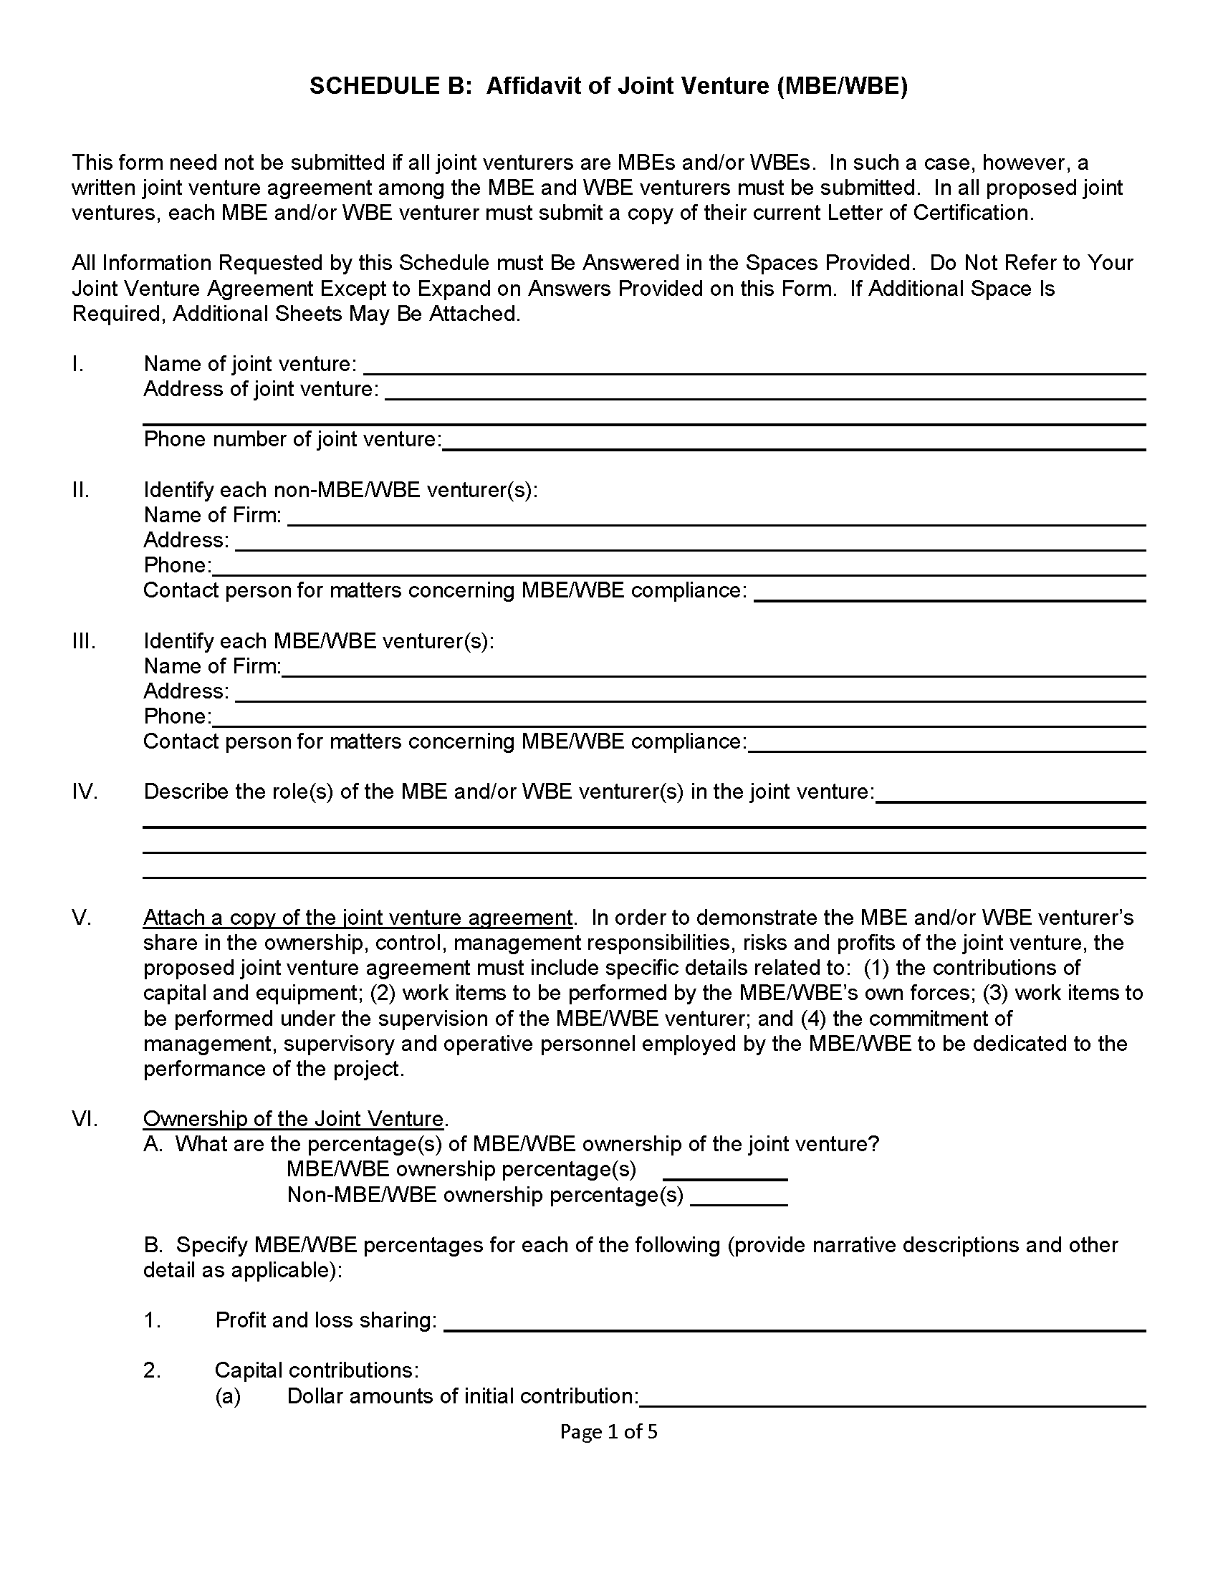
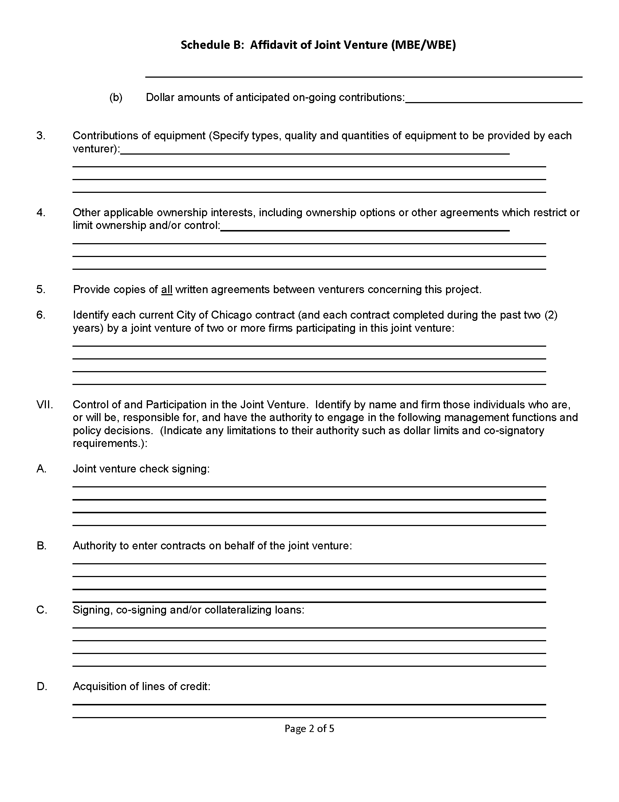
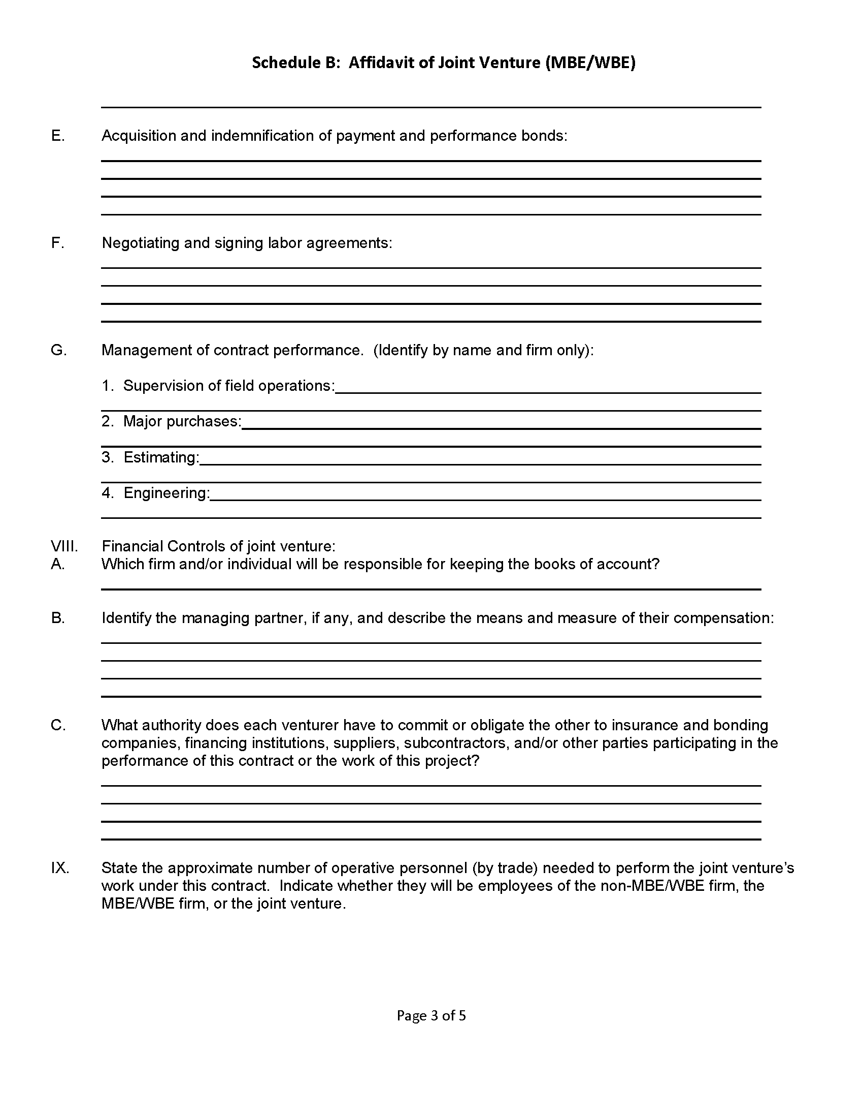
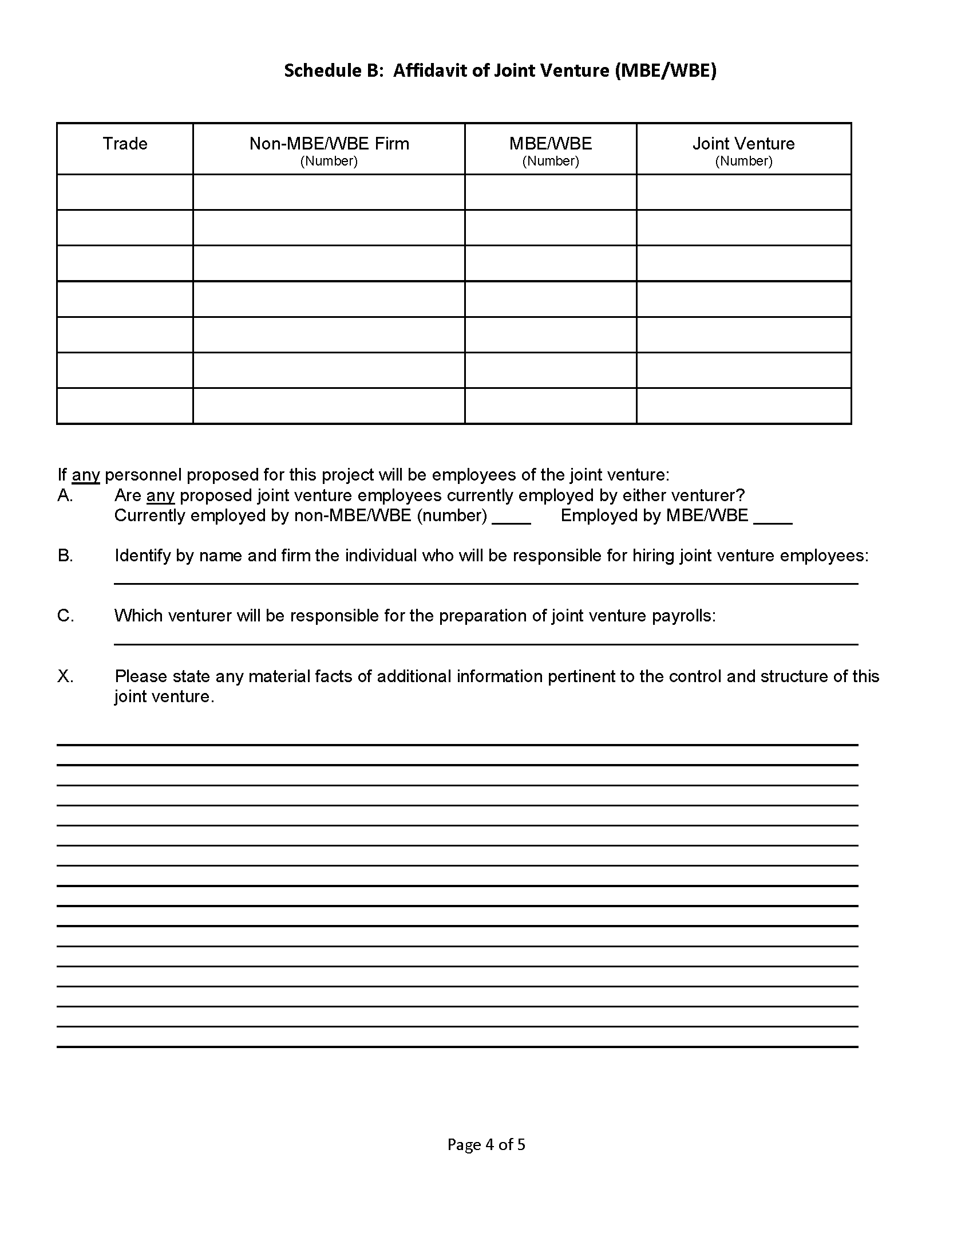
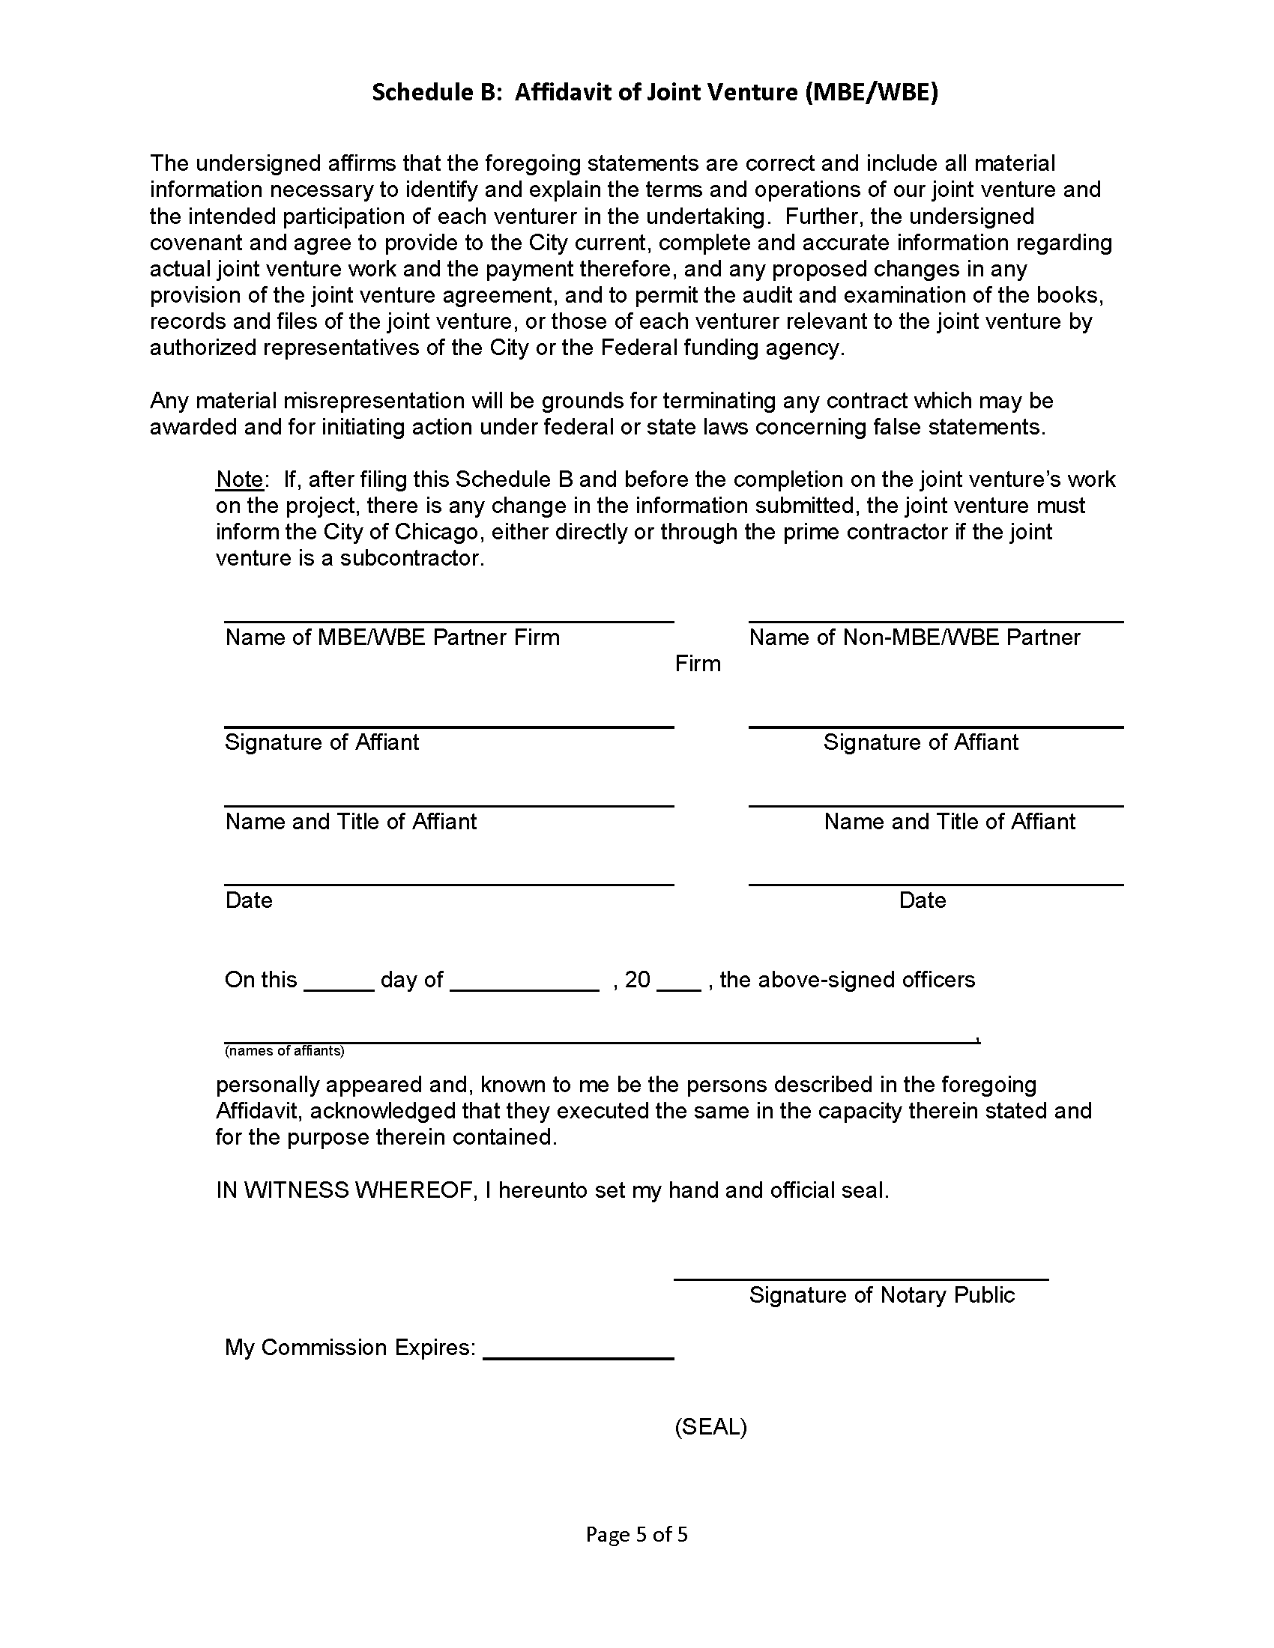

Schedule C-1: Letter of Intent From MBE/WBE To Perform As Subcontractor, Supplier and/or Consultant
Schedule D-1: Affidavit of Implementation of MBE/WBE Goals and Participation Plan

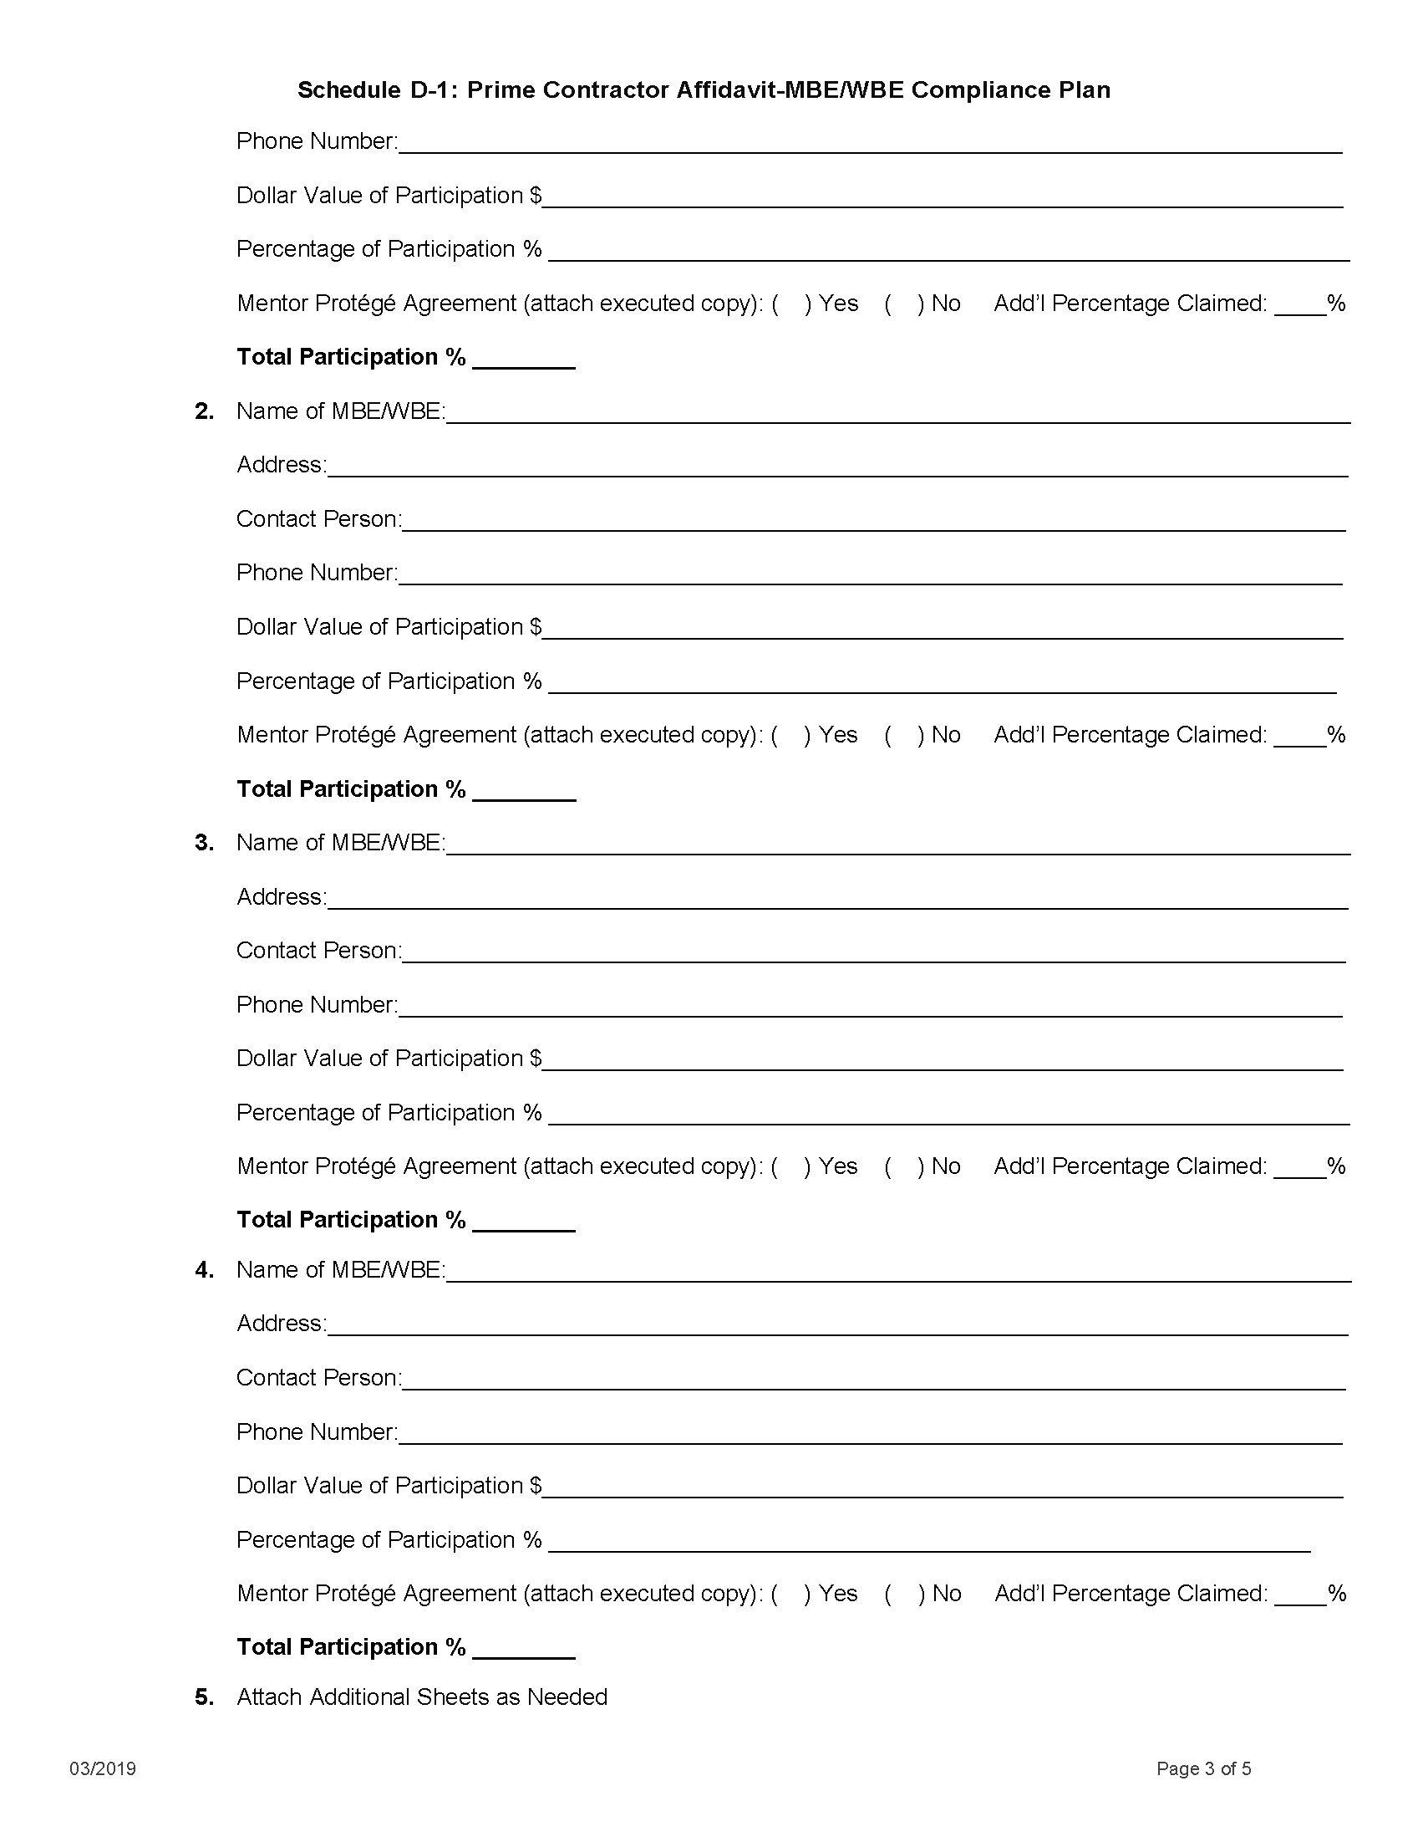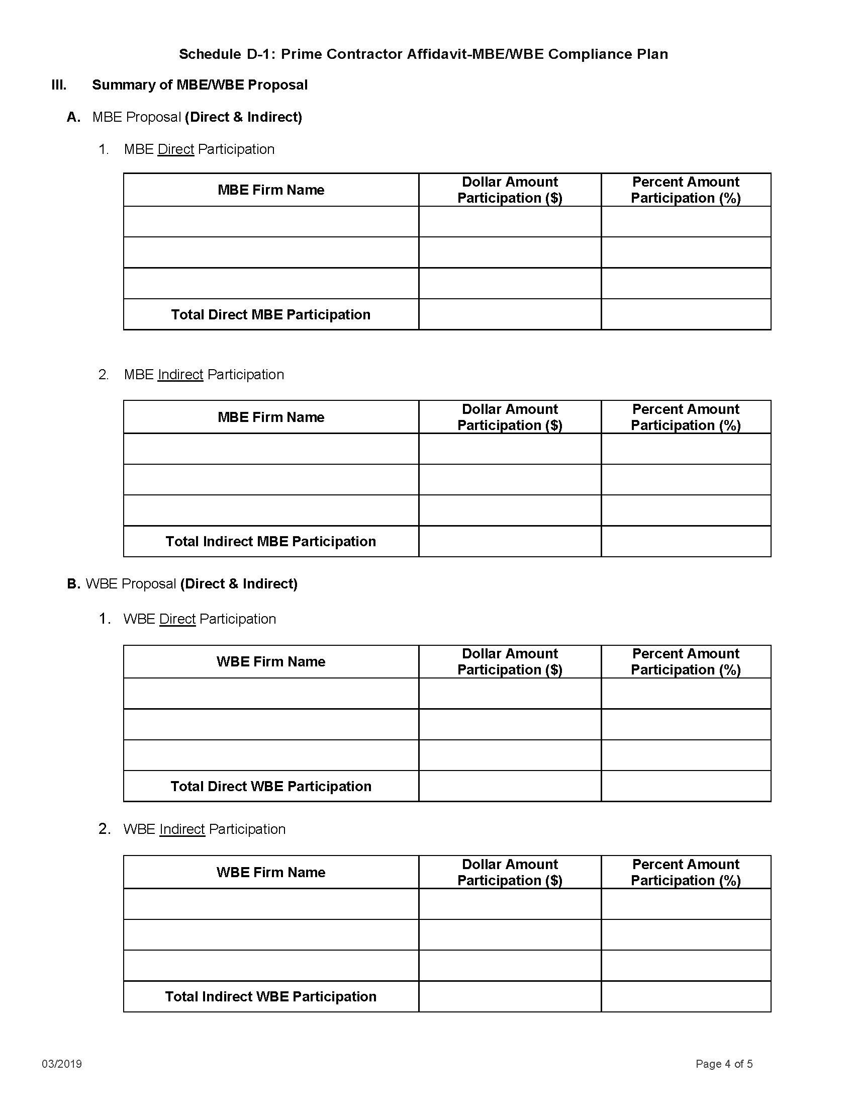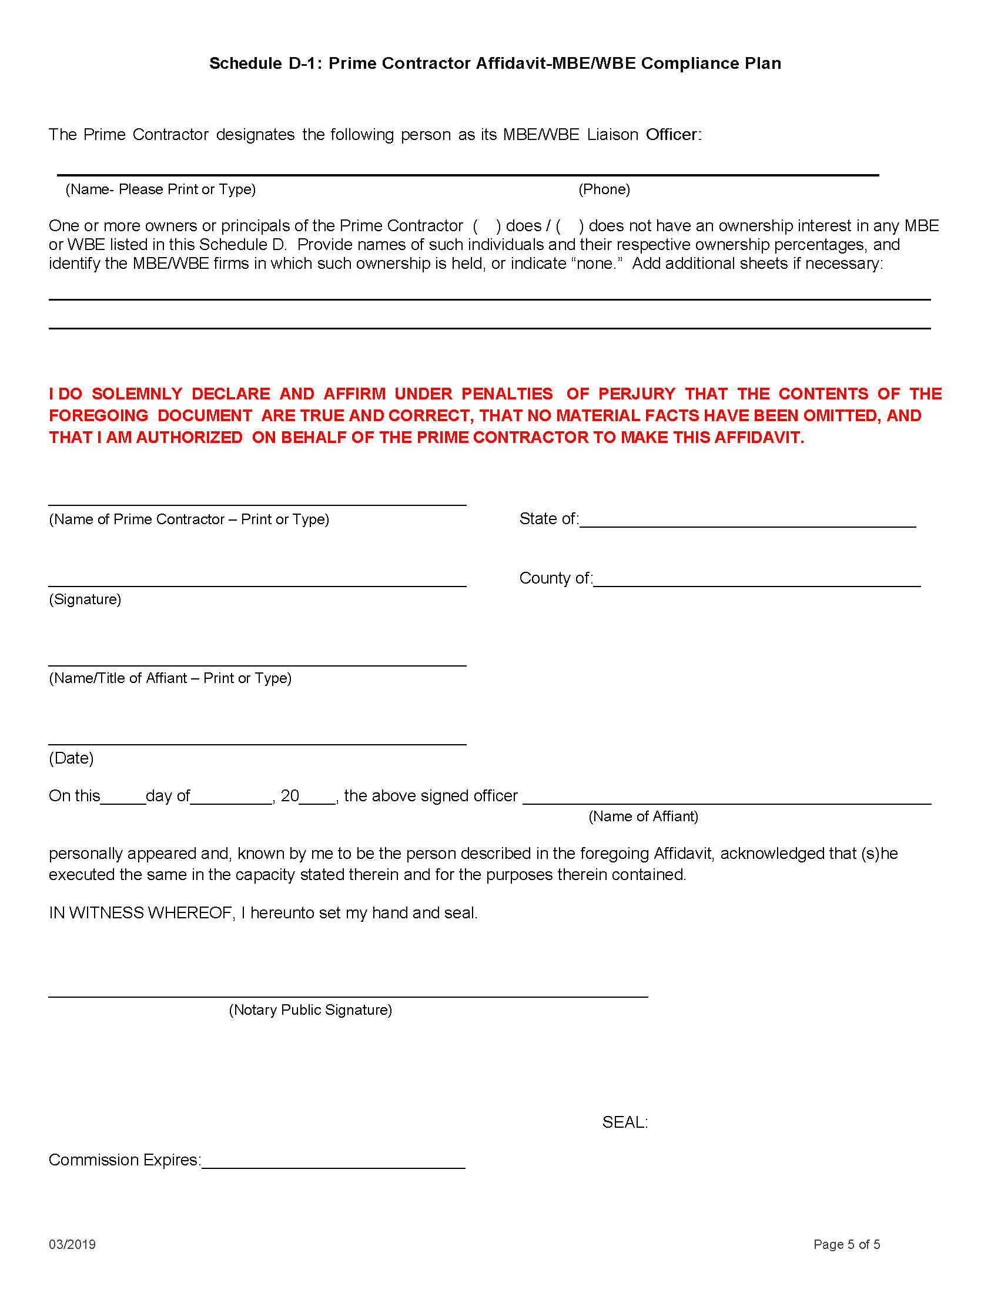

EXHIBIT 4 -ECONOMIC DISCLOSURE STATEMENT AND AFFIDAVIT

EXHIBIT 5 INSURANCE REQUIREMENTS AND EVIDENCE OF INSURANCE

EXHIBIT 6 BUSINESS ASSOCIATE AGREEMENT

BUSINESS ASSOCIATE AGREEMENT

The City of Chicago (“City”) and ___________________ (“Business Associate”) agree to the following terms and conditions, which are intended to comply with the Health Insurance Portability and Accountability Act of 1996, the Health Information Technology for Economic and Clinical Health Act, and their implementing regulations:

The terms below that are capitalized and in bold have the same meanings as set forth in the Health Insurance Portability and Accountability Act of 1996, the Health Information Technology for Economic and Clinical Health Act, which is part of the American Recovery and Reinvestment Act of 2009, and the regulations promulgated thereunder, including the privacy, security, breach, omnibus, and enforcement rules, as each may be amended from time to time (collectively, “HIPAA”). See 45 CFR parts 160 and 164.

Specifically, the following terms used in the Business Associate Agreement shall have the same meaning as in HIPAA: Breach, Business Associate, Covered Entity, Data Aggregation, Designated Record Set, Disclosure, Financial Remuneration, Fundraising, Health Care Operations, Individual, Marketing, Minimum Necessary, Notice of Privacy Practices, Protected Health Information (“PHI”), Required By Law, Secretary, Security Incident, Subcontractor, Unsecured Protected Health Information, and Use. The term “Breach” has the meaning as set forth in HIPAA when capitalized below, but has the ordinary dictionary meaning when not capitalized below.

For purposes of this Business Associate Agreement, the term “Protected Health Information” or “PHI” includes electronic PHI, also known as ePHI.

1. Interpretation of this Business Associate Agreement. A reference in this Business Associate Agreement to HIPAA means the section in effect or as amended. If there is a dispute as to whether Business Associate is, in fact, a Business Associate, the Business Associate must provide a legal memorandum to the City indicating why the Business Associate does not fall under the definition of Business Associate in HIPAA. If the City disagrees with the legal memorandum regarding the Business Associate’s conclusion that Business Associate is not a Business Associate, the City may choose to report a Breach to the Secretary or take other measures as deemed necessary to ensure the City’s compliance with HIPAA. Any ambiguity or inconsistency in this Business Associate Agreement shall be resolved in favor of a meaning that permits City to comply with HIPAA.

2. Amendment of this Business Associate Agreement. The parties hereto agree to negotiate in good faith to amend this Agreement from time to time as is necessary for City to comply with the requirements of HIPAA and for Business Associate to provide services to City. However, no change, amendment, or modification of this Agreement shall be valid unless it is set forth in writing and signed by both parties.

3. Designation of HIPAA Officer(s). Business Associate agrees to designate, in writing, a HIPAA Privacy and Security Officer(s) who will communicate with the City’s HIPAA Privacy and Security Officers for purposes of this Agreement. Business Associate agrees to notify the City’s HIPAA Privacy and Security Officers of such designation and the contact information of such officer(s):

Stephen Murphy Bruce Coffing
HIPAA Privacy Officer HIPAA Security Officer
312-747-9605 312-744-2461
Stephen.murphy@cityofchicago.org Bruce.Coffing@cityofchicago.org

4. Uses and Disclosures of PHI. Business Associate must not use or further disclose Protected Health Information (“PHI”) other than as permitted or required by this Agreement, as necessary to perform the services in this Agreement, or as required by law.
a. Business Associate will not sell PHI or use or disclose PHI for the purposes of marketing or fundraising.
b. Business Associate shall not directly or indirectly receive financial remuneration in exchange for any PHI of an individual or in exchange for making communications regarding treatment or health care operations purposes, unless otherwise allowed in this Agreement.
c. If Business Associate is authorized to use PHI to provide the City with de-identified information, Business Associate is not permitted to use or disclose the de-identified information for purposes other than those specified in the Agreement.
d. Business Associate may use PHI to provide data aggregation services to the City, relating to the health care operations of the City.
e. Business Associate may use and disclose PHI received by the Business Associate in its capacity as a Business Associate to the City, if necessary, for the proper management and administration of Business Associate or to carry out the legal responsibilities of Business Associate, provided that, as to any such disclosure, the following requirements are met:
i. The disclosure is required by law; or
ii. The Business Associate obtains reasonable assurances from the person to whom the information is disclosed that it will be held confidentially and used or further disclosed only as required by law or for the purpose for which it was disclosed to the person, and the person notifies Business Associate of any instances of which it is aware in which the confidentiality of the information has been the subject of a Breach.
f. Except as otherwise limited in this Agreement, Business Associate may use and disclose PHI obtained from or on behalf of the City to perform functions, activities, or services for, or on behalf of, the City as specified in the Agreement, provided that such use or disclosure would not violate HIPAA if done by the City.

5. Minimum Necessary. Business Associate shall use, disclose, or request only the minimum necessary PHI necessary to accomplish the intended purpose of the use, disclosure, or request. Business Associate represents that the PHI used, disclosed, or requested by Business Associate is the minimum necessary to carry out purposes of the Agreement. Prior to any use or disclosure, Business Associate shall determine whether a limited data set would be sufficient for these purposes.

6. Safeguards of PHI. Business Associate must use appropriate safeguards with respect to PHI that it creates, receives, maintains, or transmits on behalf of the City to prevent the use or disclosure of PHI other than as provided for in this Agreement. The safeguards must reasonably protect PHI from any intentional or unintentional use or disclosure in violation of HIPAA privacy regulations (45 CFR Part 164, subpart E) and limit incidental uses or disclosures made pursuant to a use or disclosure otherwise permitted by this Agreement. The safeguards must also reasonably and appropriately protect the confidentiality, integrity, and availability of PHI that Business Associate creates, receives, maintains, or transmits on the City’s behalf as required by the HIPAA security regulations (45 CFR Part 164, subpart C). Where applicable, Business Associate must comply with the HIPAA security regulations (45 CFR Part 164, subpart C) with respect to electronic protected health information, to prevent the use or disclosure other than as provided for by this Agreement. Where feasible, PHI will not leave the City’s facilities and will be accessed under the supervision of City employees.

7. Applicability of Business Associate Agreement to Subcontractors and Agents. Business Associate must ensure that any agent, including a subcontractor, that creates, receives, maintains, or transmits PHI on behalf of the Business Associate agrees to the same restrictions, conditions, and requirements that apply through this Agreement to Business Associate with respect to such information, by entering into a contract or other arrangement that complies with HIPAA. An agent or subcontractor of a Business Associate is not permitted to use or disclose PHI in a manner that would not be permissible if done by the Business Associate. Business Associate will ensure that its subcontractors and agents to which Business Associate is permitted by this Agreement or in writing by the City to disclose PHI agree to implement reasonable and appropriate safeguards to protect PHI. Business Associate will obtain reasonable assurances from any subcontractors and agents to which Business Associate discloses PHI that the subcontractor or agent will hold PHI in confidence and further use or disclose PHI only for the purpose for which Business Associate disclosed PHI to the subcontractor or agent or as required by law.

Business Associate will obtain reasonable assurances that any subcontractor or agent to which Business Associate discloses PHI will notify the Business Associate within 5 calendar days (who will, in turn, notify the City within 5 calendar days, as described below) of any instance in which the subcontractor or agent becomes aware of a Breach of unsecured PHI; possible Breach of unsecured PHI; any security incident of which it becomes aware, including: any attempted or successful unauthorized access, use, disclosure, modification, or destruction of PHI; or any attempted or successful interference with agent or subcontractor’s system operations of which agent/subcontractor becomes aware.

Agent/subcontractor is not required to report the following types of unsuccessful security incidents: pings and other broadcast attacks on agent/subcontractor’s firewall, port scans, unsuccessful log-on attempts, denial of service attacks, and any combination of the above, so long as no such incident results in unauthorized access, use, or disclosure of PHI.

If a delay is requested by a law enforcement official in accordance with 45 CFR 164.412, agent/subcontractor may delay notification to Business Associate for the time period specified in HIPAA. Agent or subcontractor’s report will include the information described in 45 CFR 164.404(c) and such other information as the Business Associate or the City may reasonably request.

8. Reporting of Breaches, Potential Breaches, and Security Incidents. Business Associate must report to the City any use or disclosure of the PHI not provided for by this Agreement of which it becomes aware, as well as any Breach of Unsecured PHI; potential Breach of unsecured PHI; any security incident of which it becomes aware; any attempted or successful unauthorized access, use, disclosure, modification, or destruction of PHI; or any attempted or successful interference with Business Associate’s system operations of which Business Associate becomes aware.

Business Associate will make the report to the City’s HIPAA Privacy and Security Officers not more than five (5) calendar days after Business Associate discovers such non-permitted use or disclosure, Breach, security incident, or other incident as described above. Business Associate shall provide any reports or notices required by HIPAA as a result of Business Associate’s Breach. On behalf of the City, Business Associate will provide such reports or notices to any party or entity (including but not limited to media, Secretary, and individuals affected by the Breach) entitled by law to receive the reports or notices. Business Associate agrees to pay the costs associated with notifying individuals affected by the Breach, which may include, but are not limited to, paper, printing, and mailing costs.

Business Associate is not required to report the following types of unsuccessful security incidents: pings and other broadcast attacks on Business Associate’s firewall, port scans, unsuccessful log-on attempts, denial of service attacks, and any combination of the above, so long as no such incident results in unauthorized access, use, or disclosure of PHI.

If a delay is requested by a law enforcement official in accordance with 45 CFR 164.412, Business Associate may delay notifying City for the time period specified in HIPAA. Business Associate’s report will include the information described in 45 CFR 164.404(c) and such other information as the City may reasonably request.

9. Mitigation and Penalties. Business Associate must mitigate, to the extent practicable, any harmful effect that is known to Business Associate of a Breach or of a use or disclosure of PHI by Business Associate in violation of the requirements of this Agreement. Business Associate shall take reasonable steps to put corrective measures in place to prevent future Breaches (such as retraining employees and upgrading security systems). At the City’s request, Business Associate shall take reasonable steps to mitigate the harm to affected Individuals whose PHI has been or may have been compromised as a result of a Breach by Business Associate, including obtaining credit monitoring services and offering identity theft insurance. To the extent that the City incurs civil or criminal monetary penalties as a result of a Breach by the Business Associate, the Business Associate agrees to reimburse the City for such penalties.

10. Designated Record Sets - Access. If the Business Associate has PHI in a Designated Record Set, then Business Associate must provide access to or otherwise make available, at the request of the City, and in the time and manner designated by the City, PHI in a Designated Record Set, to the City or, as directed by City, to an Individual in order to meet the requirements under 45 CFR 164.524.

11. Designated Record Sets – Amendments. If the Business Associate has PHI in a Designated Record Set, then Business Associate must make any amendments to PHI in a Designated Record Set that the City directs or agrees to pursuant to 45 CFR 164.526 at the request of City or an Individual, and in the time and manner designated by the City.

12. Internal Practices, Books, and Records. Business Associate must make its internal practices, books, and records relating to the use and disclosure of PHI received from, or created or received by the Business Associate on behalf of, the City available to the Secretary for purposes of determining compliance with HIPAA. Business Associate also must make internal practices, books, and records relating to the use and disclosure of PHI received from, or created or received by Business Associate on behalf of, the City available to the City in a time and manner designated by the City, for purposes of the Secretary determining City’s compliance with HIPAA.

13. Accounting of Disclosures - Documentation. Business Associate must document the disclosures of PHI and information relating to such disclosures as would be required for City to respond to a request by an individual for an accounting of disclosures of PHI in accordance with HIPAA, specifically 45 CFR 164.528.

14. Accounting of Disclosures – Provision of Information. Business Associate must provide to City or an individual, in time and manner designated by City, information collected which relates to the disclosure of PHI, to permit City to respond to a request by an individual for an accounting of disclosures of PHI in accordance with 45 CFR 164.528. If the Business Associate receives a request for accounting of disclosures directly from the individual, the Business Associate must respond to such request for an accounting of disclosures, provide the accounting of disclosures to the individual within the time required by 45 CFR 164.528, and provide the information regarding such request to the City, in the time and manner designated by the City.

15. Survival, Termination, and Return or Destruction of PHI. Upon termination of this Agreement for any reason, the Business Associate’s obligations under these contractual obligations shall survive termination and remain in effect:
(a) until Business Associate has completed the return or destruction (in accordance with the US Department of Health and Human Services’ Guidance to Render Unsecured Protected Health Information Unusable, Unreadable, or Indecipherable to Unauthorized Individuals) of all of the PHI provided by City to Business Associate, or created or received by Business Associate on behalf of City, and
(b) to the extent that Business Associate retains any PHI.

Upon the expiration or termination of the underlying Agreement, if feasible, the Business Associate must either:
(1) return all PHI received from the City, or created, maintained, or received by Business Associate on behalf of the City, which the Business Associate still maintains in any form, to the City or
(2) destroy it, at the City’s option (in accordance with the US Department of Health and Human Services’ Guidance to Render Unsecured Protected Health Information Unusable, Unreadable, or Indecipherable to Unauthorized Individuals).

This provision shall apply to PHI that is in the possession of subcontractors or agents of Business Associate. Business Associate shall retain no copies of the PHI.

If Business Associate determines that returning or destroying the PHI is infeasible, Business Associate shall extend the protections of this Agreement to such PHI and limit further uses and disclosures of such PHI to those purposes that make the return or destruction infeasible, for so long as Business Associate maintains such PHI. If it is infeasible for Business Associate to obtain, from a subcontractor or agent any PHI in the possession of the subcontractor or agent, Business Associate shall require the subcontractors and agents to agree to extend any and all protections, limitations and restrictions contained in this Agreement to the subcontractors’ and/or agents’ use and/or disclosure of any PHI retained after the termination of this Agreement, and to limit any further uses and/or disclosures to the purposes that make the return or destruction of the PHI infeasible.

In the event of a breach of the terms of these contractual obligations, the cure and remedies of the Agreement shall govern. HIPAA’s privacy rule (45 CFR § 164.504(e)(2)) requires that the Business Associate will authorize termination of the contract by the City, if the City determines that the Business Associate has violated a material term of these contractual obligations.

16. Compliance with Obligations. To the extent the Business Associate is to carry out one or more of City’s obligation(s) under Subpart E of 45 CFR Part 164, the Business Associate must comply with the requirements of Subpart E that apply to the City in the performance of such obligation(s). Business Associate may not use or disclose PHI in a manner that would violate Subpart E of 45 CFR Part 164 if done by the City.

17. No Third Party Rights. The terms and conditions of this Agreement are intended for the sole benefit of Business Associate and City and do not create any third party rights.

18. Governing Law. To the extent not preempted by federal law, the Agreement shall be governed and construed in accordance with the laws of the State of Illinois.

IN WITNESS WHEREOF, each of the undersigned has caused this Agreement to be duly executed in its name and on its behalf.

[Insert business associate’s name]
By: |  | By:
Print Name: |  | Print Name:
Title: |  | Title:
Date: |  | Date:

EXHIBIT 7 LIST OF KEY PERSONNEL

Name/Title/Role of Key Personnel:

EXHIBIT 8 SEXUAL HARASSMENT POLICY AFFIDAVIT (SECTION 2-92-612)

The policy prohibiting sexual harassment as described in Section 2-92-612 of the Municipal Code of Chicago ("MCC") is applicable to contracts paid from funds belonging to or administered by the City.
In accordance with requirements set forth in Section 2-92-612 of the MCC, Auditor hereby attests that Auditor has a written policy prohibiting sexual harassment that includes, at a minimum, the following information:
- the illegality of sexual harassment;
- the definition of sexual harassment; and
- the legal recourse available for victims of sexual harassment.
Auditor understands that it may be required to produce records to the Comptroller to verify the information provided.

Under penalty of perjury the person signing below: (1) warrants that he/she is authorized to execute this Affidavit on behalf of Auditor, and (2) warrants that all certifications and statements contained in this Affidavit are true, accurate, and complete as of the date of execution.

Name of Auditor:

Signature of Authorized Officer:
(Signature)

Title of Signatory:
(Print or Type)

State of _________________________
County of ________________________
Signed and sworn (or affirmed) to before me on ____________ (date) by
_____________________________ (name/s of person/s making statement).

______________________
(Signature of Notary Public)
(Seal)

EXHIBIT 9 AUDITOR’S RESPONSE TO REQUEST FOR PROPOSALS
[Incorporated here by reference]

EXHIBIT 10 AUDITOR’S RESPONSE TO ORAL PRESENTATION

[Incorporated here by reference]

EXHIBIT 11 DATA PROTECTION REQUIREMENTS FOR CONTRACTORS/AUDITORS, VENDORS AND THIRD PARTIES

Data Protection Requirements for Contractors/Auditors, Vendors and
Third-Parties

“Breach” means the acquisition, access, use, or disclosure of Protected Information that compromises the security or privacy of the Protected Information.

"Auditor" means an entity that receives or encounters Protected Information. Auditor includes, without limitation, entities that store Protected Information, or host applications that process Protected Information. The provisions of this Data Policy includes not only the entity that is a signatory to this Policy but all subcontractors, of whatever tier, of that entity; the signatory must inform and obtain the agreement of such subcontractors to the terms of this Data Policy.

“Protected Information” means all data provided by City to Auditor or encountered by Auditor in the performance of the services to the City, including, without limitation, all data sent to Auditor by City and/or stored by Auditor on its servers. Protected Information includes, but is not limited to, employment records, medical and health records, personal financial records (or other personally identifiable information), research data, and classified government information. To the extent there is any uncertainty as to whether any data constitutes Protected Information, the data in question shall be treated as Protected Information.

- Information Security. Auditor agrees to the following:

  - General. Notwithstanding any other obligation of Auditor under this policy, Auditor agrees that it will not lose, alter, or delete, either intentionally or unintentionally, any Protected Information, and that it is responsible for the safe-keeping of all such information, except to the extent that the City directs the Auditor in writing to do so.

  - Access to Data. In addition to the records to be stored / maintained by Auditor, all records that are possessed by Auditor in its service to the City of Chicago to perform a governmental function are public records of the City of Chicago pursuant to the Illinois Freedom of Information Act (FOIA), unless the records are exempt under the Act. FOIA requires that the City produce records in a very short period of time. If the Auditor receives a request from the City to produce records, the Auditor shall do so within 72 hours of the notice.

  - Minimum Standard for Data at Rest and Data in Motion. Auditor must, at a minimum, comply, in its treatment of Protected Information, with National Institute of Standards and Technology (NIST) Special Publication 800-53 Moderate Level Control. Notwithstanding this requirement, Auditor acknowledges that it must fully comply with each additional obligation contained in this policy. If data is protected health information or electronic protected health information, as defined in the Health Insurance Portability and Accountability Act and Health Information Technology for Economic and Clinical Health Act (HIPAA/HITECH) and regulations implementing these Acts (see 45 CFR Parts 160 and 164), it must be secured in accordance with “Guidance Specifying the Technologies and Methodologies that Render Protected Health Information Unusable, Unreadable, or Indecipherable to Unauthorized Individuals,” available on the United States Department of Health and Human Services (HHS) website
http://www.hhs.gov/ocr/privacy/hipaa/administrative/breachnotificationrule/index.html, or at Volume 74 of the Federal Register, beginning at page 42742. That guidance from the HHS states that valid encryption processes for protected health information data at rest (e.g., protected health information resting on a server), must be consistent with the NIST Special Publication 800-111, Guide for Storage Encryption Technologies for End User Devices. Valid encryption processes for protected health information data in motion (e.g., transmitted through a network) are those which comply with NIST Special Publications 800-52, Guidelines for the Selection and Use of Transport Layer Security Implementation; 800-77, Guide to IPsec VPNs; or 800-113, Guide to SSL VPNs, or others which are Federal Information Processing Standards (FIPS) 140-2 validated.

  - Where Data is to be Stored. All data must be stored only on computer systems located in the continental United States.

  - Requirement to Maintain Security Program. Auditor acknowledges that the City has implemented an information security program to protect the City’s information assets (“City Program”). Auditor shall be responsible for establishing and maintaining an information security program that is designed to: (i) ensure the security and confidentiality of Protected Information; (ii) protect against any anticipated threats or hazards to the security or integrity of Protected Information; (iii) protect against unauthorized access to or use of Protected Information; (iv) ensure the proper disposal of Protected Information; and, (v) ensure that all subcontractors of Auditor, if any, comply with all of the foregoing.

  - Undertaking by Auditor. Without limiting Auditor’s obligation of confidentiality as further described herein, in no case shall the safeguards of Auditor’s information security program be less stringent than the information security safeguards used by the City Program.

  - Right of Audit by the City of Chicago. The City of Chicago shall have the right to review Auditor’s information security program prior to the commencement of Services and from time to time during the term of this Agreement. During the performance of the Services, from time to time and without notice, the City of Chicago, at its own expense, shall be entitled to perform, or to have performed, an on-site audit of Auditor’s information security program. In lieu of an on-site audit, upon request by the City of Chicago, Auditor agrees to complete, within forty-five (45 days) of receipt, an audit questionnaire provided by the City of Chicago or the City of Chicago’s designee regarding Auditor’s information security program.

  - Audit by Auditor. No less than annually, Auditor shall conduct an independent third-party audit of its information security program and provide such audit findings to the City of Chicago, all at the Auditor’s sole expense.

  - Audit Findings. Auditor shall implement at its sole expense any remedial actions as identified by the City as a result of the audit.

  - Demonstrate Compliance - PCI. No less than annually, as defined by the City of Chicago and where applicable, the Auditor agrees to demonstrate compliance with PCI DSS (Payment Card Industry Data Security Standard). Upon City’s request, Auditor must be prepared to demonstrate compliance of any system or component used to process, store, or transmit cardholder data that is operated by the Auditor as part of its service. Similarly, upon City’s request, Auditor must demonstrate the compliance of any third party it has sub-contracted as part of the service offering. As evidence of compliance, the Auditor shall provide upon request a current attestation of compliance signed by a PCI QSA (Qualified Security Assessor).

  - Demonstrate Compliance – HIPAA / HITECH. If the Protected Information includes protected health information or electronic protected health information covered under HIPAA/HITECH, Auditor must execute, and be governed by, the provisions in its contract with the City regarding HIPAA/HITECH, the regulations implementing those Acts, and the Business Associate Agreement in its contract with the City. As specified in 1.3, protected health information must be secured in accordance with the “Guidance Specifying the Technologies and Methodologies that Render Protected Health Information Unusable, Unreadable, or Indecipherable to Unauthorized Individuals.”

  - Data Confidentiality. Auditor shall implement appropriate measures designed to ensure the confidentiality and security of Protected Information, protect against any anticipated hazards or threats to the integrity or security of such information, protect against unauthorized access or disclosure of information, and prevent any other action that could result in substantial harm to the City of Chicago or an individual identified with the data or information in Auditor’s custody.

  - Compliance with All Laws and Regulations. Auditor agrees that it will comply with all laws and regulations.

  - Limitation of Access. Auditor will not knowingly permit any Auditor personnel to have access to any City of Chicago facility or any records or data of the City of Chicago if the person has been convicted of a crime in connection with (i) a dishonest act, breach of trust, or money laundering, or (ii) a felony. Auditor must, to the extent permitted by law, conduct a check of public records in all of the employee’s states of residence and employment for at least the last five years in order to verity the above. Auditor shall assure that all contracts with subcontractors impose these obligations on the subcontractors and shall monitor the subcontractors’ compliance with such obligations.

  - Data Re-Use. Auditor agrees that any and all data exchanged shall be used expressly and solely for the purposes enumerated in the Agreement. Data shall not be distributed, repurposed or shared across other applications, environments, or business units of Auditor. As required by Federal law, Auditor further agrees that no City of Chicago data of any kind shall be revealed, transmitted, exchanged or otherwise passed to other Contractors or interested parties except on a case-by-case basis as specifically agreed to in writing by an officer of the City of Chicago with designated data, security, or signature authority.

  - Safekeeping and Security. Auditor will be responsible for safekeeping all keys, access codes, passwords, combinations, access cards, personal identification numbers and similar security codes and identifiers issued to Auditor’s employees, agents or subcontractors. Auditor agrees to require its employees to promptly report a lost or stolen access device or information to their primary business contact and to the City of Chicago Information Security Office.

  - Mandatory Disclosure of Protected Information. If Auditor is compelled by law or regulation to disclose any Protected Information, the Auditor will provide to the City of Chicago with prompt written notice so that the City of Chicago may seek an appropriate protective order or other remedy. If a remedy acceptable to the City of Chicago is not obtained by the date that the Auditor must comply with the request, the Auditor will furnish only that portion of the Protected Information that it is legally required to furnish, and the Auditor shall require any recipient of the Protected Information to exercise commercially reasonable efforts to keep the Protected Information confidential.

  - Data Breach. Auditor agrees to comply with all laws and regulations relating to data breach, including without limitation, the Illinois Personal Information Protection Act and other applicable Illinois breach disclosure laws and regulations. Data breaches of protected health information and electronic protected health information shall be governed by the provisions regarding HIPAA/HITECH, and the regulations implementing those Acts, in the Auditor’s contract with the City, specifically the Business Associate Agreement in such contract. Auditor will immediately notify the City if security of any Protected Information has been breached, and will provide information as to that breach in such detail as requested by the City. Auditor will, if requested by the City, notify any affected individuals of such breach at the sole cost of the Auditor.

  - Data Sanitization and Safe Disposal. All physical and electronic records must be retained per federal, state and local laws and regulations, including the Local Records Act. Where disposal is approved, the Auditor agrees that prior to disposal or reuse of all magnetic media (e.g. hard disk, floppy disk, removable media, etc.) which may have contained City of Chicago data shall be submitted to a data sanitization process which meets or exceeds DoD 5220.28-M 3-pass specifications. Certification of the completion of data sanitization shall be provided to the City of Chicago within 10 days of completion. Acceptance of Certification of Data Sanitization by the Information Security Office of the City of Chicago is required prior to media reuse or disposal. All other materials which contain City of Chicago data shall be physically destroyed and shredded in accordance to NIST Special Publication 800-88, Guidelines for Media Sanitization, specifications.

  - End of Agreement Data Handling. The Auditor agrees that upon termination of this Agreement it shall return all data to the City of Chicago in a useable electronic form, and erase, destroy, and render unreadable all data in its entirety in accordance to the prior stated Data Sanitization and Safe Disposal provisions. Data must be rendered in a manner that prevents its physical reconstruction through the use of commonly available file restoration utilities. Certification in writing that these actions have been completed must be provided within 30 days of the termination of this Agreement or within 7 days of a request of an agent of the City of Chicago, whichever shall come first.
◙

EXHIBIT 12 CITY OF CHICAGO IDENTIY PROTECTION POLICY

City of Chicago
Identity Protection Policy
- Purpose

The City of Chicago (the “City”) adopts this Identity Protection Policy pursuant to the Identity Protection Act, 5 ILCS 179/1 et seq. The Identity Protection Act (the “Act”) requires each local and State government agency in Illinois to draft, approve, and implement an Identity Protection Policy to ensure the confidentiality and integrity of Social Security numbers (“SSNs”) that agencies collect, maintain, and use.

The purpose of this Policy is to set forth the procedures and restrictions that must be observed by all City employees regarding the use and availability of SSNs belonging to City employees and the public. This Policy is effective immediately.

- Access to Social Security Numbers

  - Limited access: Only those City employees who are required to use or handle information or documents that contain SSNs in the course of performing their duties will have access to such information or documents.
  - Training: All City employees who have access to SSNs will receive training on the proper handling of information that contains SSNs.

- Displaying or Printing SSNs

The City shall not:
  - Publicly post or publicly display in any manner an individual’s SSN. “Publicly post” or “publicly display” means to intentionally communicate or otherwise intentionally make available to the general public.
  - Print an individual’s SSN on any card required for an individual to access products or services provided by the City.
  - Require an individual to transmit a SSN over the Internet, unless the connection is secure or the SSN is encrypted.
  - Print an individual’s SSN on any materials that are mailed to the individual through the U.S. Postal Service, any private mail service, electronic mail, or any similar method of delivery, unless State or federal law requires the SSN to be on the document to be mailed.

SSNs may be included in applications and forms sent by mail, including but not limited to, any material mailed in connection with the administration of the Unemployment Insurance Act, any material mailed in connection with any tax administered by the Department of Finance, and documents sent as part of an application or enrollment process or to establish, amend, or terminate an account, contract, or policy or to confirm the accuracy of the SSN.

A SSN that is permissibly mailed must not be printed, in whole or in part, on a postcard or other mailer that does not require an envelope, or be visible on an envelope without the envelope having been opened.

- Collection, Use or Disclosure of SSNs

The City shall not:
  - Collect, use, or disclose SSNs from individuals unless:
    - required to do so under State or federal law, rules, or regulations, or the collection, use, or disclosure of the SSN is otherwise necessary for the performance of the City’s duties and responsibilities;
    - the need and purpose for the SSN is documented before collection of the Social Security number; and
    - the SSN collected is relevant to the documented need and purpose.
  - Require an individual to use his or her SSN to access an Internet website.
  - Use the SSN for any purpose other than the purpose for which it was collected.
  - Exceptions: The prohibitions in Sections 4a) – 4 c) of this Policy do not apply in the following circumstances:
The disclosure of SSNs to agents, employees, contractors, or subcontractors of a governmental entity or disclosure by a governmental entity to another governmental entity or its agents, employees, contractors, or subcontractors, provided that:
      - disclosure is necessary in order for the entity to perform its duties and responsibilities; and
      - if disclosing to a contractor or subcontractor, prior to such disclosure, the governmental entity first receives from the contractor or subcontractor a copy of the contractor's or subcontractor's policy that sets forth how the requirements imposed under this Act on a governmental entity to protect an individual's SSN will be achieved.
    - The disclosure of SSNs pursuant to a court order, warrant, or subpoena.
    - The collection, use, or disclosure of SSNs in order to ensure the safety of: State and local government employees; persons committed to correctional facilities, local jails, and other law-enforcement facilities or retention centers; wards of the State; and all persons working in or visiting a State or local government agency facility.
    - The collection, use, or disclosure of SSNs for internal verification or administrative purposes.
    - The disclosure of SSNs by a State agency to any entity for the collection of delinquent child support or of any State debt or to a governmental agency to assist with an investigation or the prevention of fraud.
    - The collection or use of SSNs to investigate or prevent fraud, to conduct background checks, to collect a debt, to obtain a credit report from a consumer reporting agency under the federal Fair Credit Reporting Act, to undertake any permissible purpose that is enumerated under the federal Gramm Leach Bliley Act, or to locate a missing person, a lost relative, or a person who is due a benefit, such as a pension benefit or an unclaimed property benefit.

- Statement of Purpose for Collection of SSNs

Whenever an individual is asked to provide a SSN to the City, the City shall provide that individual with a statement of the purpose or purposes for which the City is collecting and using the SSN. The City shall also provide the statement of purpose upon request. A sample Statement of Purpose is attached to this Policy.

- Requirement to Redact Social Security Numbers

  - Public inspection and copying of information: The City shall comply with the provisions of any other State law with respect to allowing the public inspection and copying of information or documents containing all or any portion of an individual’s SSN. The City shall redact SSNs from the information or documents before allowing the public inspection or copying of the information or documents.
  - Manner of collecting SSNs: When collecting SSNs, the City shall request each SSN in a manner that makes the SSN easily redacted if required to be released as part of a public records request.

“Redact” means to alter or truncate data so that no more than five sequential digits of a SSN are accessible as part of personal information.

- Department Responsibilities

Each department head must ensure that the procedures and restrictions stated in this Policy are followed by department employees, and that the requirements of Act as described in this Policy, are met.

- Monitoring

All departments are subject to auditing of any city policy with or without prior notice. As stated in Chapter 2-26 of the Chicago Municipal Code, it is the duty of every officer, employee, department, and agency of the city to cooperate with the Board of Ethics, and every department must make its premises, equipment, personnel, books, records and papers readily available.

- Compliance

Penalties for a violation of this policy include disciplinary action up to and including termination and/or criminal prosecution as provided in the Identity Protection Act. (5 ILCS 179/45).
◙
CITY OF CHICAGO
STATEMENT OF PURPOSE
FOR THE COLLECTION OF SOCIAL SECURITY NUMBERS

The Illinois Identity Protection Act, 5 ILCS 179/1 et seq., requires every local and state government agency to have an Identity Protection Policy and to provide a Statement of Purpose explaining why the agency is collecting and using an individual’s Social Security Number (“SSN”). The City of Chicago is providing you with this Statement of Purpose because you have been asked to provide your SSN or because you requested a copy.

Why have you been asked for your SSN?
You are being asked for your SSN for one or more of the following permissible reasons:
- Identity verification
- Fraud prevention
- Law enforcement investigation
- Background check
- Child support collection
- Billing, payment or debt collection
- Employment-related administrative purposes
- Pursuant to a court order, warrant or subpoena
- City license application
- To comply with State or federal law, rules or regulations or because the City agency making the request requires the SSN to perform its duties and responsibilities

What does the City of Chicago do with your SSN?
The City will only use your SSN for the purpose for which it was collected.

The City will not:
- Sell, lease, loan, trade or rent your SSN to a third party for any purpose;
- Publicly post or display your SSN;
- Print your SSN on any card required to access City services;
- Require you to transmit your SSN over the Internet unless the connections secure or your SSN is encrypted; or
- Print your SSN on any materials that are being mailed to you unless State or federal law requires that number to be on such documents or unless the City is confirming the accuracy of your SSN. If mailed, your SSN will not be visible without opening the envelope in which it has been mailed.

If you have questions or comments about this Statement of Purpose, write to:

City of Chicago Board of Ethics
740 North Sedgwick Street
Suite 500
Chicago, Illinois 60654
◙

