From: Reifman, David
Sent: Tuesday, June 27, 2017 6:08 PM
To: Berlin, Steve
Subject: FW: REMINDER: Invitation to Ethical Redevelopment Salon Finale | June 22

Steve – I attended this event. Not sure I need to report it, but I am. There was a dinner.

From: Theaster Gates [mailto:theaster@uchicago.edu]
Sent: Thursday, June 08, 2017 8:29 AM
To: Reifman, David
Subject: Fwd: REMINDER: Invitation to Ethical Redevelopment Salon Finale | June 22

Hey David,

Hope you can join us at the Salon Finale. Even if not, I wanted to share what the PlaceLab team has been up to for this past year. We’ll share everything online afterwards if you're interested.

Looking forward,
T

---------- Forwarded message ----------
From: Theaster Gates <theaster@uchicago.edu>
Date: Tue, Jun 6, 2017 at 1:07 PM
Subject: REMINDER: Invitation to Ethical Redevelopment Salon Finale | June 22
To: theaster@uchicago.edu
View email in your browser

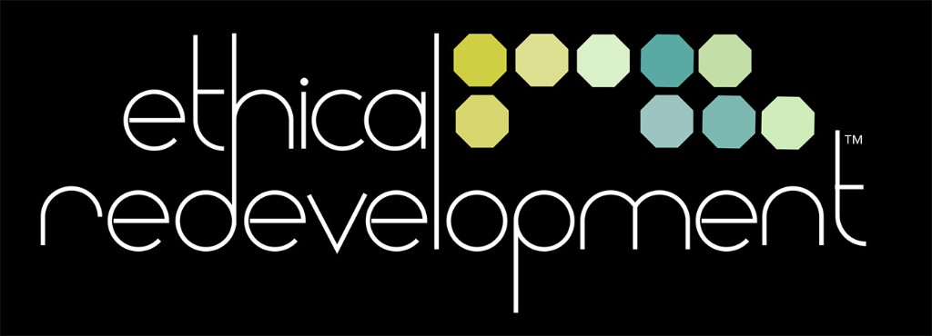

Join us for the
SALON FINALE
Thursday, June 22nd
4:00–7:00 pm
Arts Block
301 E Garfield Blvd, Chicago



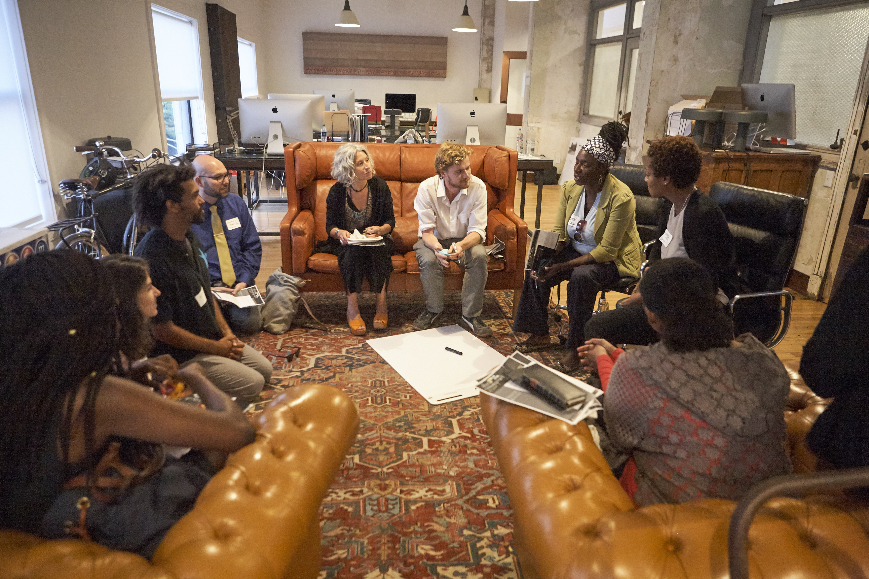

Program
The focus is on the impact of Ethical Redevelopment: the value of Salon Members participating in the Salons, the ways the Principles have advanced work in cities across the country—including Knight Cities—and the next steps for maintaining the cross-city networks that we have established together.
The program includes panel discussion by Salon Members, workshops, the premier screening of a new Ethical Redevelopment video, and the release of a publication of essays and reflections.
Our thinking has been profoundly shaped by the conversations in the Salon Sessions. A reception and performances celebrate our year of work together. Content will be made available to the public after the event.
4:00 pm: Opening and video screening
5:00 pm: Breakout Sessions led by Salon Members
6:00 pm: Panel Discussion with Salon Members and Place Lab staff
with a Closing by Theaster Gates
7:00 pm: Reception and Dinner at Currency Exchange Cafe

About
Ethical Redevelopment is an evolving approach to making cities and neighborhoods more equitable, livable, and successful. Over the course of the Salon Series we have collaboratively refined the 9 Principles of Ethical Redevelopment to more accurately articulate the values, process, and aim of equitable community practice.
Place Lab will continue to make the case for Ethical Redevelopment to the wider world with the hope that people everywhere can apply it to the places they care about.
We hope that you will join us to help make the case.

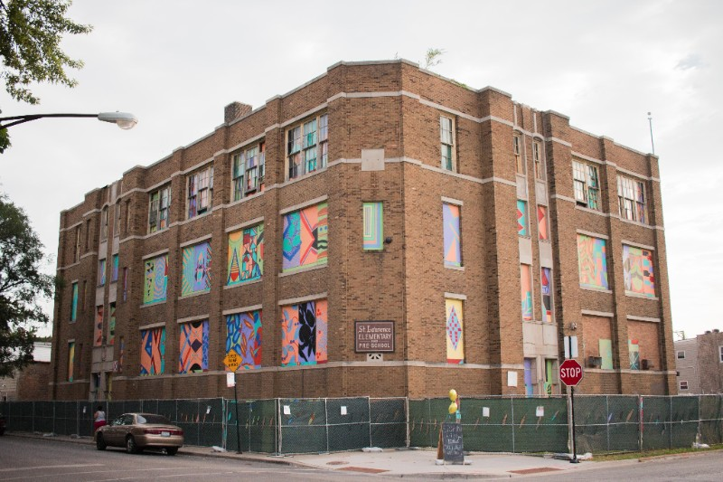
Ethical Redevelopment Online
Visit Place Lab's SITE: Blog for photos, recaps, and videos of past Salon Sessions, as well as updates on other Place Lab projects.
Notes from the past Salon Sessions are posted on the shared Google Drive.

Questions? Contact Naomi Miller at millern@uchicago.edu

ABOUT PLACE LAB
Place Lab is a team of professionals from the diverse fields of law, urban planning, architecture, design, social work, arts administration, and gender and cultural studies. A partnership between Arts + Public Life, an initiative of UChicago Arts, and the Harris School of Public Policy, Place Lab is a catalyst for mindful urban transformation and creative redevelopment. Led by renowned artist and University of Chicago faculty member Theaster Gates, this joint enterprise merges Chicago Harris’ Cultural Policy Center’s commitment to cultural policy and evidence-based analysis with Place Lab’s work at Arts + Public Life on arts- and culture-led neighborhood transformation.



Copyright (C) 2017 Place Lab All rights reserved.
Thank you for your interest in Place Lab at the University of Chicago. You are receiving this email because you opted in at our website or requested to be added by a staff member.
Want to change how you receive these emails?
You can update your preferences or unsubscribe from this list
Our mailing address is:
Place Lab
301 E Garfield Blvd
Chicago, IL 60637

--
Theaster Gates, Jr.
Director
Arts + Public Life
301 E. Garfield Blvd.
Chicago, IL 60637

