From: Reifman, David
Sent: Friday, December 04, 2015 9:51 AM
To: Berlin, Steve
Subject: FW: Reminder | Please join us to jingle/mingle tonight!

Steve – please be advised that I attended this event for networking in my official capacity. Thanks.

From: Sterling Bay [mailto:bparker=sterlingbay.com@mail151.atl101.mcdlv.net] On Behalf Of Sterling Bay
Sent: Thursday, December 03, 2015 6:15 PM
To: Reifman, David
Subject: Reminder | Please join us to jingle/mingle tonight!

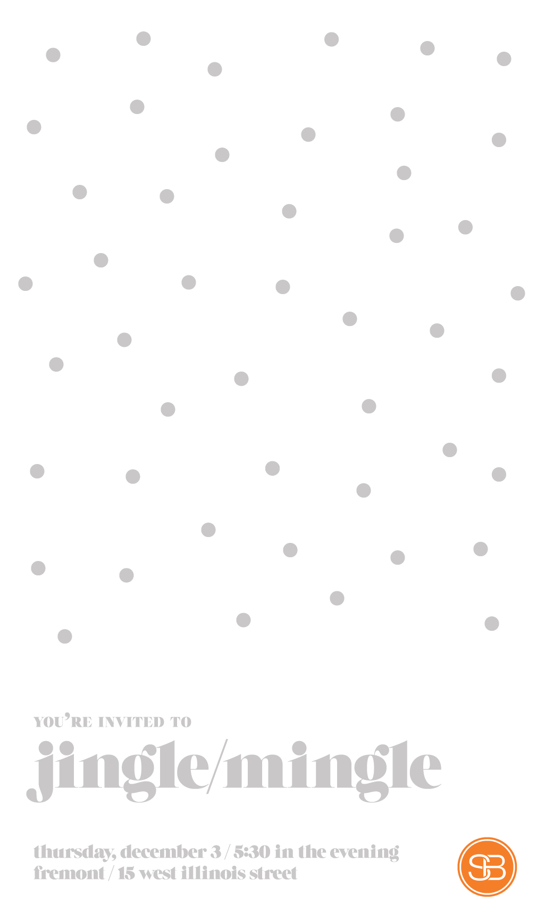

Copyright © 2015 Sterling Bay, All rights reserved.
You are cordially invited to a Sterling Bay event.
Our mailing address is:
Sterling Bay
1040 West Randolph Street
Chicago, IL 60607
Add us to your address book
Want to change how you receive these emails?
You can update your preferences or unsubscribe from this list

