From: Reifman, David
Sent: Friday, December 18, 2015 4:47 PM
To: Berlin, Steve
Subject: FW: You are confirmed for Sue Leonis and Terry Teele’s event!

Steve – I attended this event.

From: Paperless Post [mailto:paperlesspost@paperlesspost.com]
Sent: Monday, November 23, 2015 8:51 AM
To: Reifman, David
Subject: You are confirmed for Sue Leonis and Terry Teele’s event!



You replied “attending.”
“Terry Teele & Sue Leonis Holiday Party”
Thursday, December 17th
5:30 pm to 7:30 pm

Add to calendar | Message host

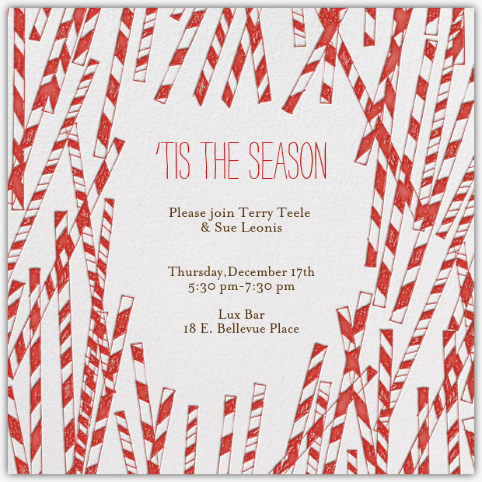 | Address Location  Lux Bar  18 E. Bellevue Place, Chicago, IL  View location

Create, send, and track expressive invitations with Paperless Post.

