From: Reifman, David
Sent: Tuesday, November 15, 2016 5:35 PM
To: Berlin, Steve
Subject: FW: Official Invitation Gandhi Luncheon November, 15th, 2016

Steve – I attended this lunch in my official capacity. Thanks.

From: Smita Shah [mailto:smita@spaantech.com]
Sent: Friday, November 11, 2016 3:18 PM
To: Reifman, David
Subject: Official Invitation Gandhi Luncheon November, 15th, 2016



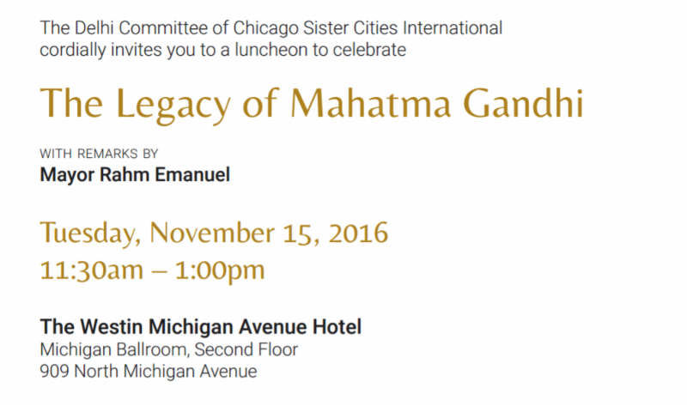

Click Here to RSVP by November 11
This invitation is non-transferable.



