From: Brian Bannon [mailto:bbannon@chipublib.org]
Sent: Tuesday, December 20, 2016 4:32 PM
To: Berlin, Steve
Subject: FW: You have tickets to Mr. and Mrs. Pennyworth!

This is to notify you that I attended this event in my role at CPL. Thank you, Brian

From: Cooke, Cheryl [mailto:Cheryl.Cooke@allstate.com]
Sent: Friday, December 16, 2016 5:33 PM
To: Brian Bannon <bbannon@chipublib.org>; Rhona Frazin <rfrazin@cplfoundation.org>; Grady, Graham C. <GGrady@taftlaw.com>
Cc: Woolwine, David <david.woolwine@allstate.com>
Subject: FW: You have tickets to Mr. and Mrs. Pennyworth!

Looking forward to seeing you on Sunday. I know that we are all hearty Chicagoans that will not let a little snow stop us from seeing a great show that is only 80 minutes! See you at the reception!

Cheryl
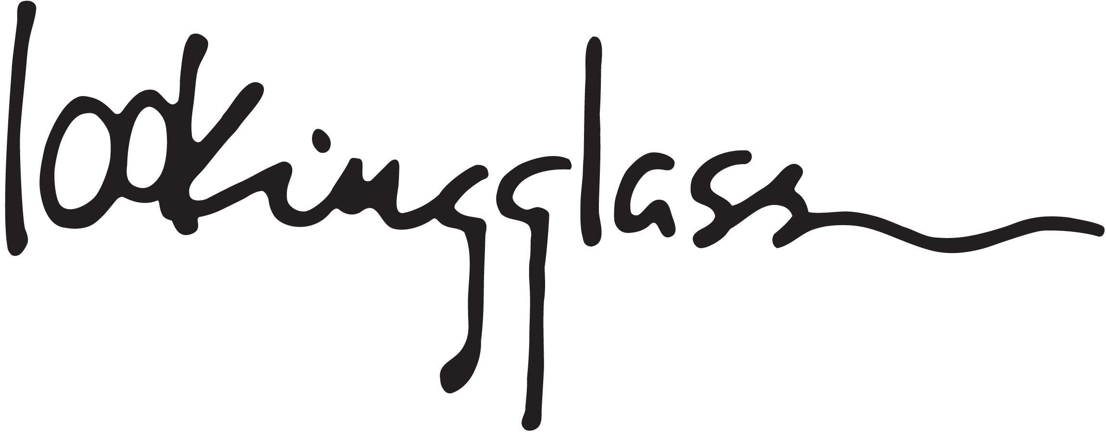
BUY TICKETS PLAYS & EVENTS DONATE EDUCATION



We look forward to seeing you at Lookingglass for our production of
Mr. and Mrs. Pennyworth on December 18th at 6:00pm.
To make the most of your visit, we're pleased to provide you with the following information about the performance and our venue. If you have any questions, please call our box office at 312.337.0665, or visit lookingglasstheatre.org/visit for more information.
Mr. and Mrs. Pennyworth runs approximately ninety minutes with no intermission.
View our online program.
Click here to learn more about REFLECT, our post-show discussion panels that take place after select Sunday matinees.
Directions
Lookingglass Theatre Company is located in the historic Water Tower Water Works at 821 N Michigan Ave at Pearson St.
Parking
Discounted parking is available the day of the performance at the John Hancock Self Park. Please bring your parking ticket to the box office and our staff will validate it. We cannot provide validation without a parking ticket present.
- For up to six (6) hours for only $10. Patrons must enter the garage after 1PM.
- Park at The Olympia Centre Self Park for up to six (6) hours for only $11. The Olympia Centre Self Park now offers the ability to pre-pay for your parking. Click here to purchase. A service fee of $1 will be added to online parking purchases.
- Park at Water Tower Place Self Park for up to four (4) hours for only $12 or between four (4) and seven (7) hours for $15.
Pre-paid parking is non-refundable, non-transferable, and may only be used for the date purchased. These special rates are for Lookingglass patrons and are valid only on performance days for paying ticket holders. Parking spaces are subject to availability.

Production Sponsors

Allstate is the Production Sponsor and proud supporter of the matinee program for
Mr. and Mrs. Pennyworth.
Elizabeth F. Cheney Foundation
The Mindy Chapman Memorial Fund

Producer's Circle
Abbie Helene Roth and Sandra Galdstone Roth

Special thanks to our Opening Night sponsor
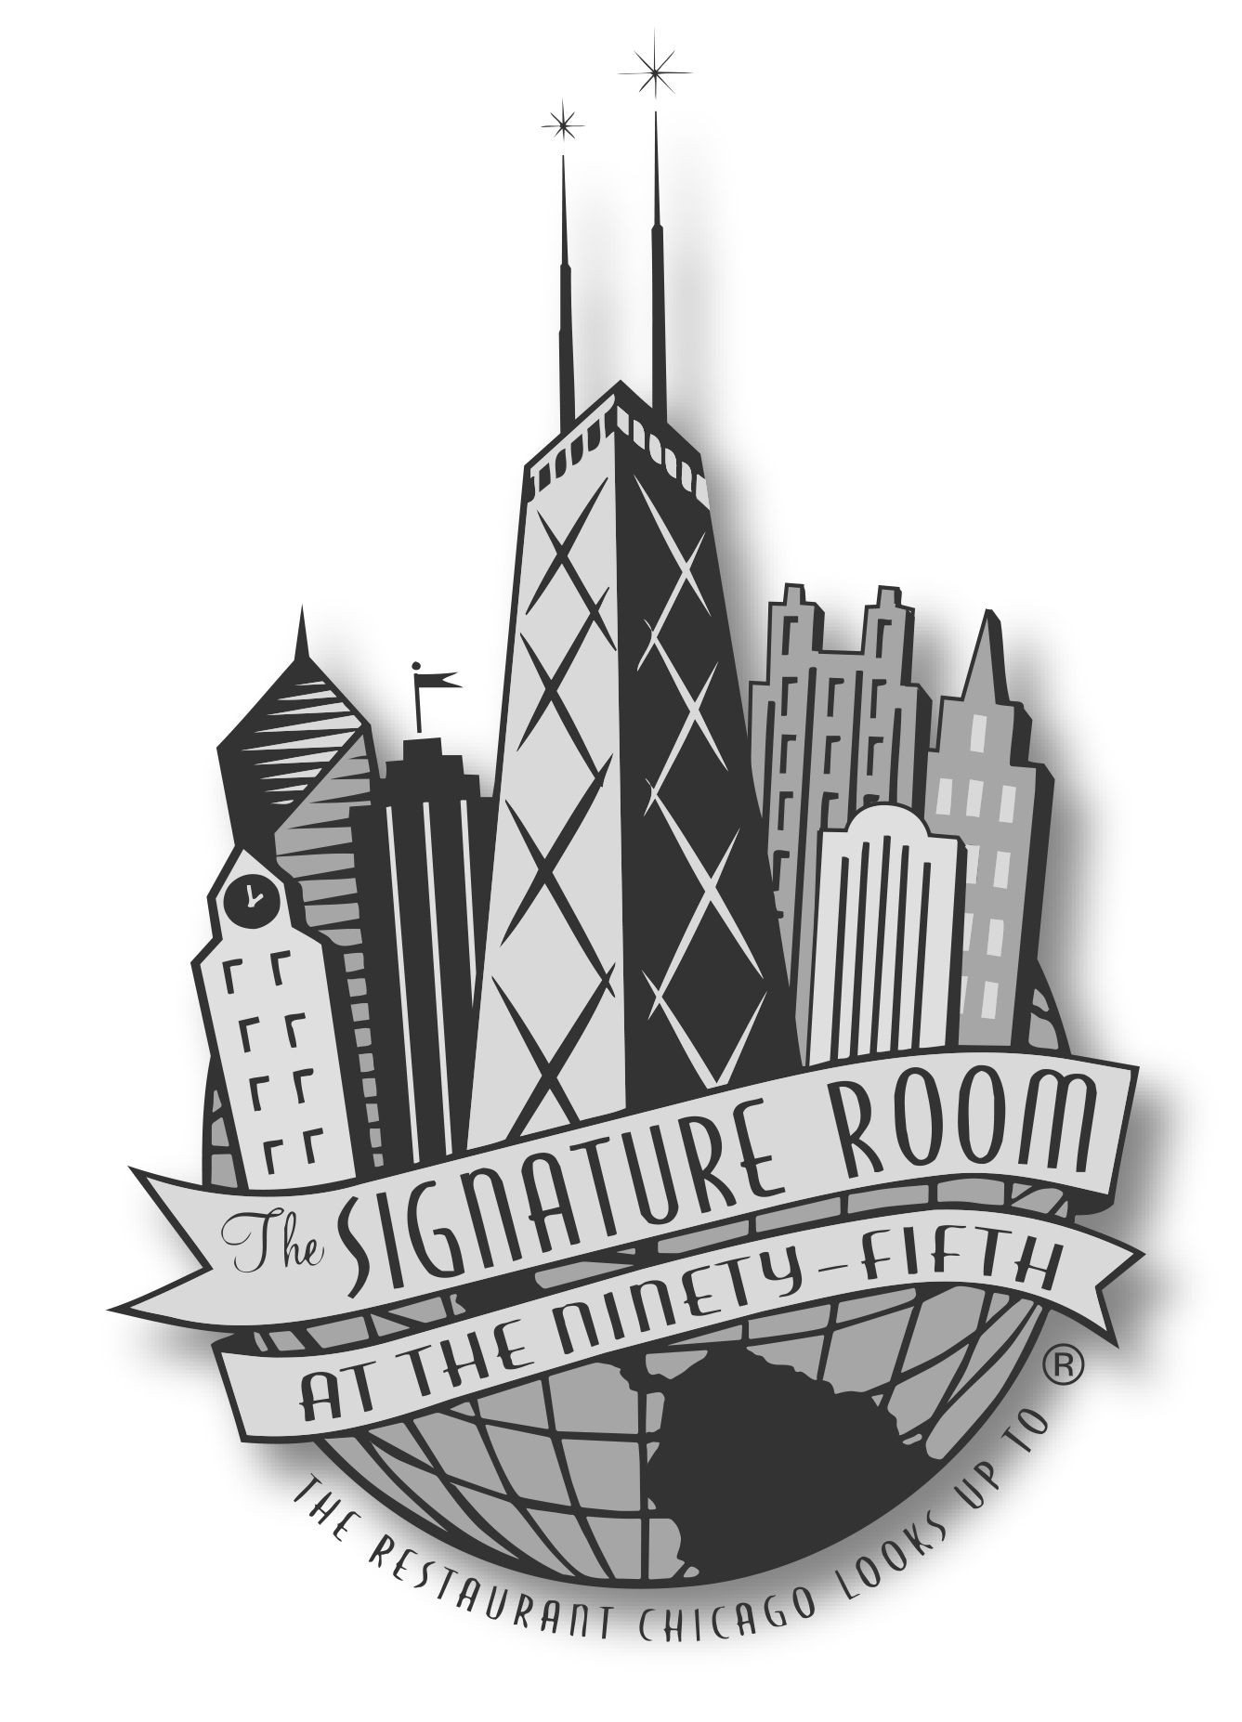
Restaurant Partners
Visit our restaurant partners for an outstanding experience before or after the show. Please call each restaurant to confirm discounts or special offers. Menus and prices may be subject to change.
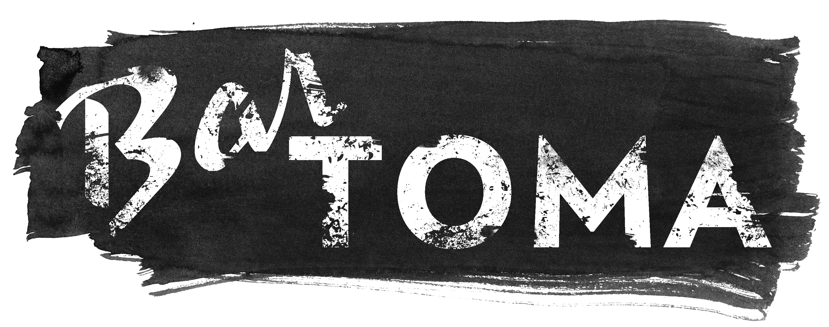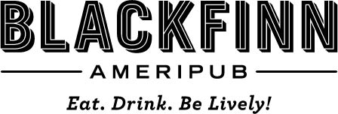

Accessibility
Lookingglass Theatre is accessible to people who use wheelchairs, those who cannot walk stairs, and patrons with visual and hearing impairments. Please notify the box office in advance of your visit so that we can best accommodate your needs. Box office: 312.337.0665 or box@lookingglasstheatre.org.
Lookingglass is pleased to offer an open captioned and an audio described performance for each production in our 2016-17 season. For more information visit lookingglasstheatre.org/accessibility.



Cheryl Cooke| Manager| Corporate Giving
Allstate Insurance Company
2775 Sanders Road Suite F4| Northbrook, Illinois 60062

