Bob Klunk <bobklunk65@gmail.com>
Sent: Friday, December 16, 2016 8:12 PM
To: Berlin, Steve
Subject: Donation

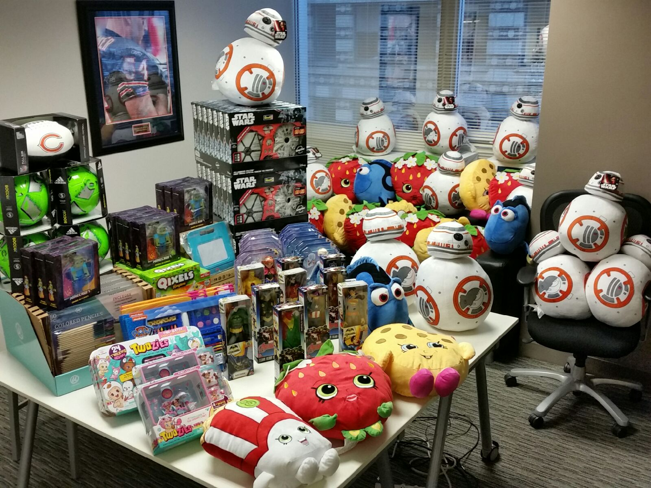
On behalf of the city of Chicago
George Burciaga donated the gifts pictured above to Alderman Danny Solis of the 25 th Ward for his Kids Christmas giveaway at Harrison Park December 16th 2016

