From: Reifman, David
Sent: Wednesday, December 14, 2016 8:22:02 AM
To: Berlin, Steve
Subject: FW: Richard M. Daley's Holiday Reception

Steve – I attended this event.

From: Dan Gibbons [mailto:paperlesspost@paperlesspost.com]
Sent: Friday, December 02, 2016 11:28 AM
To: Reifman, David
Subject: Richard M. Daley's Holiday Reception



View the Card
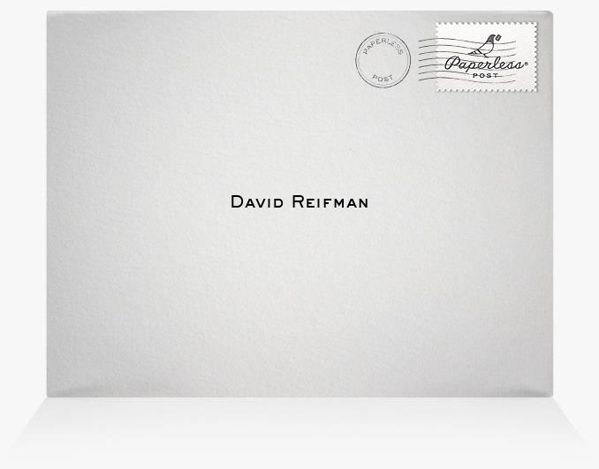

RICHARD M. DALEY'S HOLIDAY RECEPTION
Monday, December 12th from 6:00 PM to 9:00 PM
Luxbar
18 E Bellevue Pl, Chicago, IL

View map Add to Calendar: Google, Outlook, iCal, or Yahoo
Access event on the go: Get the iPad and iPhone app

For the best Paperless Post experience, add paperlesspost@paperlesspost.com to your address book to ensure you receive all cards and invitations in your inbox. Block this person from sending you Paperless Post mail. Click here to stop receiving emails from Paperless Post including invitations and cards. Learn more about our privacy policy.


