From: Frydland, Judith
Sent: Tuesday, June 21, 2016 6:44 PM
To: Berlin, Steve
Cc: Simon, Mimi
Subject: FW: Lendlease Speaker Series - Tuesday, June 7, 2016

Good evening,

Mimi Simon, our director of public affairs, and I attended this panel in our official capacity. Breakfast was served. Please let me know if you need anything further. Thank you.

Judith Frydland
City of Chicago
Building Commissioner
312-744-8670

From: Ousley, Peter [mailto:Peter.Ousley@lendlease.com]
Sent: Friday, May 13, 2016 9:09 AM
To: Frydland, Judith; Hopkins, Marlene
Subject: FW: Lendlease Speaker Series - Tuesday, June 7, 2016

Judith, it was a pleasure seeing you at City Club yesterday. Please see the attached. We intend to distribute the invitation today. Your names are listed in alphabetical order. We have 150 invitees and expect 70 participants. It should be a diverse and esteemed audience. I hope you are still committed to participating. I will provide you with a list of four to five questions you can expect we will ask as we facilitate discussion. I will make myself available to meet if you would like to discuss the who, how and what (at your convenience).

Peter

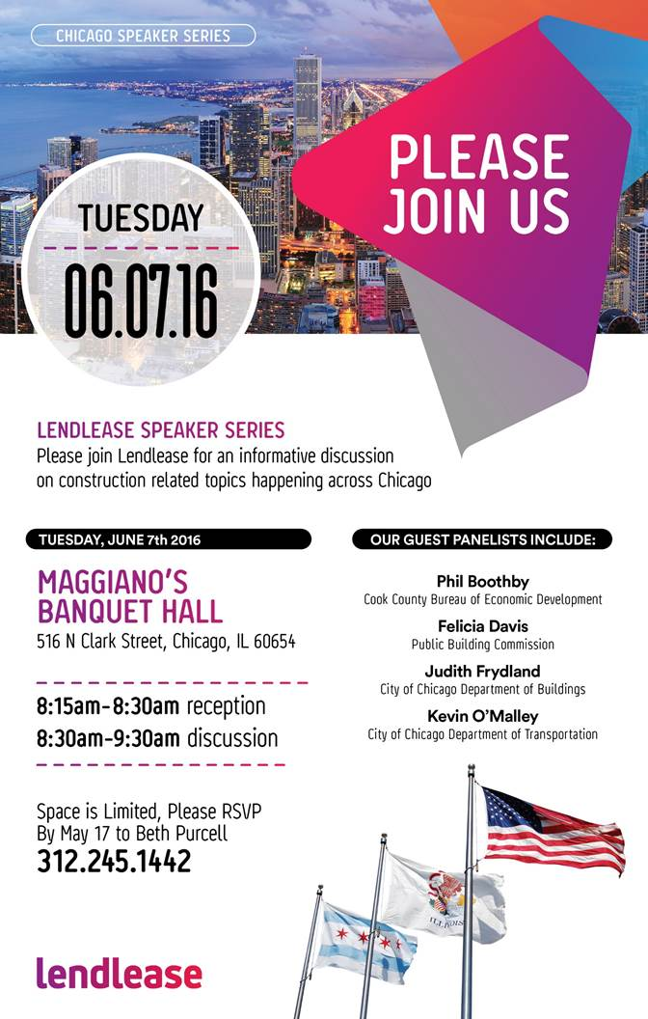

Peter Ousley
Project Executive | Project Management & Construction

