From: Frydland, Judith
Sent: Tuesday, June 21, 2016 6:40 PM
To: Berlin, Steve
Subject: FW: Nobu Hospitality Invites You -- Monday, June 20th!

Good evening,

I hope all is well. Kevin Ayakhan, a coordinator here at DOB, and I attended this groundbreaking and dinner in our official capacity. Please let me know if you need anything further. Thank you.

Judith Frydland
City of Chicago
Building Commissioner
312-744-8670

From: Carly Mason [mailto:Carly_Mason@dkcnews.com]
Sent: Wednesday, June 15, 2016 10:46 AM
To: Frydland, Judith
Subject: Re: Nobu Hospitality Invites You -- Monday, June 20th!

Great, we look forward to having you there!

CARLY GEER MASON
Account Executive



35 East Wacker Drive, Suite 3500 – Chicago, IL 60601
T: (312)-667-1412
M: (502)-468-9639
E: Carly_Mason@dkcnews.com

DKC Facebook Twitter Blog

From: <Frydland>, Judith <Judith.Frydland@cityofchicago.org>
Date: Wednesday, June 15, 2016 at 11:44 AM
To: Carly Mason <Carly_Mason@dkcnews.com>
Subject: Re: Nobu Hospitality Invites You -- Monday, June 20th!

Good morning,

Thank you for the invitation, I am delighted to attend.

Judith Frydland
City of Chicago
Building Commissioner
312-744-8670

On Wed, Jun 15, 2016 at 10:09 AM -0500, "Carly Mason" <Carly_Mason@dkcnews.com> wrote:
Hi, Judy- hope you hare having a nice week,

I’d like to extend a special invite your way. As you know, Nobu Hotel Chicago is officially breaking ground on the project this Monday, June 20th in the West Loop.

We’d love to have you be part of the groundbreaking ceremony at 854 W. Randolph St. at 2:30pm and join us at Maple & Ash for a special dinner following.

Thanks, and please let me know if you can make it!
Carly

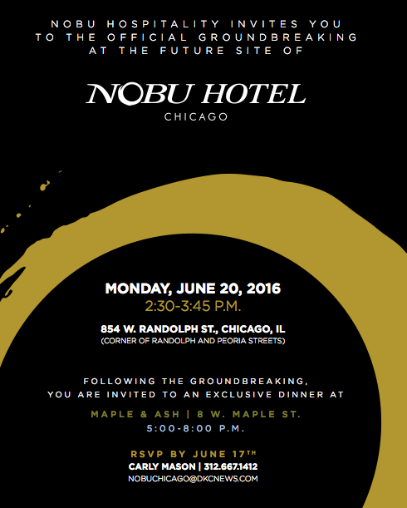
CARLY GEER MASON
Account Executive

35 East Wacker Drive, Suite 3500 – Chicago, IL 60601
T: (312)-667-1412

