Sent: Monday, February 29, 2016 4:09 PM
To: Berlin, Steve
Cc: Munoz, Gina; mjnaghavi@yahoo.com
Subject: Re: Noon-O-Kabab

Mir,
Thanks again.
Deb
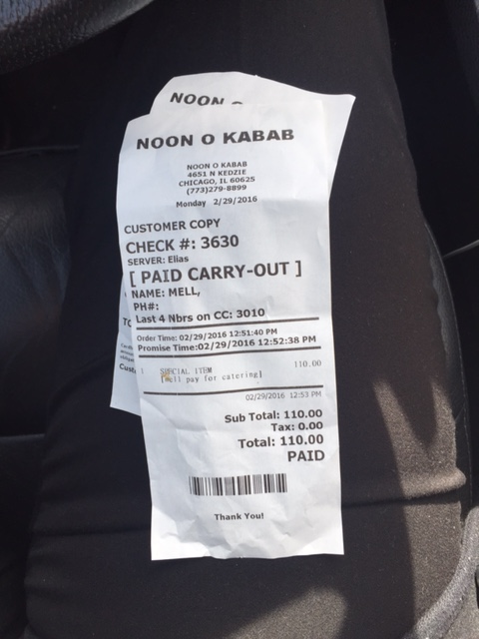
Sent from my iPhone

From: Munoz, Gina
Sent: Tuesday, February 23, 2016 9:26 AM
To: mjnaghavi@yahoo.com
Cc: Berlin, Steve; Mell, Deborah
Subject: Noon-O-Kabab

Dear Mir,

While I very much appreciate your gesture of paying for me and my friends’ meal on February 13th, I do not want a kind gesture like that to be misunderstood and embarrassing to either you or me. City ethics laws prohibit me, as a City official, from accepting any gifts worth more than $50 from any person, including Noon-O-Kabab. Therefore, I am, respectfully, sending you a check for $110.00 to cover the entire cost of the meal.

Your restaurant is a famous, delicious and prominent member of our community, and adds immeasurably to the greatness of the 33rd Ward.

Kindly,
Deb Mell

Gina Muñoz
Aldermanic Assistant

Ald. Deb Mell
-33rd Ward-

