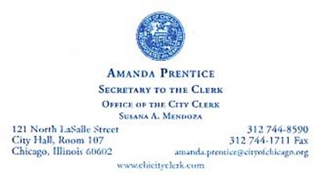

From: Gay, John
Sent: Tuesday, December 15, 2015 3:19 PM
To: Collazo, Ana
Cc: Prentice, Amanda
Subject: RE: Dec 10-14: Your Final Rodel Seminar in Aspen, CO

Ana, on behalf of Clerk Mendoza, I am reporting back that the seminar the Clerk attended has concluded. Do you need any additional information?

Thanks,

John Gay
Chief Counsel and Director of Policy
Office of the City Clerk

