From: Reifman, David
Sent: Friday, January 29, 2016 10:29 AM
To: Berlin, Steve
Subject: FW: JLL & Gensler Present Chicago 2025 | Featuring David Reifman

Not sure if I need to report this, but doing so anyway. I was the keynote speaker at this event. As far as I know it was free to invitees. There were drinks and hors d’oeuvres afterwards, and I had a glass of wine and a few appetizers. Thanks.

From: O'Connor, Meredith [mailto:Meredith.O'Connor@am.jll.com]
Sent: Friday, December 18, 2015 12:09 AM
To: Reifman, David
Subject: FW: JLL & Gensler Present Chicago 2025 | Featuring David Reifman

Fyi.

Meredith L. O'Connor
International Director
200 E. Randolph, 47th Floor
Chicago, IL 60601
Direct: 312-228-2576
Fax: 312-601-1785
Cell: 312-523-8737
meredith.oconnor@am.jll.com


From: JLL [mailto:Chicago2025@am.jll.com]
Sent: Thursday, December 17, 2015 1:34 PM
To: O'Connor, Meredith
Subject: JLL & Gensler Present Chicago 2025 | Featuring David Reifman

Trouble reading this e-mail? View as a web page | Want to share this information? Forward to a Friend

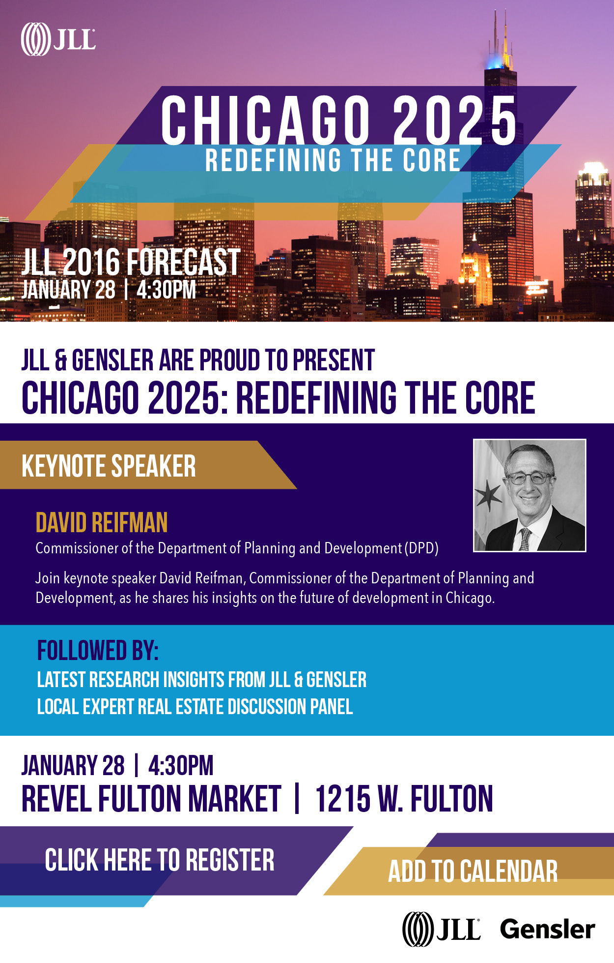
Copyright (c) Jones Lang LaSalle IP, Inc. 2015. All rights reserved. No part of this publication may be reproduced by any means, whether graphically, electronically, mechanically or otherwise howsoever, including without limitation photocopying and recording on magnetic tape, or included in any information store and/or retrieval system without prior written permission of Jones Lang LaSalle IP, Inc. Jones Lang LaSalle Brokerage, Inc., California license # 01856260. Jones Lang LaSalle Americas, Inc., California license # 01223413.
This email was sent to meredith.oconnor@am.jll.com by Jones Lang LaSalle, Inc.
200 East Randolph Drive Chicago, Illinois 60601
View Privacy Policy | Update Profile | Unsubscribe

