From: Reifman, David
Sent: Monday, June 27, 2016 10:51 AM
To: Berlin, Steve
Subject: FW: Your Tickets for Studio Gang Open House

Hi Steve. I attended this event. No real items of value – it was just a reception/open house. Thanks

From: Eventbrite [mailto:orders@eventbrite.com]
Sent: Thursday, June 02, 2016 12:29 PM
To: Reifman, David
Subject: Your Tickets for Studio Gang Open House


Find events My Tickets

Hi David , this is your order confirmation for Studio Gang Open House
Organized by Studio Gang Architects

Here are your tickets

Mobile Tickets



 | Add to  Passbook

Available on
App Store
or

Paper Tickets
Open the email attachment
or download here

Questions about this event?
Contact the organizer at chatten@studiogang.net

Order Summary | June 2, 2016
Order #: 523610870
Name | Type | Quantity
David Reifman | RSVP | 1

This order is subject to Eventbrite Terms of Service, Privacy Policy, and Cookie Policy

About this event
 | Thursday, June 23, 2016 from 5:00 PM to 8:00 PM (CDT)
 | 1520 W Division St  Chicago, IL 60642
 | Add to my calendar:  Google · Outlook · iCal · Yahoo

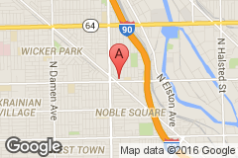
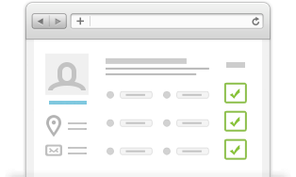

Your Account
Log in to access tickets and manage your orders.

    Create your own event
    Anyone can sell tickets or manage registration with Eventbrite.
    Learn More
    
    Discover great events
    Find local events that match your passions.
    See events
    

  About
  Help
  My Account
  Contact Us
  Privacy
  Terms
  Blog

This email was sent to David.Reifman@cityofchicago.org
Eventbrite | 155 5th St | San Francisco, CA 94103
Copyright © 2016 Eventbrite. All rights reserved.

