From: Adam Gypalo <adam@ward43.org>
Sent: Friday, January 20, 2017 6:00:46 PM
To: Berlin, Steve
Subject: Alderman Smith Gift Reporting: Bouquet of Flowers

Hi Steve,

We'd like to report a bouquet of flowers our office received earlier today from Salon Rouge, a new business that recently opened up in our ward that wished to express their thanks for some assistance our office had rendered them during their permitting process.

The flowers (photo below) are called "Siren Green" and they're priced at $59.99 - we're planning on accepting these and posting them in our office, as we can use some cheer during these troubling times!

Please let me know if you need anything further on my end!

Best,

Adam

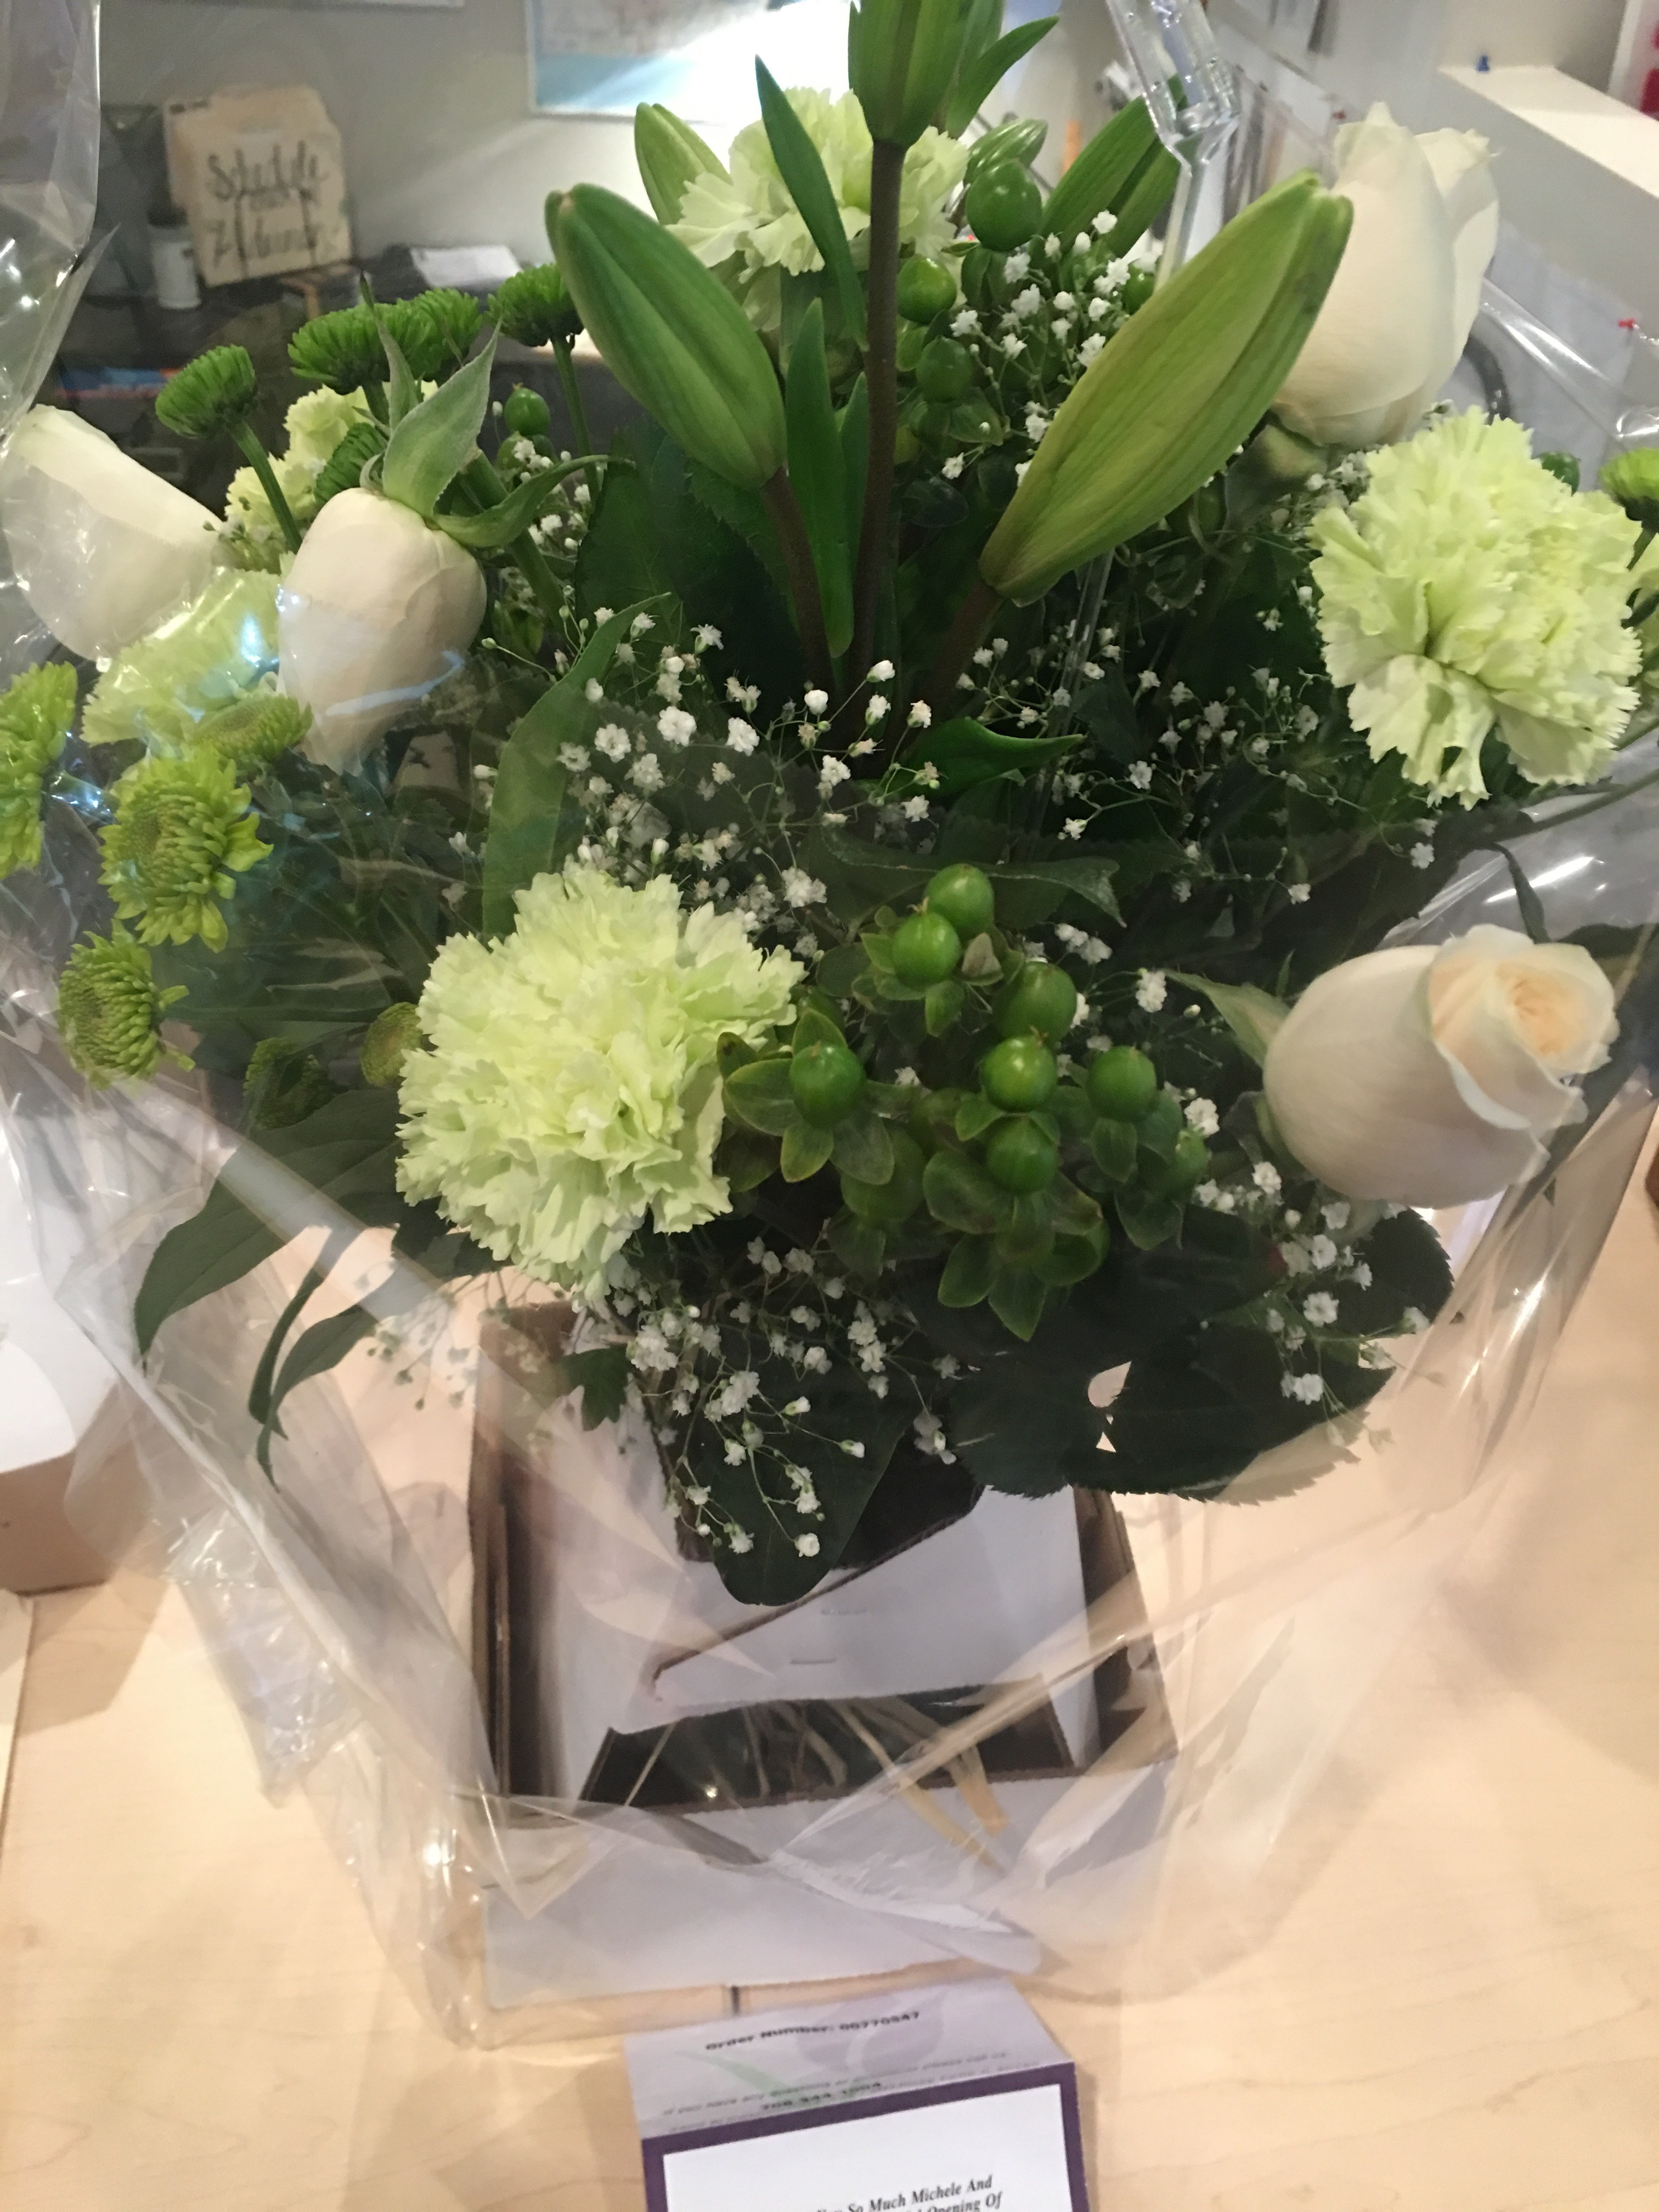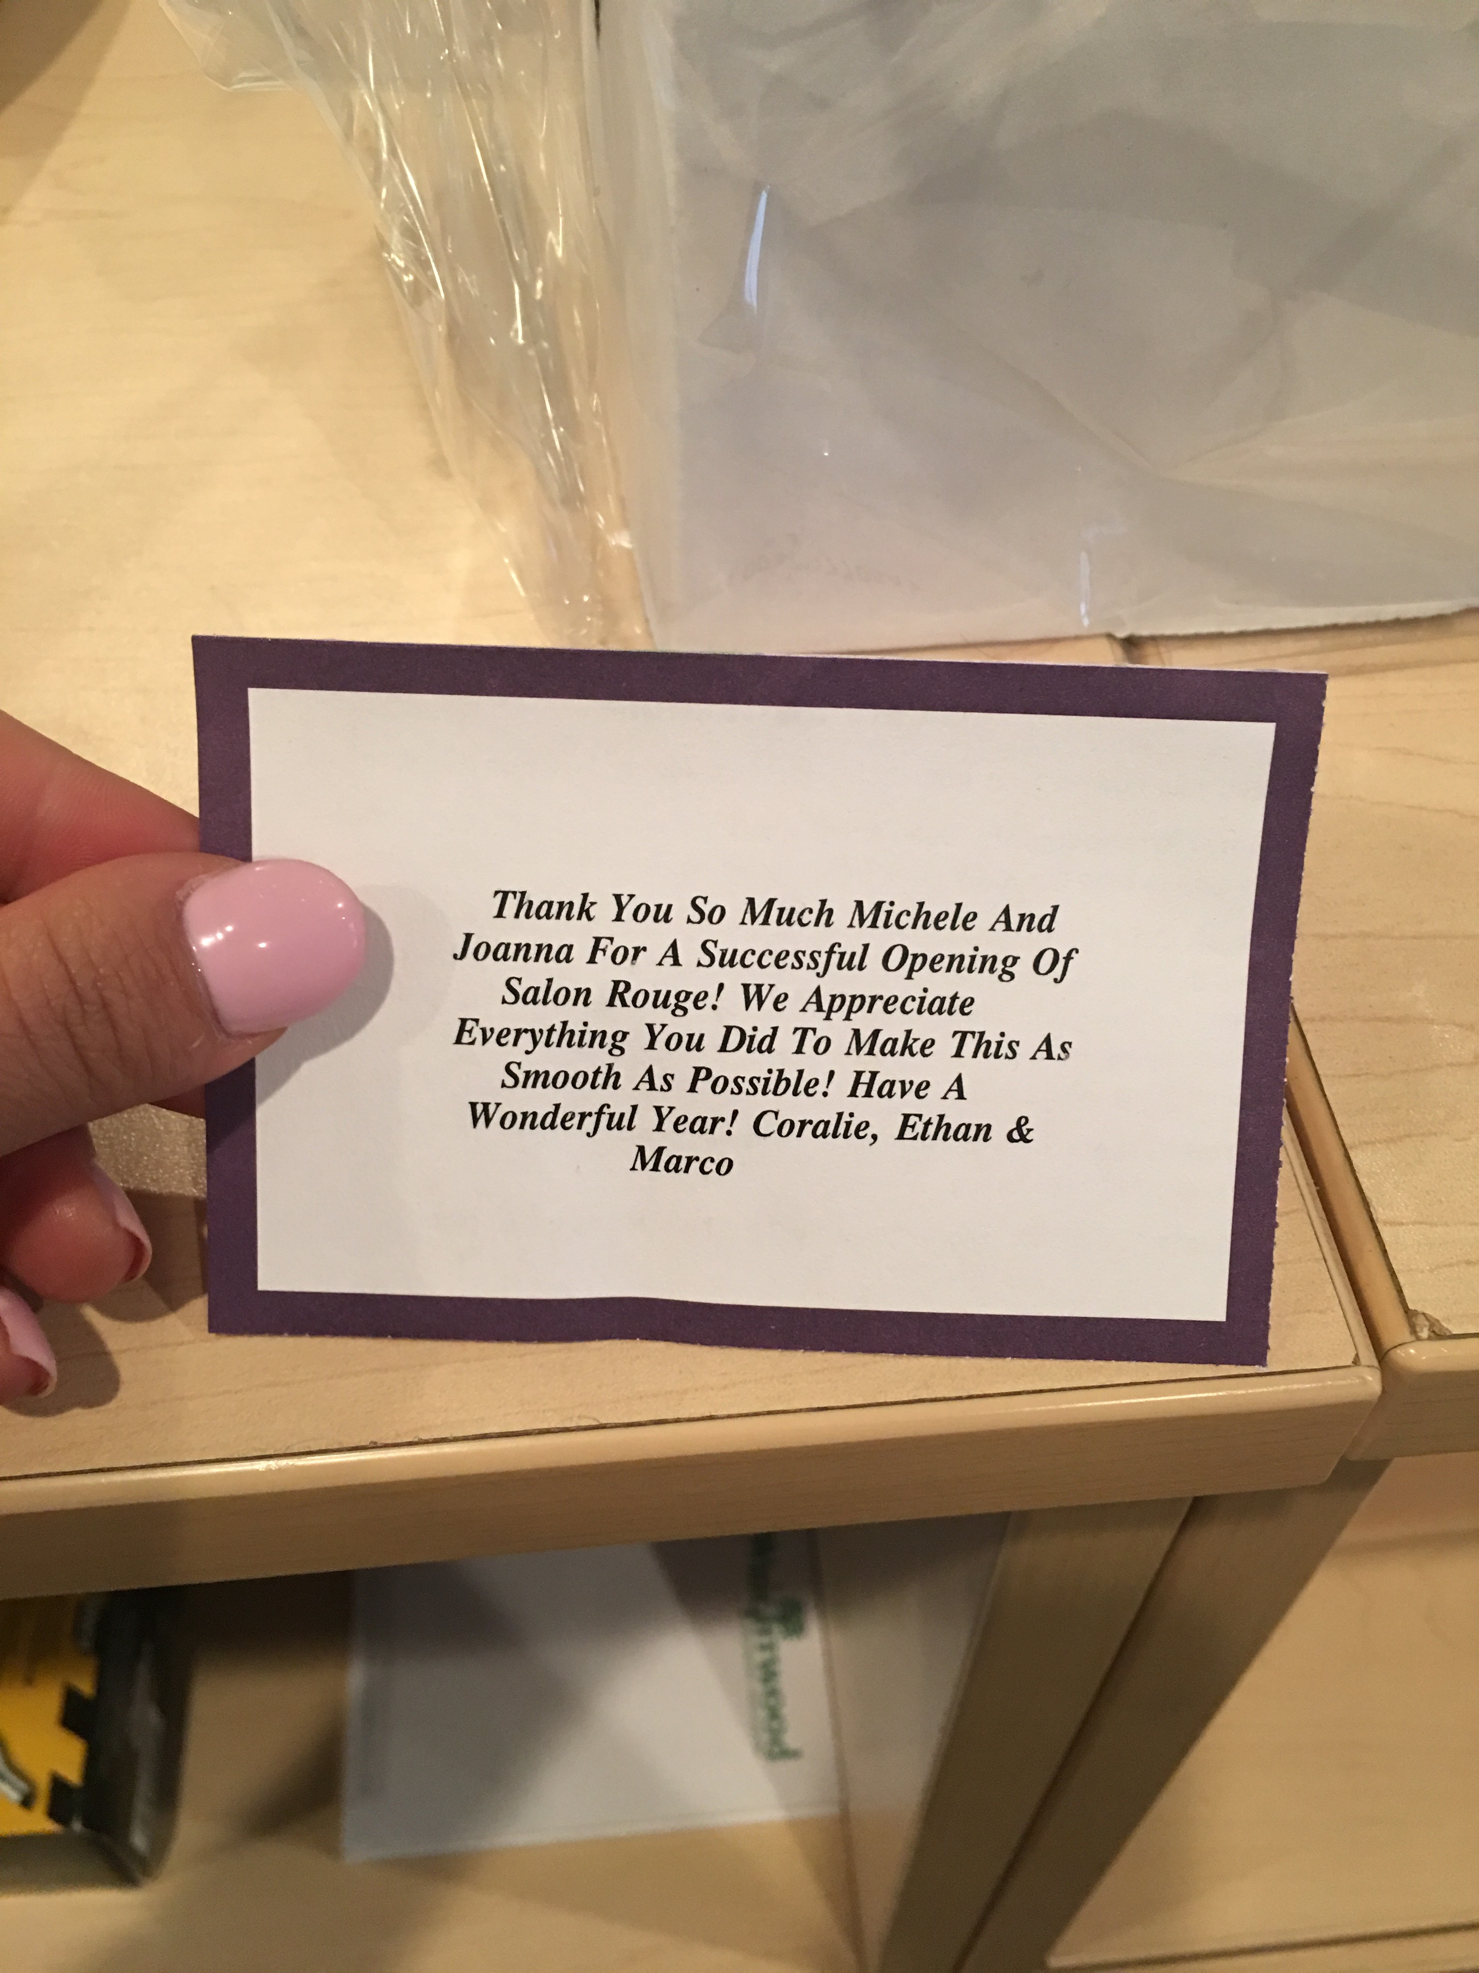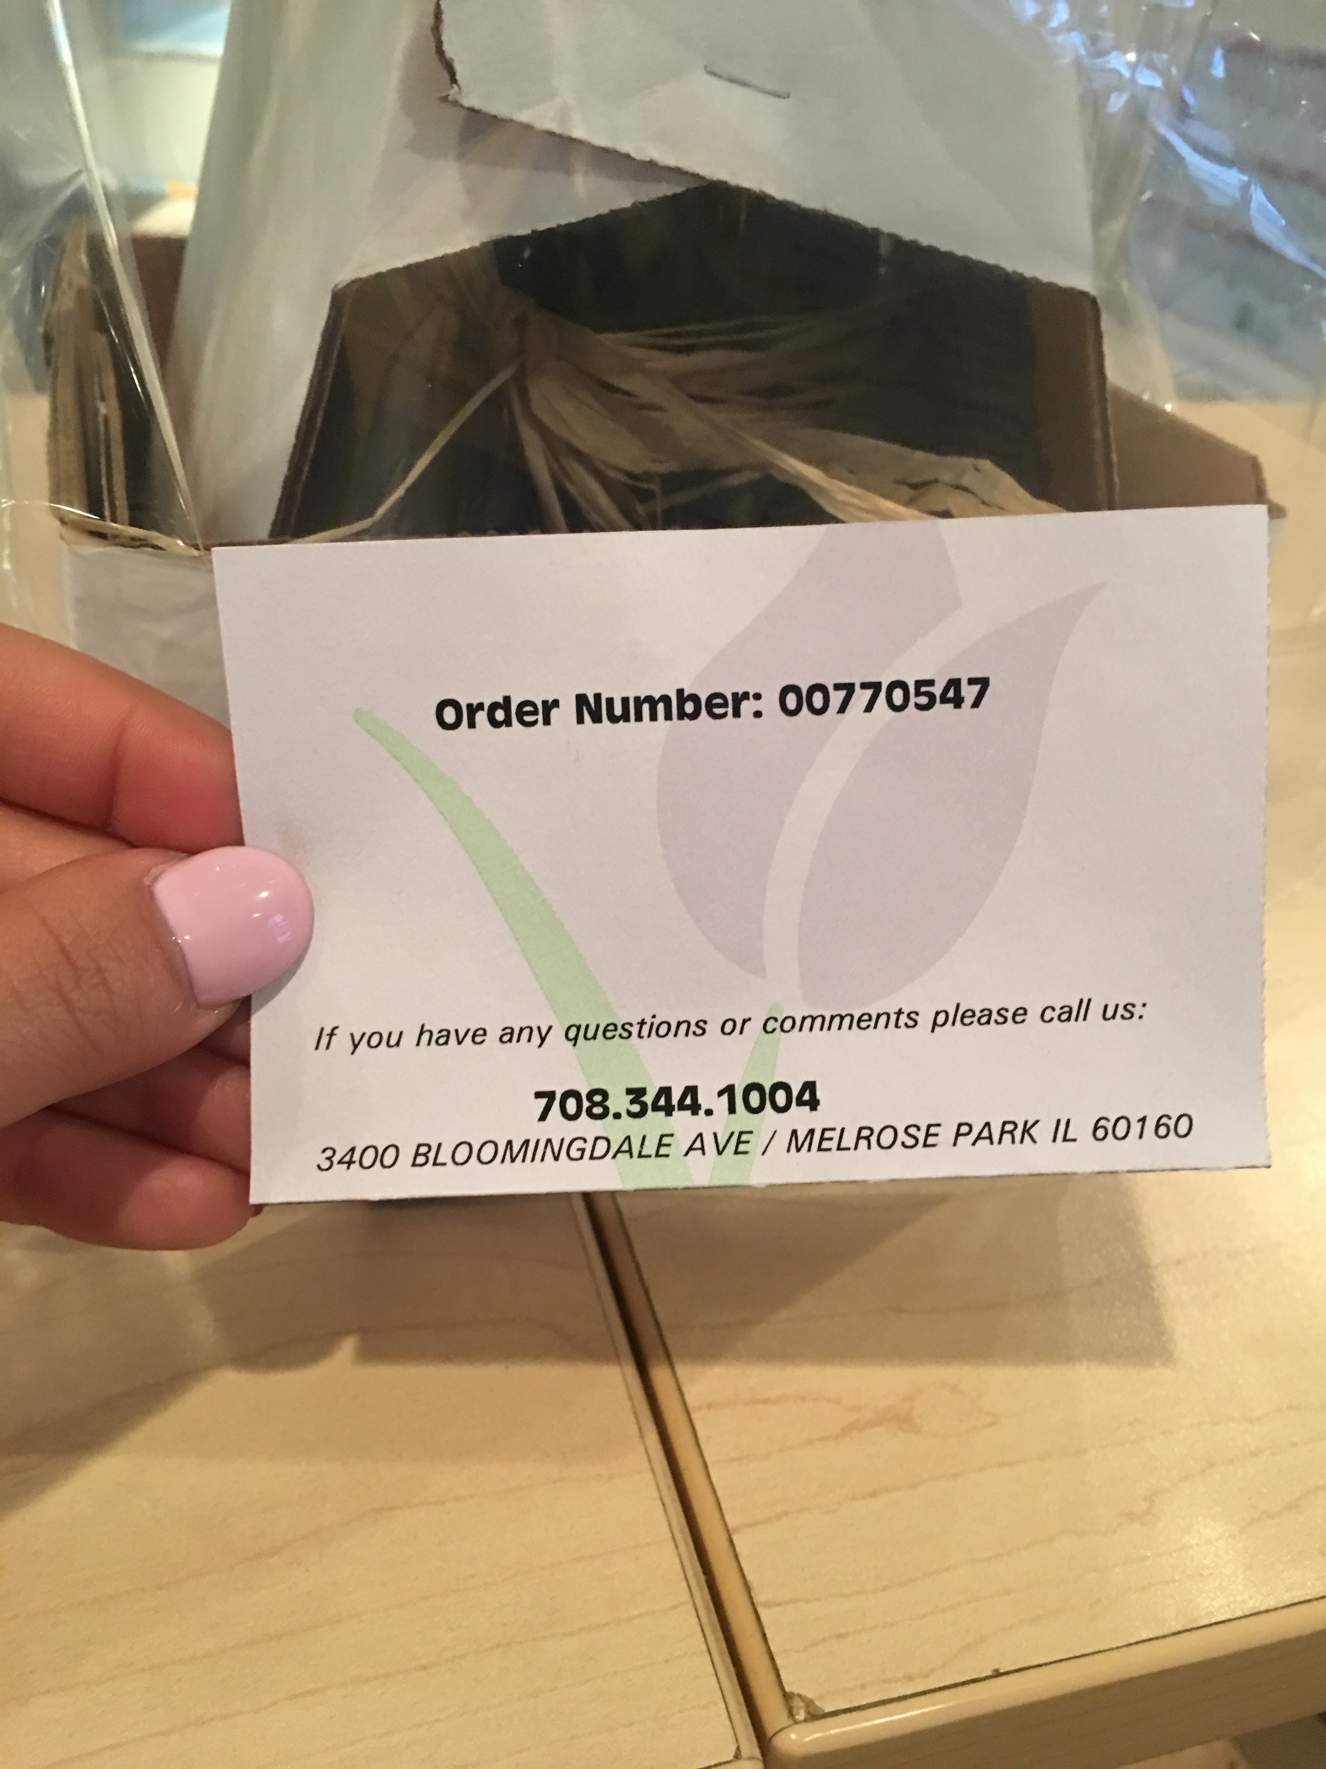

--
Adam Gypalo
Chief of Staff

Alderman Michele Smith
43rd Ward

