From: Adam Gypalo [mailto:adam@ward43.org]
Sent: Thursday, February 23, 2017 1:11 PM
To: Berlin, Steve
Subject: 43rd Ward Gift Reporting: "Real Chocolate Doodles" Package

Hi Steve,

We had a resident drop off a box of "real chocolate doodles" yesterday afternoon as a thank you for some assistance we rendered them recently.

We're unable to find the actual price tag for the item online, but the box itself contains six (6) total pieces, so the price is likely under $50.

We've placed these in our office reception area for local residents to enjoy as they enter our office.

Please let me know if you require any additional information!

Best,

Adam

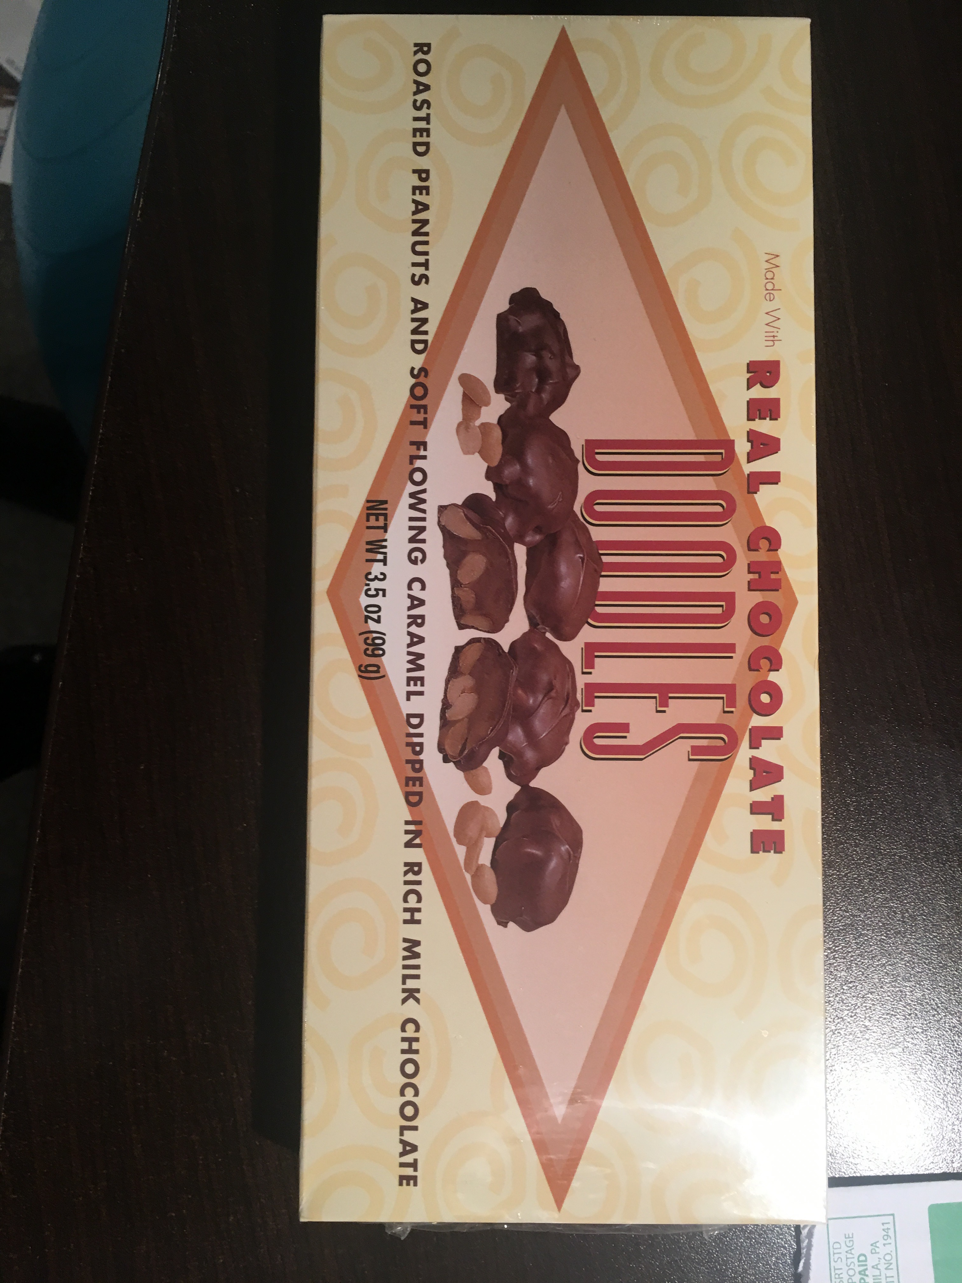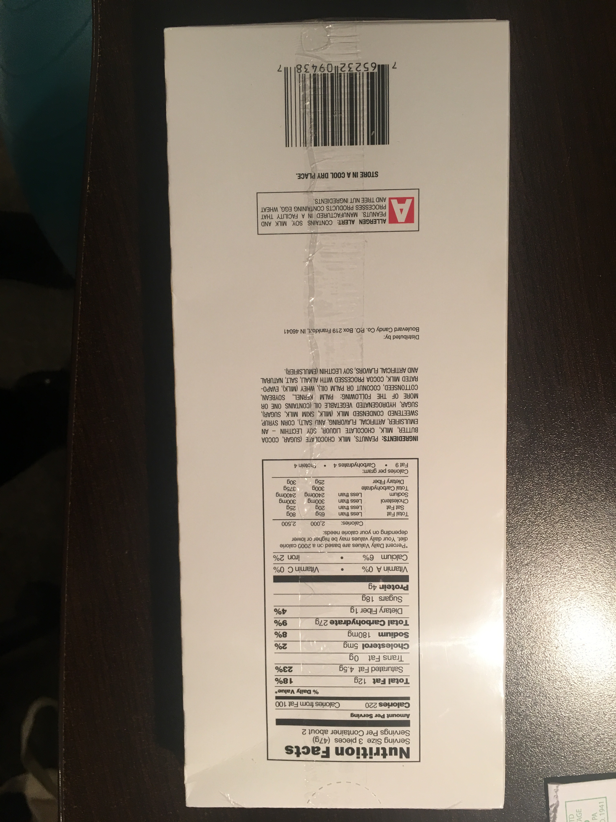

--
Adam Gypalo
Chief of Staff

Alderman Michele Smith

