From: Reifman, David
Sent: Monday, November 20, 2017 5:54 PM
To: Berlin, Steve
Subject: FW: Invitation: Reception in Recognition of Community Partnerships, November 15

Steve – I attended this event.

From: Office of the President [mailto:univ-events@uchicago.edu]
Sent: Tuesday, October 24, 2017 2:29 PM
To: Event Invitees
Subject: Invitation: Reception in Recognition of Community Partnerships, November 15

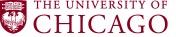
 | President Robert J. Zimmer cordially  invites you to  A Reception in Recognition  of Community Partnerships  and a celebration of Sonya Malunda’s Two Decades  of Service to the University of Chicago  Wednesday, November 15, 2017  5:00 – 6:30 pm  Polsky Center for Entrepreneurship and Innovation  1452 East 53rd Street  Second Floor  Entrance located on Harper Avenue in the Harper Theater Lobby  Complimentary valet parking provided | 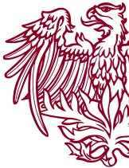
Please click here to respond by November 8.
For more information, or to request special assistance, please contact Lucas McAuley in the
Office of University Events and Ceremonies at 773.702.9626 or univ-events@uchicago.edu.

