From: Reifman, David
Sent: Wednesday, November 22, 2017 8:41 AM
To: Berlin, Steve
Subject: FW: Serafin party

Steve – I attended this event.

From: Lissa Druss Christman [mailto:Lissa@serafin.com]
Sent: Monday, November 20, 2017 11:35 AM
To: Reifman, David
Subject: Serafin party

Let us know if you’re able to make it tomorrow or RSVP at www.SerafinParty.com.  Hope to see you!  Lissa | 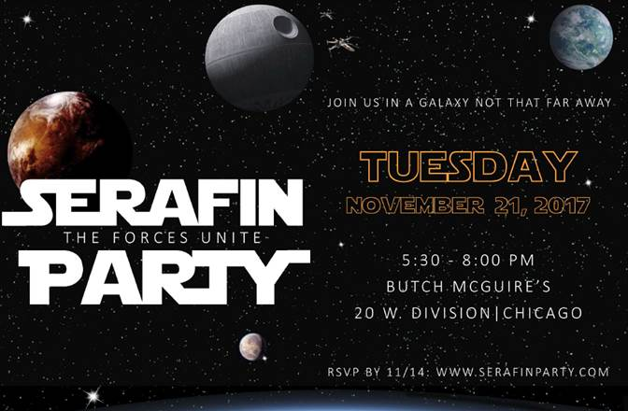

Lissa Druss Christman
Serafin.

