From: Reifman, David
Sent: Thursday, December 7, 2017 11:20:53 AM
To: Berlin, Steve
Subject: FW: You're invited to a celebration for the Chicago Architecture Biennial hosted by our Chairman Jack Guthman

Steve- I attended this even.t

From: Ashley Galloway [mailto:ashley@chicagoarchitecturebiennial.org]
Sent: Tuesday, October 31, 2017 12:45 PM
To: Ashley Galloway
Subject: You're invited to a celebration for the Chicago Architecture Biennial hosted by our Chairman Jack Guthman

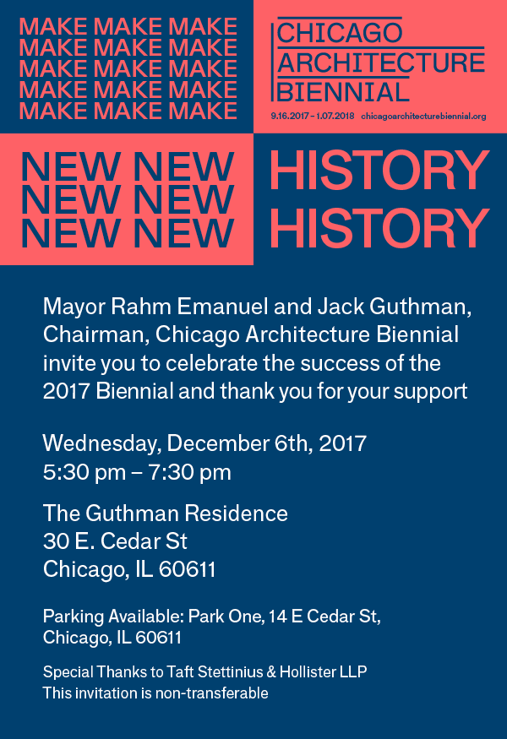

To RSVP, please contact Ashley Galloway:
ashley@chicagoarchitecturebiennial.org

Biennial Sponsors
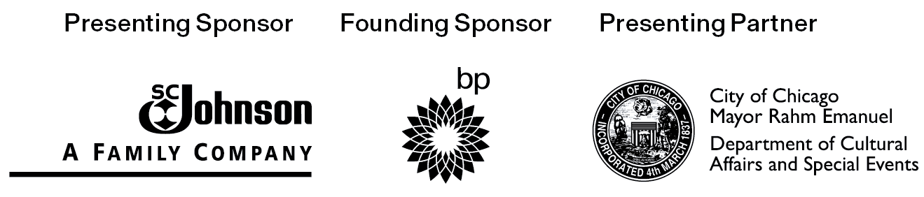


Copyright © 2017 Chicago Architecture Biennial, All rights reserved.
You are receiving this email because you signed up for notifications on our website.
Unsubscribe from this list
Update subscription preferences
Chicago Architecture Biennial
78 E. Washington
Chicago, IL 60602
312.854.8200

