March 24, 2017

Steven I. Berlin
Executive Director
Chicago Board of Ethics
740 North Sedgwick Street, 5th Floor
Chicago, IL 60654

Dear Executive Director Berlin,

Pursuant to Section 2-156-142(d)(8), the Department of Buildings wishes to report the following gifts our department received from a delegation of government officials from the Seoul Metropolitan Council, Republic of Korea.

The delegation met with our Manager of Regulatory Review Mr. Robert Fahlstrom today Room 906 of City Hall at the delegation’s request to discuss the City’s high rise permit and inspection process. The delegation consisted of government officials from the Seoul Metropolitan Council led by Mr. Suk Ju Lee and Mr. In Je Kim. At the conclusion of the meeting, Mr. Lee and Mr. Kim presented one promotional poster, two promotional pamphlets and one portable smartphone charger (photo below) to the department.

The gifts were accepted on behalf of the City of Chicago, the value of which could not be determined, and will be used for City business purposes and placed in an area of public display by the Department.
Sincerely,

Matthew W. Beaudet
First Deputy Commissioner
cc: Judith Frydland, Commissioner 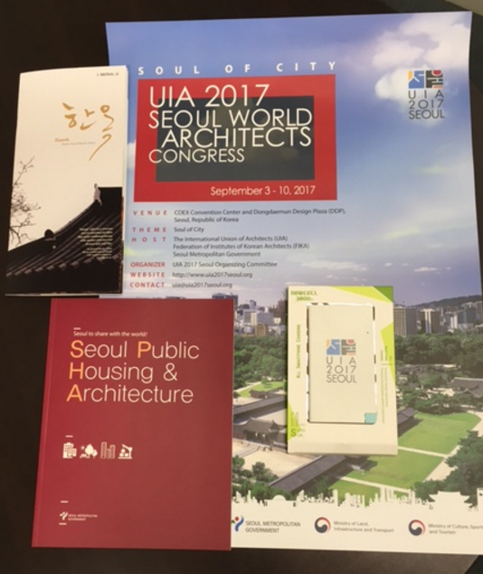
Emily Berman, Deputy Director of Strategic Partnership & Global Affair, Mayor’s Office

