From: Frydland, Judith
Sent: Friday, March 31, 2017 8:56 AM
To: Berlin, Steve
Subject: FW: Sinclair Apartments Topping Off Party

Hi Steve,

I attended this event in my official capacity. Thank you.

Judith Frydland
City of Chicago
Building Commissioner
312-744-8670

From: Sinclair Apartments [mailto:paperlesspost@paperlesspost.com]
Sent: Tuesday, March 07, 2017 4:23 PM
To: Frydland, Judith
Subject: Sinclair Apartments Topping Off Party



For: Judith.frydland@cityofchicago.org
SINCLAIR APARTMENTS TOPPING OFF PARTY
Tuesday, March 28th from 11:30 AM to 1:00 PM
Sinclair Apartments Retail Space: Enter Off Divison
1201 N LaSalle Blvd, Chicago, IL, 60610, United States
View the card

Will Attend Will Not Attend
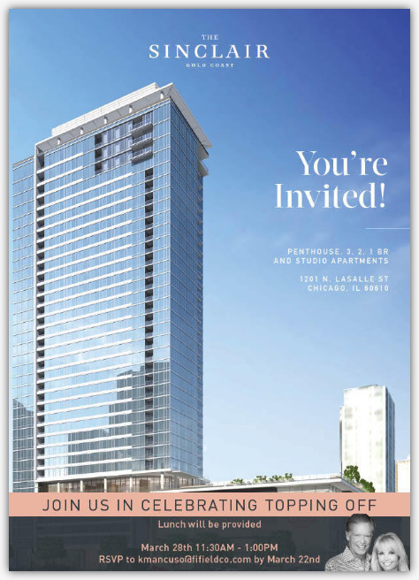

View map Add to Calendar: Google, Outlook, iCal, or Yahoo
Access event on the go: Get the iPad and iPhone app

For the best Paperless Post experience, add paperlesspost@paperlesspost.com to your address book to ensure you receive all cards and invitations in your inbox. Block this person from sending you Paperless Post mail. Click here to stop receiving emails from Paperless Post including invitations and cards. Learn more about our privacy policy.


