From: Collins, Felicia
Sent: Tuesday, May 16, 2017 2:59 PM
To: Berlin, Steve
Subject: RE: Salvation Army 2017 Civic Luncheon

Good afternoon Mr. Berlin,
On Friday, May 12 at 11:00 a.m., I was a guest at the Salvation Army’s 2017 Civic Luncheon. The Salvation Army is a DFSS delegate agency and I attended the event as their guest.

Thanks so much

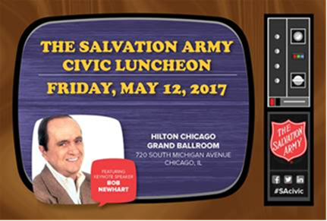

Felicia Collins
Administrative Assistant II
Homeless Division
1615 West Chicago Ave. 3rd floor
312-746-8245


