From: Libby, Chandra
Sent: Wednesday, May 17, 2017 2:51 PM
To: Berlin, Steve
Cc: Mitchell, Joel; Riley, Christine
Subject: Sal Army luncheon

Mr. Berlin,

I am writing to inform you that on Friday, May 12 at 11:00 a.m., I was the guest at the Salvation Army’s 2017 Civic Luncheon. The Salvation Army is a DFSS delegate agency and I attended the event as their guest.

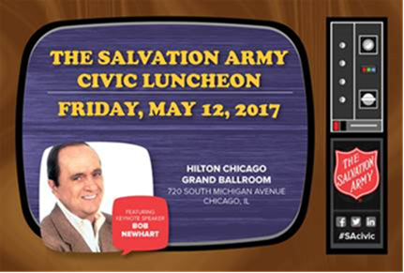
2017 Civic Luncheon
Friday, May 12, 2017 11:00 - 1:30PM
Hilton Chicago
720 S. Michigan Avenue
Grand Ballroom

Thank you,

Chandra Libby, Director
DFSS/Homeless Outreach and Prevention
Garfield Community Service Center
10 S. Kedzie, Rm 200
Chicago, IL. 60612
(Office) 312-746-5443
Chandra.Libby@cityofchicago.org


