From: Riley, Christine
Sent: Tuesday, May 16, 2017 2:50 PM
To: Berlin, Steve
Subject: Salvation Army 2017 Civic Luncheon

Good afternoon Mr. Berlin,
On Friday, May 12 at 11:00 a.m., I was the guest at the Salvation Army’s 2017 Civic Luncheon. The Salvation Army is a DFSS delegate agency and I attended the event as their guest.

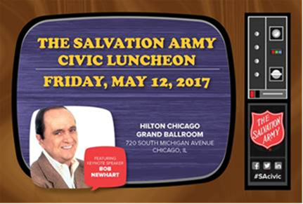
2017 Civic Luncheon
Friday, May 12, 2017 11:00 - 1:30PM
Hilton Chicago
720 S. Michigan Avenue
Grand Ballroom

Christine Riley, M.Div. | Homeless Services Division
1615 West Chicago Avenue | Chicago, IL | 60622
Phone: 312-746-8727 | Email: Christine.Riley@cityofchicago.org


