From: Rivera, Cyndi
Sent: Wednesday, May 17, 2017 1:25 PM
To: Berlin, Steve
Subject: Salvation Army 2017 Civic Luncheon - Attendee

Good Afternoon Mr. Berlin -

On Friday, May 12 at 11:00 a.m., I was the guest at the Salvation Army’s 2017 Civic Luncheon. The Salvation Army is a DFSS delegate agency and I attended the event as their guest.

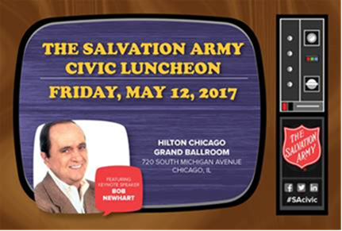

2017 Civic Luncheon
Friday, May 12, 2017 11:00 - 1:30PM
Hilton Chicago
720 S. Michigan Avenue
Grand Ballroom

Thanks,
Cyndi

Cyndi Rivera
Assistant to the Commissioner | Homeless Division
1615 W. Chicago Avenue | Chicago, IL | 60622
Phone: (312) 746-8858
cyndi.rivera@cityofchicago.org


