From: Villarreal, Cristina
Sent: Tuesday, May 16, 2017 3:14 PM
To: Berlin, Steve
Subject: Salvation Army 2017 Civic Luncheon

Dear Mr. Berlin,
On Friday, May 12 at 11:00 a.m., I was the guest at the Salvation Army’s 2017 Civic Luncheon. The Salvation Army is a DFSS delegate agency and I attended the event as their guest.

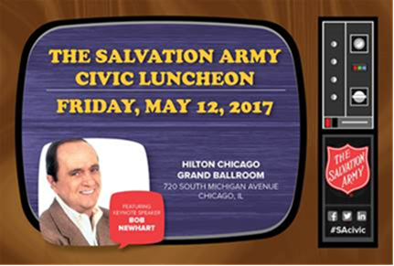
2017 Civic Luncheon
Friday, May 12, 2017 11:00 - 1:30PM
Hilton Chicago
720 S. Michigan Avenue
Grand Ballroom

Thank you,
Cristina

Cristina Villarreal, Director of Public Affairs
1615 West Chicago Ave., 5th FL | Chicago, IL | 60622
Phone: (312) 743-2031| Cell: (312) 497-5188
Cristina.villarreal@cityofchicago.org


