From: Reifman, David
Sent: Friday, June 9, 2017 5:25:41 PM
To: Berlin, Steve
Subject: FW: 2017 Chicago Forum on Global Cities - Know Before You Go!

Steve - I attended the opening dinner. thanks.

From: Chicago Forum on Global Cities [mailto:CFGCRegistration@agencyea.com]
Sent: Friday, June 02, 2017 2:31 PM
To: Reifman, David
Subject: 2017 Chicago Forum on Global Cities - Know Before You Go!

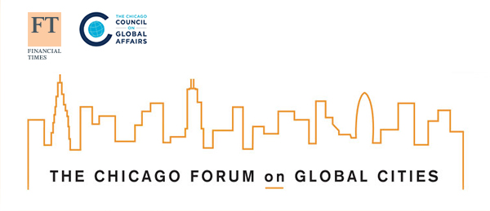
Dear David L.,
Thank you for registering for the 2017 Chicago Forum on Global Cities, taking place in Chicago Wednesday - Friday, June 7 - 9. Please find below additional logistical details as you prepare for the forum.
Review Your Participation
To modify your agenda selection, visit the registration site here. Click "Modify Registration" and enter the email used to register and the reference number below. Your personalized agenda based on selections made while registering or when using the mobile app is detailed at the bottom of this email. For registration questions, please email CFGCRegistration@agencyea.com
25113761
Name Badge Pick-Up
Delegates will receive one name badge to wear throughout the forum. This will serve as your credential to all forum sessions and events. Name badges will be available for pick up in the Drawing Room at the Park Hyatt lower level on Wednesday, June 7, from 9:00 a.m. to 3:00 p.m. If you are unable to pick up your badge at the Park Hyatt, you may pick it up when you check in for the Opening Program at the Art Institute on Wednesday evening beginning at 5:30 p.m. Badges will also be available for pick up Thursday and Friday morning at the Columbus street entrance to the Art Institute (230 S Columbus Drive).
Agenda
The up-to-date agenda, including venue addresses and new speakers, is available on chicagoforum.org and in the forum mobile app. If any significant updates occur, such as a change of venue or session cancellation, the app will be updated and a direct email will be sent to all delegates with the notification.
Operational Pre-Tours - Wednesday, June 7
If you registered for one of the optional pre-tours on Wednesday, June 7, meeting points and additional instructions will be communicated to you separately via another email. If you would like to register, please see "Review Your Participation" above to update your registration.
Mobile App
A Chicago Forum mobile app is available now in the Apple App and Google Play stores. Network with a purpose, view your personal schedule and session details, speaker bios, and exclusive content!
Engage
Help spread the word about the forum using the digital toolkit resources here! Don't forget to engage before and during the forum by following @ChicagoForum and using #GlobalCities2017.
Hotels
The following hotels are being used by Chicago Forum speakers and delegates:
Park Hyatt Chicago, 800 North Michigan Avenue
Hyatt Regency, 151 East Wacker Drive
Attire
Business attire for all Chicago Forum events and dinners. The weather forecast is expected to be in the low 70 degrees Fahrenheit, with a change of rain Wednesday-Friday.
Things to Do
For a few featured additional activities and events taking place in Chicago around the time of the forum please see the Things to Do page on the forum website.
Books
A selection of books authored by forum speakers will be made available for purchase during forum registration in the Drawing Room at the Park Hyatt lower level on Wednesday, June 7, from 9:00 a.m. to 3:00 p.m. as well as again at the Next Generation @ The Chicago Forum Reception on Thursday, June 8 form 5:30 p.m. to 7:30 p.m. at the Chicago Council on Global Affairs Conference Center.
Personalized Agenda
June 7, 2017
5:30 pm - 6:30 pm | Registration and Reception  Venue: Art Institute of Chicago, Stock Exchange Room, 230 South Columbus Drive
6:30 pm - 6:45 pm | Welcome  Speakers:  Ivo Daalder, President, Chicago Council on Global Affairs  Gillian Tett, US Managing Editor, Financial Times  Rahm Emanuel, Mayor, City of Chicago, Illinois  Venue: Art Institute of Chicago, Rubloff Auditorium, 230 South Columbus Drive
6:45 pm - 7:55 pm | PLENARY: Open Cities, Closed Borders: A Response to Globalization  Description:  How do we balance the tension between progressive urban policies and increasingly insular national agendas? How can global cities decrease the growing divide between cities' and regional populations? How can collective action among a nation's cities transform their national policies on issues such as immigration, climate, and trade? Are the urban elite out of touch with today's realities?  Speakers:  Ivo Daalder, President, Chicago Council on Global Affairs  Rahm Emanuel, Mayor, City of Chicago, Illinois  Gillian Tett, US Managing Editor, Financial Times  Venue:  Art Institute of Chicago, Rubloff Auditorium, 230 South Columbus Drive
8:00 pm - 10:00 pm | Opening Dinner & Night Owl Cocktails  Venue: Art Institute of Chicago, Griffin Court, 159 East Monroe Street
We look forward to seeing you at the 2017 Chicago Forum on Global Cities. For any questions or registration issues, please contact CFGCRegistration@agencyea.com.
The Chicago Forum on Global Cities

