From: Reifman, David
Sent: Monday, July 10, 2017 11:36 AM
To: Berlin, Steve
Subject: FW: Hon. John Cullerton 7.6.17 AM

Steve – I attended this event.

From: City Club of Chicago [mailto:City.Club.Chicago=cityclub-chicago.org@mail94.atl11.rsgsv.net] On Behalf Of City Club of Chicago
Sent: Friday, June 16, 2017 11:15 AM
To: Reifman, David
Subject: Hon. John Cullerton 7.6.17 AM


View this email in your browser

Hon. John Cullerton  Senate President  State of Illinois  Thursday, Jul 6, 2017  7:30 a.m. reception  8:00 a.m. breakfast  Maggiano's Banquets  111 W. Grand Avenue  Chicago, IL | 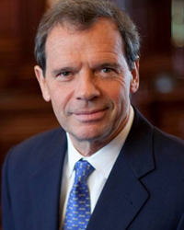
  REGISTER NOW

Speaker

Hon. John Cullerton
John Cullerton’s tenure as Senate President has been marked by collaborative efforts to solve major problems and push Illinois forward.
His leadership helped preserve economic viability at McCormick Place through needed workplace reforms, ended the state’s scandal-plagued death penalty, and established marriage equality as the law for all of Illinois.
He cast the final vote to expel Rod Blagojevich from office, and he was among the first to speak up on the practical need for immigrant motorists to have a legal system to become tested, licensed and insured drivers.
He has emerged as an outspoken advocate of all that is good in Illinois and a tireless consensus builder in trying to resolve what is wrong.
A native of Chicagoland, John J. Cullerton earned a Bachelor's Degree in Political Science from Loyola University Chicago, as well as a Juris Doctorate from its prestigious School of Law.
He began his legal career working in the Cook County Public Defender’s office. He is currently a partner with the law firm of Thompson Coburn.
His legislative career began in 1978 when he was elected to the Illinois House. In 1991, he was appointed to the Senate to fill the seat vacated when the trailblazing Dawn Clark Netsch became state Comptroller.
As a member of the Illinois Senate, Cullerton developed a reputation as a pragmatic dealmaker able to reach across the partisan divide to find compromise and get laws passed.
In 2009, John Cullerton was elected President of the Illinois Senate by his colleagues. His first action was to lead the impeachment trial. Since then, President Cullerton has labored to change the political tone of Springfield by encouraging bipartisanship and cooperation.
Earlier this year, he was re-elected Senate President, though he cast his vote for Republican Minority Leader Christine Radogno.

More upcoming speakers
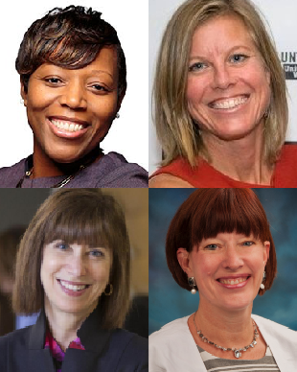 |  | Crisis in Mental Health Policy:  Treatment vs. Incarceration  Nneka Jones Tapia, Kelly O'Brien,  Hon. Heather Steans, and Karen Teitelbaum  Tuesday, Jun 27, 2017

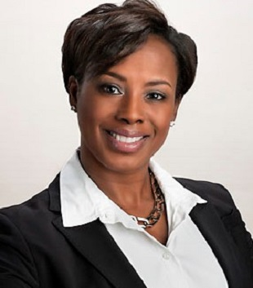 |  | Suzet McKinney  CEO/Executive Director  Illinois Medical District  Wednesday, Sep 6, 2017

Videos of recent speakers
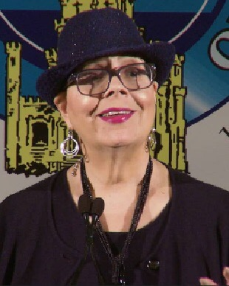 |  | Karen Lewis  President  Chicago Teachers Union  Tuesday, May 23, 2017

  LinkedIn |   Facebook |   Twitter |   iTunes

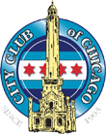 | City Club of Chicago  400 N Michigan Ave, Suite 1018  Chicago, IL 60611  (312) 565-6500 (phone)  (312) 245-2763 (fax)  info@cityclub-chicago.org

Copyright © 2017, All rights reserved.

Unsubscribe from this list Update subscription preferences

