From: David Reifman
Sent: Friday, March 16, 2018 12:26 PM
To: Steve Berlin
Subject: FW: Dont miss HACIA's Annual Banquet March 14th @ Hilton Chicago

Steve – I attended this event

From: HACIA [mailto:ncintron@haciaworks.org]
Sent: Tuesday, February 20, 2018 3:13 PM
To: Reifman, David
Subject: Dont miss HACIA's Annual Banquet March 14th @ Hilton Chicago


  Having trouble viewing this email? Click here





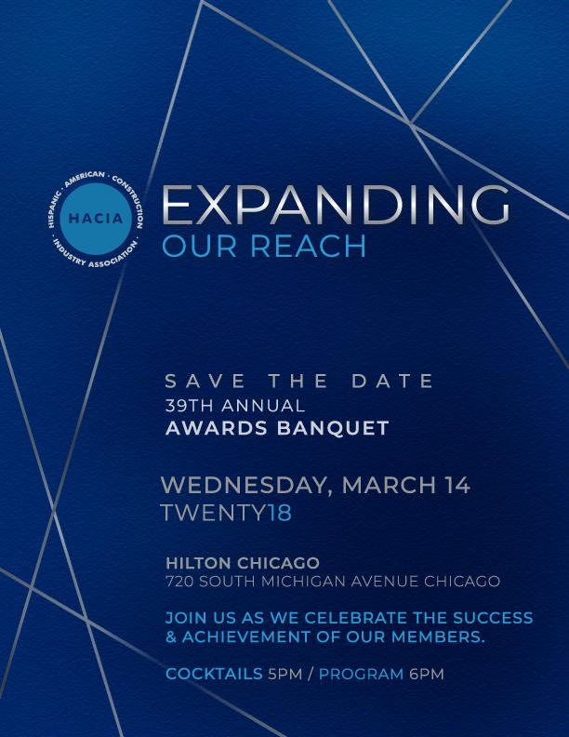
39th HACIA Annual Banquet Registration Form
39th HACIA Annual Banquet Sponsorship Packages
Silver Sponsor(s)


Bronze Sponsor(s)


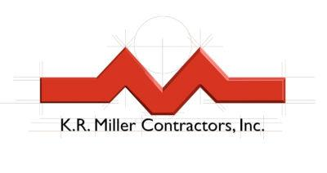
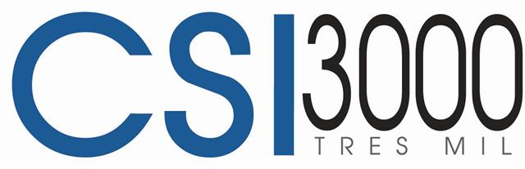

HACIA
650 W. Lake Street Suite 415 Chicago, IL 60661
P: 312.575.0389 F: 312.575.0544
STAY IN TOUCH

HACIA, 650 W. Lake Street, Ste. 415, Chicago, IL 60661
SafeUnsubscribe™ david.reifman@cityofchicago.org

Forward this email | Update Profile | About our service provider

Sent by ncintron@haciaworks.org in collaboration with


Try it free today

