From: David Reifman
Sent: Tuesday, March 20, 2018 10:33 AM
To: Steve Berlin
Subject: FW: Richard M. Daley's St. Patrick's Day Party

Steve – I attended this event.

From: Richard M.Daley [mailto:paperlesspost@paperlesspost.com]
Sent: Thursday, February 22, 2018 4:12 PM
To: Reifman, David
Subject: Richard M. Daley's St. Patrick's Day Party



View the Card
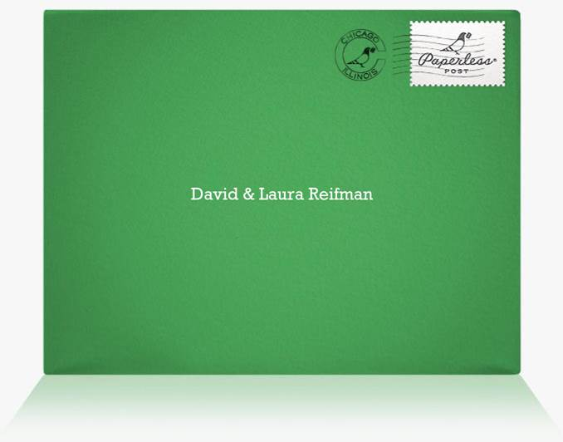

RICHARD M. DALEY'S ST. PATRICK'S DAY PARTY
Saturday, March 17th from 12:30 PM to 3:30 PM
Gibsons Italia
233 N Canal St, Chicago, IL

View map Add to Calendar: Google, Outlook, iCal, or Yahoo
Access event on the go: Get the iPad and iPhone app

