From: David Reifman
Sent: Thursday, July 05, 2018 11:33 AM
To: Steve Berlin
Subject: FW: Happy Place Chicago Opening Party

Steve- I stopped by this event to check it out.

From: Shapack Partners [mailto:paperlesspost@paperlesspost.com]
Sent: Monday, June 25, 2018 2:56 PM
To: David Reifman
Subject: Happy Place Chicago Opening Party



For: Commissioner David Reifman
HAPPY PLACE CHICAGO OPENING PARTY
Wednesday, June 27th from 6:00 PM to 9:00 PM
Happy Place
1004 N Elston Ave, Chicago, IL
View the card

Will Attend Will Not Attend
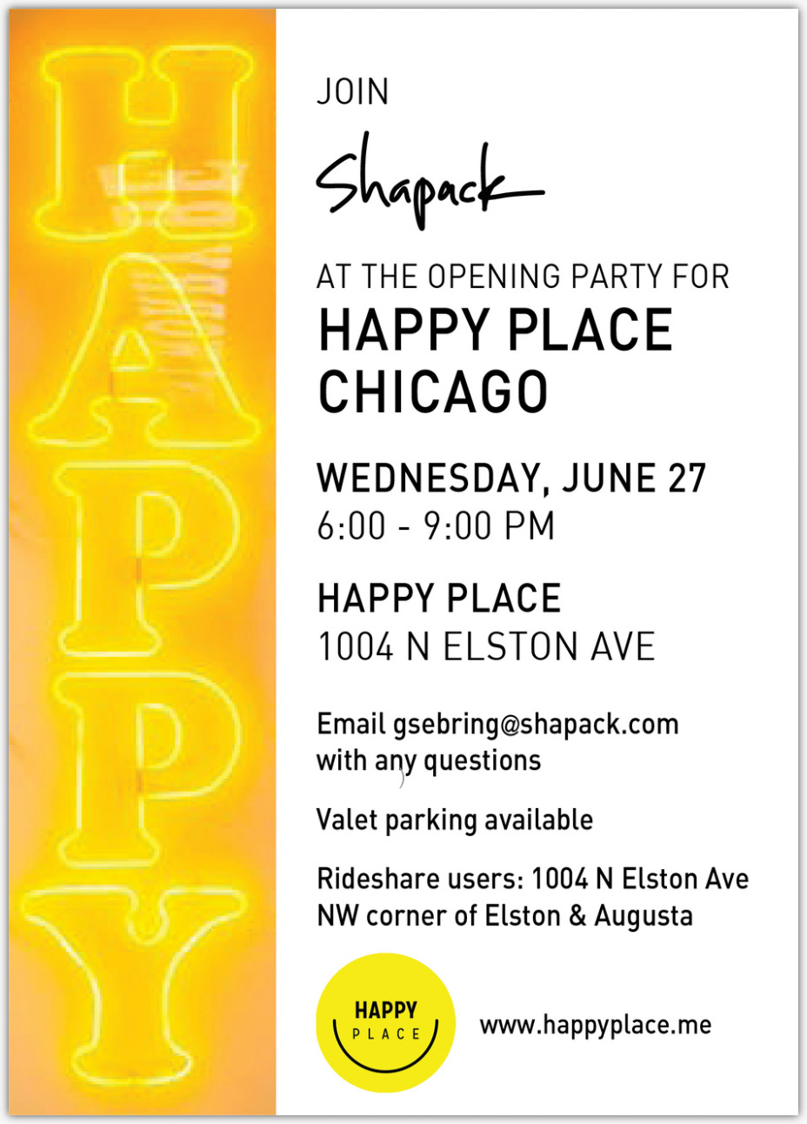

View map Add to Calendar: Google, Outlook, iCal, or Yahoo
Access event on the go: Get the iPad and iPhone app

For the best Paperless Post experience, add paperlesspost@paperlesspost.com to your address book to ensure you receive all cards and invitations in your inbox. Click here to unsubscribe from receiving Paperless Post invitation and card emails. Click here to opt out of receiving marketing emails from Paperless Post. Learn more about our privacy policy.

© Paperless Post • 115 Broadway, New York, NY 10006

