From: David Reifman
Sent: Thursday, December 06, 2018 8:13 AM
To: Steve Berlin
Subject: FW: Holiday Party Invite

Steve – I attended this event

From: O'Connor, Meredith [mailto:Meredith.OConnor@am.jll.com]
Sent: Friday, November 16, 2018 5:53 PM
To: O'Connor, Meredith
Cc: Miller, Jamie; Carolan, Matt
Subject: FW: Holiday Party Invite

Greetings!

It’s that time of the year when we can make and excuse to leave work a little early and appreciate the years accomplishments with friends. My partners and I are hoping to share a bit of cheer with you on December 5th at Porter Kitchen, which is conveniently located in the West Loop at 150 North Riverside. Please come by between 4:00 and 8:00 (I certainly won’t kick you out if you want to stay later) for a toast to 2018 and the start to a great 2019! Hope to see you there and if I don’t, then a happy holidays to you and your families! Also, my apologies if you are receiving this twice. I may have some emails included twice. The detailed invite is below.

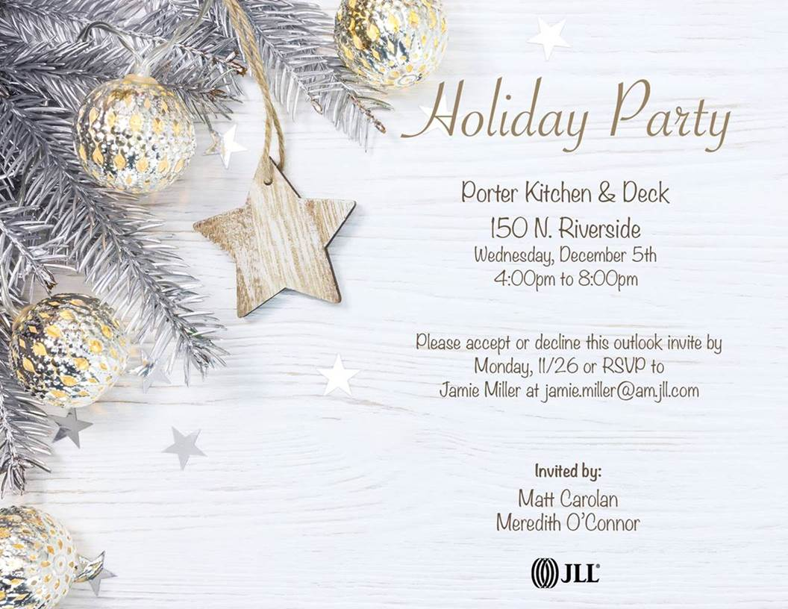

Meredith L. O'Connor
Executive Managing Director
JLL
200 E. Randolph, 45th Floor
Chicago, IL 60601
Direct: 312-228-2576
Cell: 312-523-8737
meredith.oconnor@am.jll.com


