From: David Reifman
Sent: Friday, December 14, 2018 1:08 PM
To: Steve Berlin
Subject: FW: Save the Date: Lurie Children's Hospital Annual Community Leaders Breakfast - Dec. 13

Steve- I attended this breakfast.

From: Lurie Children's [mailto:info@luriechildrens.org]
Sent: Friday, November 09, 2018 12:11 PM
To: David Reifman
Subject: Save the Date: Lurie Children's Hospital Annual Community Leaders Breakfast - Dec. 13

Lurie Children's Hospital
Annual Community Leaders Breakfast
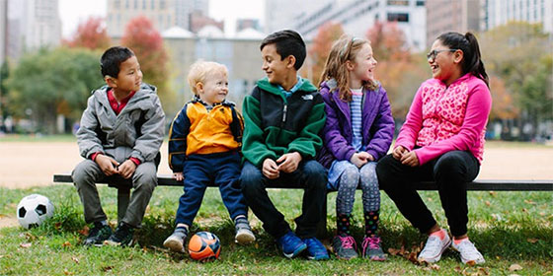
We welcome this annual opportunity to bring together our hospital leaders with Chicago business, community and elected leaders to share updates and continue an open dialogue about our mutual work on behalf of the community.
Thursday, December 13, 2018
8:00 a.m. – 9:30 a.m.
Harry Caray's 7th Inning Stretch, Chicago Sports Museum, Water Tower Place
835 North Michigan Avenue
Level 7
Chicago, IL 60611
RSVP


This e-mail was sent to:
david.reifman@cityofchicago.org
View in Browser | Unsubscribe | Manage e-mail interests
225 E. Chicago Avenue, Box 4 Chicago, IL 60611-2991
312.227.7500
LCurtis@luriechildrens.org
Copyright © 2018 Ann & Robert H. Lurie Children’s Hospital of Chicago. All rights reserved.
Privacy & Legal Information

