From: Christopher Shields
Sent: Monday, December 17, 2018 8:45 AM
To: Steve Berlin
Cc: Allison Arwady; Marielle Fricchione; Maribel Chavez-Torres; Mahita Ciezczak; Christopher Shields
Subject: RE: Agency Funded travel to DC (Crimson Contagion-2019 planning team) - Shields

Good morning Steve:

I have returned from Washington DC, after participating in the HHS Crimson Contagion Initial Planning conference. Costs for this travel / lodging were paid for directly by HHS. During this meeting, we were presented the remaining dates associated to this National exercise, with 3 additional travel dates in 2019. Will I need to submit a letter to your office for each travel or will I be able to submit 1 letter for the remaining travel dates? I have placed in the body of this email the expected dates chart. I formal letter from HHS is expected shortly with the specific ask and final dates.

Thank you in advance

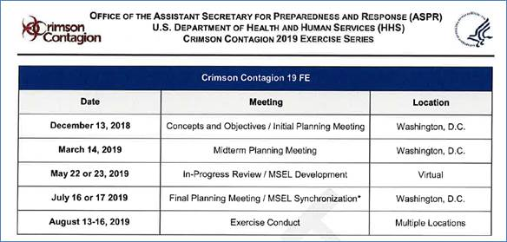

Christopher

Christopher Shields BS, EMT-P
Assistant Commissioner
Chicago Department of Public Health

