From: David Reifman
Sent: Friday, June 22, 2018 3:30 PM
To: Steve Berlin
Subject: FW: Join Us to Celebrate Steven Elrod's Installation as the Chicago Bar Association's 142nd President

Steve – I attended this event.

From: Holland & Knight Events [mailto:hkevents@hklaw.com]
Sent: Tuesday, May 22, 2018 9:42 AM
To: David Reifman
Subject: Join Us to Celebrate Steven Elrod's Installation as the Chicago Bar Association's 142nd President

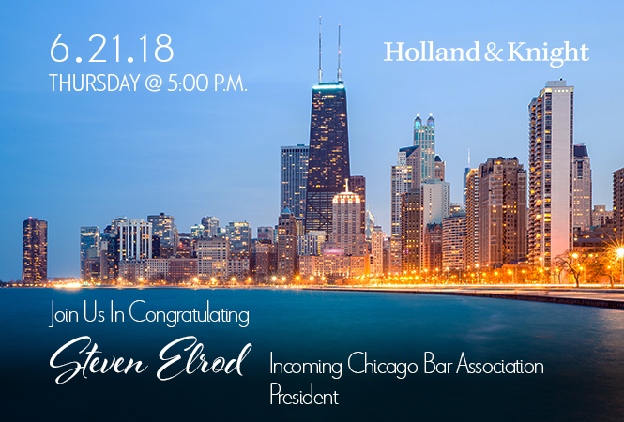

Holland & Knight's Chicago Office Executive Partner Steven M. Elrod will be inducted as the 142nd President of The Chicago Bar Association at the Association's annual meeting.
You are cordially invited to join the attorneys of Holland & Knight, the members of the Chicago Bar, and the Chicago Judiciary for a cocktail reception honoring the newly inducted President.
 | Date/Time: | Thursday, June 21, 2018  5:00 – 7:30 p.m.
 | Where: | Holland & Knight  131 South Dearborn Street  30th Floor  Chicago, IL 60603
RSVP for David Reifman
Space is limited. Please register by June 15.
Register here to attend.
No, I am unable to attend.
If this email was forwarded to you by David Reifman, please click here to register.
Connect
With Us:
 | 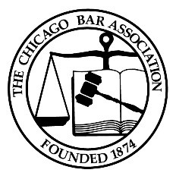

You are currently subscribed to receive Holland & Knight event notifications as David.Reifman@cityofchicago.org. Your email address is never shared with any third parties. For more information, view our Privacy Policy. To learn how to prevent these communications from hkevents@hklaw.com being intercepted by your spam filter, click here. If you would prefer not to receive any additional email event notifications from us in the future, please unsubscribe and we will remove your name from our email list. If this email was forwarded to you, and you would like to begin receiving event notifications directly, please subscribe now.
The information provided herein presents general information and should not be relied on as legal advice when analyzing and resolving a specific legal issue. If you have specific questions regarding a particular fact situation, please consult with competent legal counsel about the facts and laws that apply.
Copyright © 2018 Holland & Knight LLP All Rights Reserved
Holland & Knight LLP | Operations Center | 524 Grand Regency Blvd. | Brandon, FL 33510-3931 | www.hklaw.com

