From: David Reifman
Sent: Monday, April 16, 2018 10:50 AM
To: Steve Berlin
Subject: FW: Chicago Cares Breakfast 4/16

Steve – I attended this event this morning.

From: Jenne Myers [mailto:jmyers@chicagocares.org]
Sent: Friday, April 06, 2018 8:19 AM
To: David Reifman
Subject: Chicago Cares Breakfast 4/16

Hi David -

Great to see you last night at CNDA. If you can make our breakfast on April 16th – we’d love to have you. MRE is attending but in and out right after he speaks.

Please be my guest at the State of Volunteerism Address on Monday, April 16, 2018. Held over breakfast at the Four Seasons Hotel, the event will engage Chicago’s top corporate leaders as well as leaders from the public, nonprofit, and philanthropy sectors to learn about the latest trends in civic engagement. This year’s event will not be your standard breakfast. Focusing on the theme of “The Power of Togetherness”, and featuring Rev. Dr. Otis Moss, and Young Chicago Authors, we will be using innovative mediums to challenge us all to do more good in Chicago.

Please RSVP by this Friday, April 6. Thank you for your continued partnership, and commitment to our city.

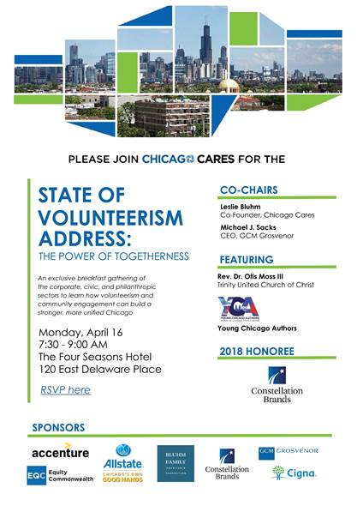

Best,
J

