From: Rey Phillips_Santos
Sent: Wednesday, October 24, 2018 3:38 PM
To: Steve Berlin
Subject: gift received on behalf of the City

Hi Steve,

Good talking to you today. I received a framed collection of 2018 FIFA World Cup city pins, see photo drawn from the internet below, from a colleague, Kara Bachman, the Executive Director of the Chicago Sports Commission. We worked together on a project this past winter and have kept in touch over our mutual interest in sports and soccer. The FIFA website (https://eu.store.fifa.com/uk_en/2018-fifa-world-cup-russiatm-pin-collection-host-cities-framed) indicates that the framed pins cost £53.99, and though I seriously doubt that she paid money for it, that’s still a value of over $50. I therefore accept the gift on behalf of the City, and will display it here at City Hall where others may enjoy it as well.

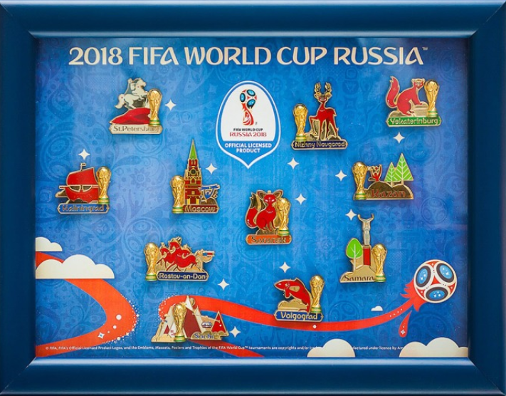

Regards,

Rey A. Phillips Santos
Senior Assistant Corporation Counsel
City of Chicago Department of Law

