From: David Reifman
Sent: Monday, October 29, 2018 3:47 PM
To: Steve Berlin
Subject: FW: Invitation: Reception in Recognition of Community Partnerships, October 23

Steve- I attended this event.

From: Office of the President [mailto:univ-events@uchicago.edu]
Sent: Monday, September 24, 2018 3:08 PM
To: Event Invitees
Subject: Invitation: Reception in Recognition of Community Partnerships, October 23

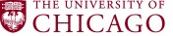
PRESIDENT ROBERT J. ZIMMER CORDIALLY
INVITES YOU TO
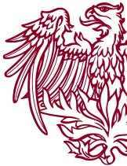
A Reception in Recognition
of Community Partnerships
Tuesday, October 23, 2018
5:00 – 6:30 P.M.
POLSKY CENTER FOR ENTREPRENEURSHIP AND INNOVATION
1452 EAST 53RD STREET
SECOND FLOOR
Entrance located on Harper Avenue in the Harper Theater Lobby
Complimentary valet parking provided
Please click here to respond by October 16
For more information, or to request special assistance, please contact Kelly Meisner in the
Office of University Events and Ceremonies at 773.702.9626 or univ-events@uchicago.edu.

