From: David Reifman
Sent: Monday, November 12, 2018 11:06 AM
To: Steve Berlin
Subject: FW: Reminder: Green Line Performing Arts Center Opening

Steve – I attended this event.

From: University of Chicago [mailto:universityofchicagoevents@uchicago.edu]
Sent: Friday, November 09, 2018 10:00 AM
To: David Reifman
Subject: Reminder: Green Line Performing Arts Center Opening

We look forward to seeing you on Saturday, November 10.
Problems viewing this email? View online.
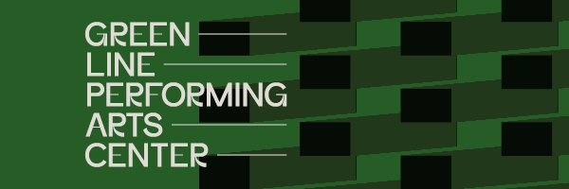

Green Line Performing Arts Center Dedication

We look forward to seeing you at the Green Line Performing Arts Center Dedication and Celebration.

Saturday, November 10
Noon-1:15 p.m.: Lunch
Arts Incubator
301 East Garfield Boulevard
Chicago, Illinois

1:30-3:00 p.m.: Dedication Program
Green Line Performing Arts Center
329 East Garfield Boulevard
Chicago, Illinois

3:00-6:00 p.m.: Grand Opening
Green Line Performing Arts Center
329 East Garfield Boulevard
Chicago, Illinois

Complimentary valet parking will be available at the entrance of the Arts Incubator.

If your plans have changed, you require special assistance, or you have questions, please contact the Office of Strategic Events at 773.834.5228 or universityofchicagoevents@uchicago.edu.


The University of Chicago
5801 South Ellis Avenue, Chicago, IL 60637
1.800.955.0065



