From: David Reifman
Sent: Friday, September 14, 2018 8:28 AM
To: Steve Berlin
Subject: FW: You're Invited to FCB Open House 2018

Steve- I attended this event.

From: FCB Chicago [mailto:fcbchicago=fcb.com@mail138.atl81.rsgsv.net] On Behalf Of FCB Chicago
Sent: Tuesday, August 07, 2018 2:00 PM
To: David Reifman
Subject: You're Invited to FCB Open House 2018

View this email in your browser

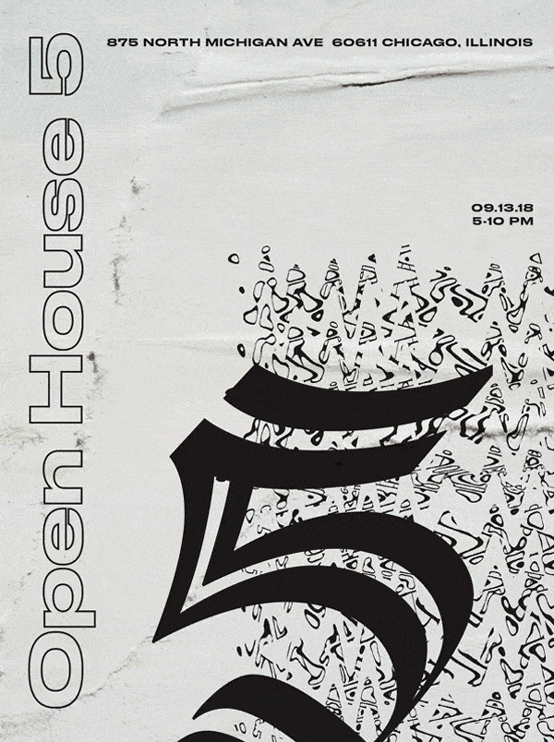



5TH ANNUAL OPEN HOUSE

Content Sessions - Live Music - Food & Drinks

September 13th, 2018 from 5-10 PM, 21st Floor

875 N Michigan Ave, Chicago IL, 60611

RSVP


