From: David Reifman
Sent: Wednesday, September 12, 2018 4:02 PM
To: Steve Berlin
Subject: FW: Be Our Guest at the 2018 MPC Annual Luncheon

Steve- I attended this event today.

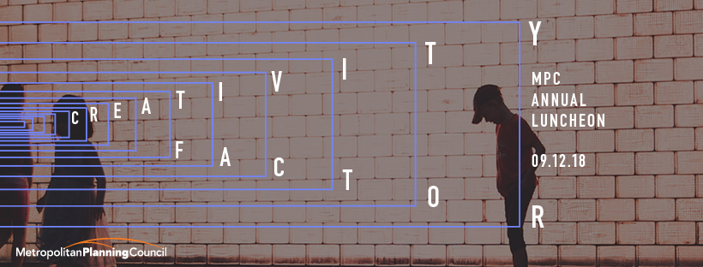

August 23, 2018

Dear David,
I am delighted to invite you to join the Metropolitan Planning Council (MPC) as our guest on Wednesday, September 12th, for the 2018 Annual Luncheon: The Creativity Factor.
MPC’s 2018 Annual Luncheon will feature a celebrated museum director and one of our nation’s most successful entrepreneurs. The keynote, Lonnie G. Bunch III, founding director of the Smithsonian’s National Museum of African American History and Culture and former president and director of the Chicago History Museum, will discuss how history and culture are essential to a vibrant community and healthy economy. He will be joined in conversation with Joy Bivins, chief curator for Charleston's International African American Museum, which opens in 2020. MPC will also honor Patrick G. Ryan, Chairman & CEO of Ryan Specialty Group, with the Champion Fighter Award for his extraordinary civic leadership.
This is a complimentary admission in recognition of your valued partnership with the Metropolitan Planning Council. It is not transferable. We expect a very large crowd for this event, and ask you to respond by August 31, 2018. Click the button below to RSVP.

RSVP

You have also been mailed a hard copy invitation with a “complimentary” sticker. To RSVP using the reply card, fill it out and mail it to PJH & Associates (or fax your reply to 312.553.2007). If you already have been invited to be someone else’s guest that day, please tell us who your host will be.
I hope to see you on September 12th!
All the best,
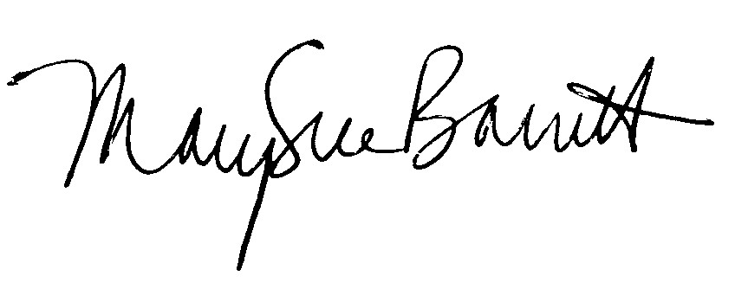
MarySue Barrett
President | Metropolitan Planning Council
140 S. Dearborn St. | Suite 1400 | Chicago, Ill. 60603
P 312.863.6001 | F 312.922.5619 | T @MarySueMPC | msbarrett@metroplanning.org

 | Like
 | Tweet
 | Share
 | Read Later
 | Forward to Friend

Copyright © 2018 Metropolitan Planning Council, All rights reserved.
You are receiving this email because you subscribed online at metroplanning.org or you signed up in person at an MPC event. You may update your preferences or unsubscribe at any time.
Our mailing address is:
Metropolitan Planning Council
140 South Dearborn
Suite 1400
Chicago, Illinois 60603
Add us to your address book
unsubscribe from this list update subscription preferences

