From: Erik Wallenius [mailto:erik@ward43.org]
Sent: Friday, August 03, 2018 1:54 PM
To: Steve Berlin
Subject: LP Zoo

Hi Steve,

Just wanted to let you know that I met today with Marybeth Johnson (VP of Government Relations and External Affairs for Lincoln Park Zoo).

It was in my official capacity, we discussed constituent services and policy, and establishing a relationship for future communications since I'm new to this office.

Marybeth insisted on paying for lunch.

The venue was The Patio at Cafe Brauer at the Lincoln Park Zoo (2021 N Stockton Drive).

Photo of the receipt is attached.

Thanks, and please let me know if there's anything further you need from me - happy Friday!
Erik Wallenius
Chief of Staff
Alderman Michele Smith
43rd Ward
2523 N. Halsted
Chicago, IL 60614
773-348-9500 (office)
773-348-9594 (fax)
Pronouns: he/him/his

---------- Forwarded message ----------
From: Erik Wallenius <erik@ward43.org>
Date: Fri, Aug 3, 2018 at 1:09 PM
Subject: LP Zoo
To: Erik Wallenius <erik@ward43.org>
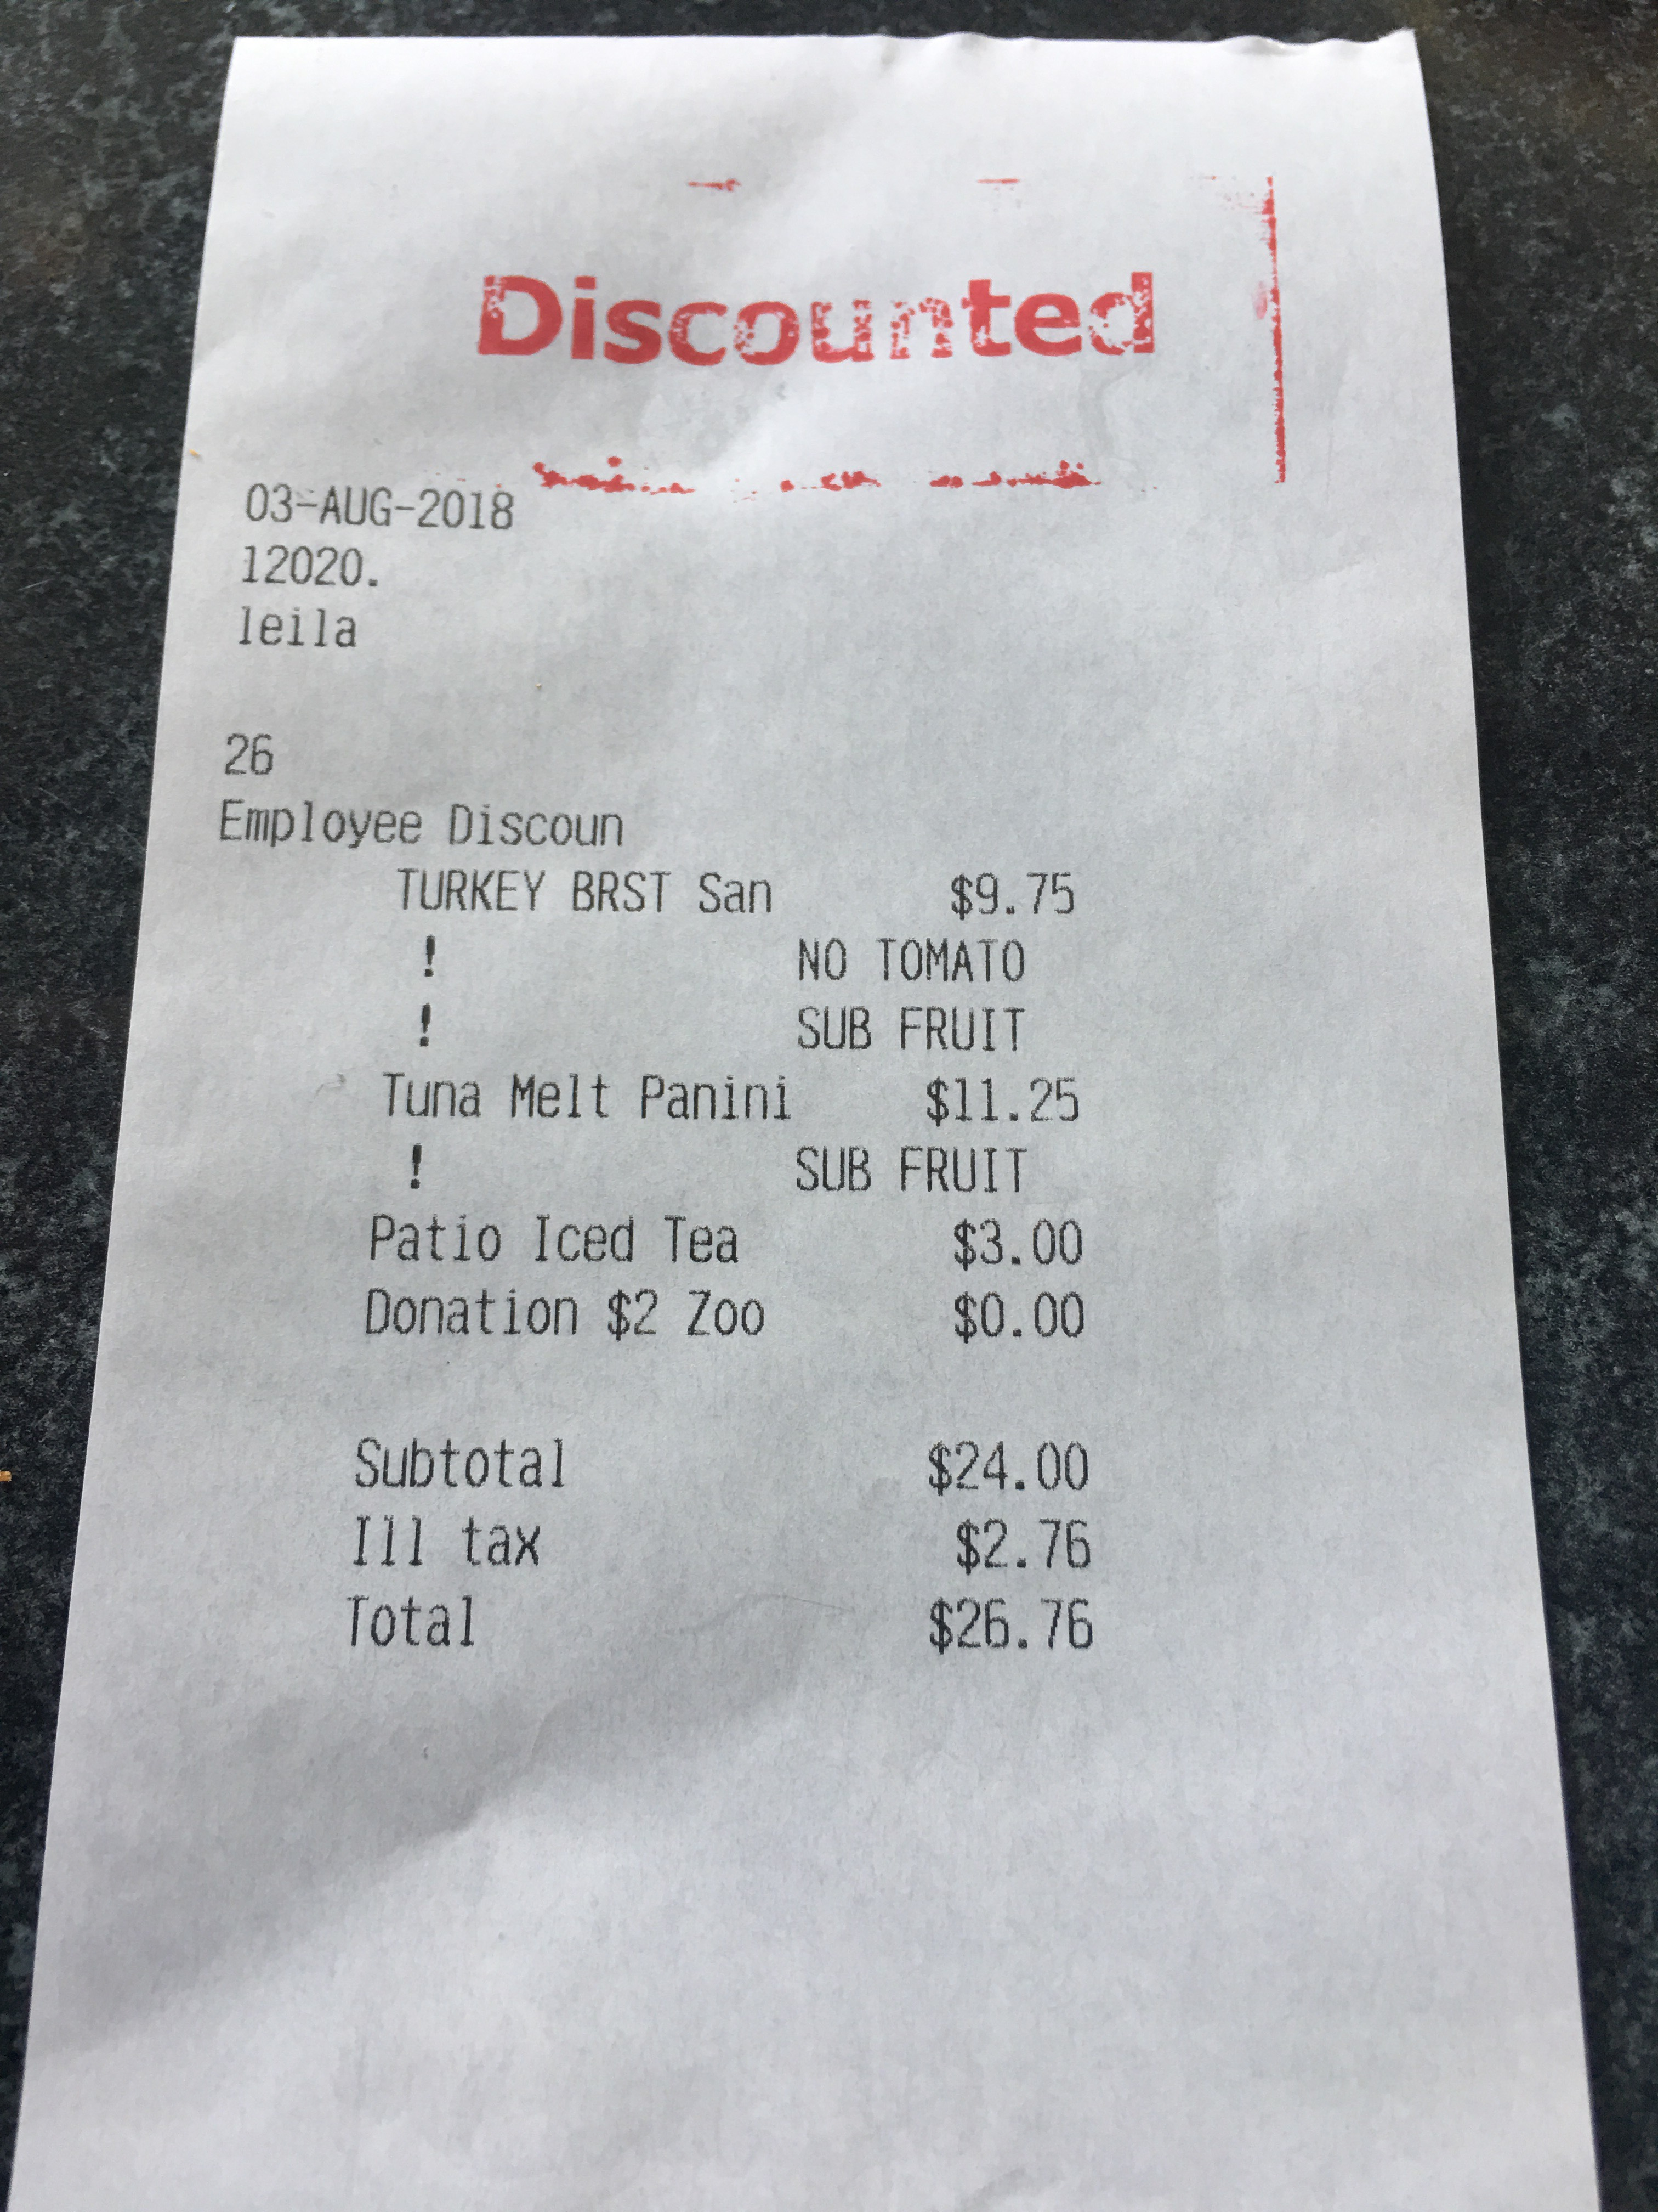
--
Erik Wallenius
Chief of Staff

