From: David Reifman
Sent: Wednesday, August 29, 2018 2:19:13 PM
To: Steve Berlin
Subject: FW: See you at the Chicago Architecture Center VIP Reception!

Steve- I attended this event. Thank you.

From: Chicago Architecture Center [mailto:cacreceptionforvips@splash.events]
Sent: Friday, August 24, 2018 3:31 PM
To: David Reifman
Subject: See you at the Chicago Architecture Center VIP Reception!

We look forward to celebrating with you at the VIP Reception on Tuesday, August 28 at 5:30 PM!

We look forward to celebrating with you at the VIP Reception on Tuesday, August 28 at 5:30 PM.
The entrance to the event will be on the plaza, just east of the Chicago Architecture Center’s front door at 111 East Wacker Drive. Upon arrival, please check in at the Registration desk.
5:30 PM Guest arrival and check in
6:00 PM Remarks in the Gand Lecture Hall
6:20 PM Explore the new Chicago Architecture Center
8:00 PM Reception concludes
Festive business attire is recommended for the event. Please email us if your plans have changed.

  Chicago Architecture Center
  111 East Upper Wacker Drive
  Chicago IL 60601
  Tuesday, August 28
  5:30PM - 8:00PM CDT
  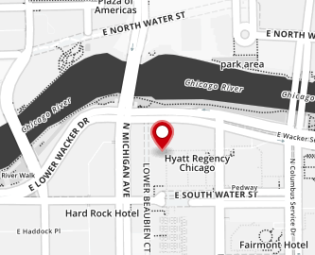

For more information about the event, visit:

https://cacreceptionforvips.splashthat.com


Unsubscribe
Powered by Splash
Make a Splash! at splashthat.com
122 W 26th St, New York, NY 10001
Copyright © 2018 All rights reserved.

