From: Thomas, Latasha
Sent: Wednesday, July 09, 2014 3:00 PM
To: Berlin, Steve
Subject: Hosting report

Steve,

Please be advised that I attended a luncheon sponsored by AfterSchool Matter; ComEd and the Art Institute. A gift bag was distributed of a book and notebook with a light. (See attached photo) pAll together, doesn't meet gift threshold.
​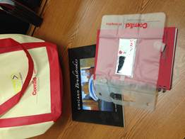

If you have any questions, please do not hesitate to contact me.

Best,

Latasha R. Thomas
Alderman, 17th Ward

