From: Ahmed, Nafees
Sent: Wednesday, August 13, 2014 4:02 PM
To: Berlin, Steve
Subject: Emirates Gala Events

Steve,

In honor of new nonstop flights from Chicago to Dubai I attended the Emirates Gala event at Navy Pier on Wednesday, August 6th, 2014.
I received a gift bag which was distributed at the event. Inside the gift bag was a luggage tag and a passport holder. Please let me know if you need any additional information.

Thanks

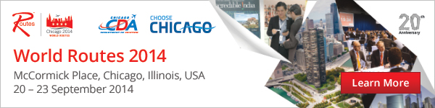

To learn more about World Routes 2014 go to http://www.routesonline.com/events/170/world-routes-2014

