From: Beaudet, Matthew
Sent: Tuesday, December 16, 2014 4:53 PM
To: Berlin, Steve
Cc: Davis, Felicia; Meyer, Kenneth; Hopkins, Marlene; Loeff, Scott
Subject: Donation of Unreturnable Gifts to Dept Employee

Dear Executive Director Berlin,

On December 15, 2014, Department of Buildings employees John McEneany and Dominick Vittorini reported to me that that the below items where left out on the Department of Buildings' front counter in room 906 of City Hall in a Macy's paper bag for them. The bag contained a tin of Jacob's Afternoon Tea Biscuits (retail value $29.99 on internet) and two envelopes addressed to "John" amd "Dominic" (misspelled). Each envelope contained a thank you card addressed to John and Dominick signed "PJ" and both cards also contained a $100.00 gift card to Lettuce Entertain You. "PJ" did not provide a last name and John and Dominick know of two regular contractors who pull permits that go by "PJ." I instructed John and Dominick to get the names and phone numbers of the two "PJs." I telephoned both "PJs" - PJ Sweeney 312-437-0500 and PJ Fazio 630-924-0400. Neither of them stated that they were the gift giver or that the gifts were sent on their behalf. John and Dominick could not think of anyone who would have given the gifts or signed the cards.

As the Department cannot accept the gifts under its No Gift Policy or under the City Ethics Ordinance, please note that the Department will donate the gifts on behalf of the City to a non-profit organization as allowed by and in compliance with Section 2-156-144 of the City Ethics Ordinance. The Department will donate the gifts to The Cara Program at 237 S. Desplaines St. in Chicago. The Cara Program is a 501(c)(3) on-profit organization which prepares and inspires motivated individuals to break the cycle of homelessness and poverty, transform their lives, strengthen our communities, and forge paths to real and lasting success. http://www.thecaraprogram.org/

Please feel free to contact me if your require any additional information.

Best Regards,

Matthew Beaudet

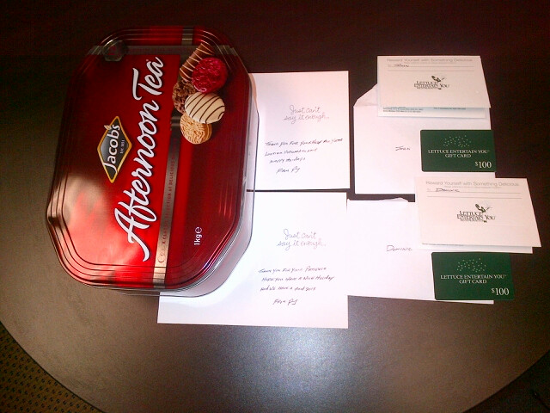

Matthew W. Beaudet
First Deputy Commissioner
City of Chicago - Dept. of Buildings

