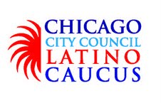
June 3, 2014

Mr. Steven I. Berlin
Executive Director
City of Chicago Board of Ethics
740 N. Sedgwick, Suite 500
Chicago, IL 60654

Dear Mr. Berlin:

The Chicago City Council Latino Caucus would like to report a scheduled meeting of the CCCLC to discuss regular business at Emerald Loop located at 216 N. Wabash on Wednesday May 28, 2014. At this lunch meeting the following individuals accepted a lunch paid for by Alderman Daniel Solis.

Alderman Proco Joe Moreno
Alderman Roberto Maldonado
Alderman Ariel Reboyras
Alderman Rey Colón
Alderman Toni Foulkes
Alderman George Cardenas
Alderman Ricardo Munoz
Alderman Michael Zalewski

Legislative Aide Stacy Raker

Sincerely,

Alderman Rey Colón
Chairman, Chicago City Council Latino Caucus

