DELETING A CLIENT
There are several steps you must take in order to delete a client.
- File an activity report for each client you wish to delete (almost all of this step will be the same as filing a quarterly report with some small differences)
- Have that activity report reviewed and approved by Board staff
- Actually deleting the clients appearing in your registration, for whom you submitted activity reports in your registration.
- Having your amended registration reviewed and approved by Board staff.

After logging into ELF, choose View Activity Reports from the left-hand menu.
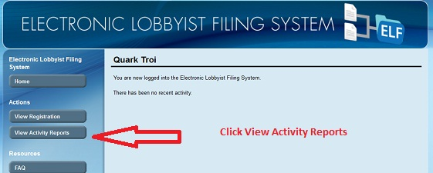

Confirm that you are in the proper year and that you are choosing the correct period for the reporting and then click Create Activity Report.

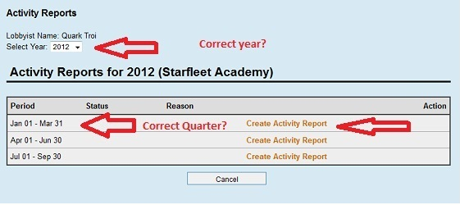

Report any Gifts that the lobbyist made by the lobbyist to any official or employee of the City.
Provide the requested information and click Add Gift to add more. If you did not make any gifts or when all gifts have been listed click Continue at the bottom of the screen.

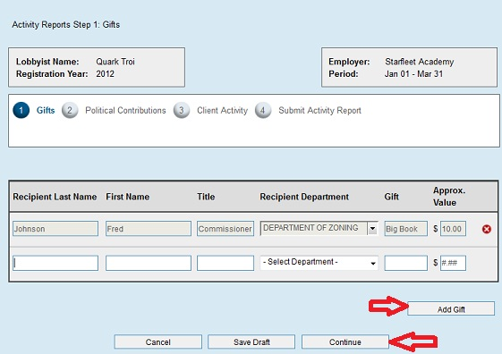

Report any political contributions made by the REGISTRANT (not the company or firm) to any candidate for City office, any elected official of City government and any official or employee of the City seeking election to an office other than a City office during the reporting period. Use the Add Political Contribution to add more contributions. If there were no contributions or when all contributions have been reported click Continue at the bottom of the screen

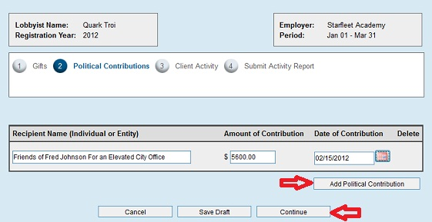

To delete a client you MUST answer yes to the question regarding lobbying, a list of all your clients will pop up. You will then report on those clients you wish to delete, even if all your answers are no or “blank”.

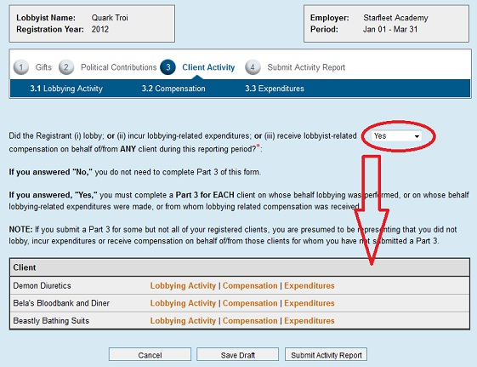

To report on your individual clients, choose Lobbying Activity after their name.

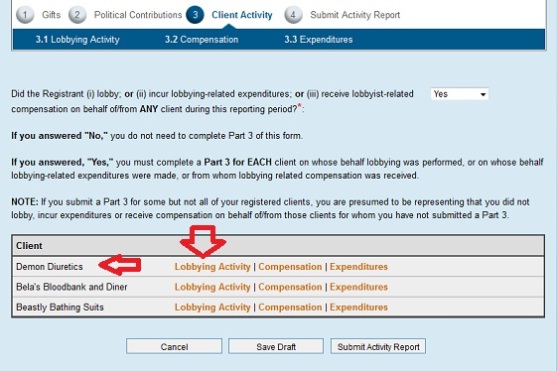

If you answer the top question (you must answer this question), you will be asked to provide the name and information of that client.
NOTE – if you say Yes, and the particular person or entity is not already registered to you, you will have to add this client to your registration. Because the ELF system only allows you one process at a time, you will have to delete the work you have done thus far (see toward the end of this tutorial about how to delete your activity report draft) and begin by adding the client, having that addition approved, and then pay for that client. You will then begin all over in submitting your activity report.

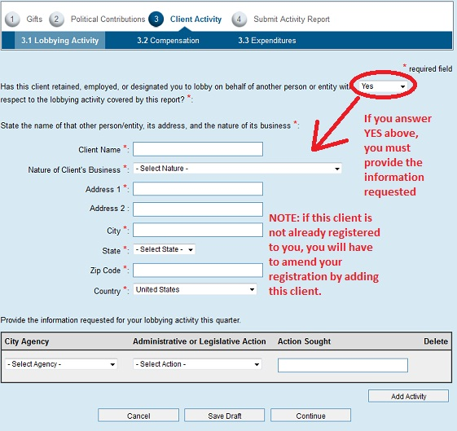

Provide the requested information for your lobbying activity for this client during this period.
Use the Add Activity button to continue adding other activities for this client.
When completed, of if there was NO activity, click the Continue button.

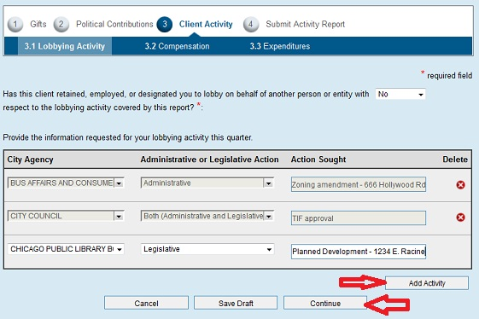

You must now answer the question regarding lobbying related compensation. If you answer NO, you may then click Continue. If you answer Yes, provide the amount of lobbying-related compensation received from this client and then click Continue.

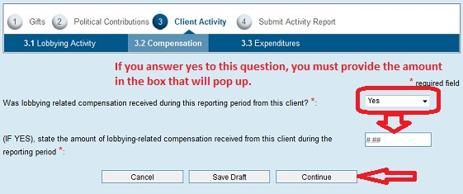

The next screen asks you to list your expenditures. The top box asks you to list each single expenditure of 250.00 or more. Please provide all the requested information for each of these expenditures. Use the Add Expenditures button to keep adding more. Other expenses are reported for each category asked for. If there were no expenses or when all expenses are reported, click the Continue button at the bottom of the screen.

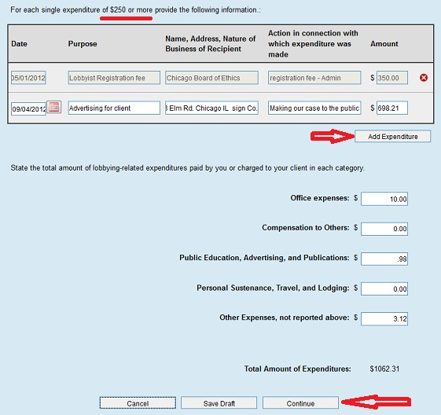

Continue reporting on each of the clients you wish to delete. After completing all your reports for the clients you wish to delete, click the Submit Activity Report button on the bottom of the screen.

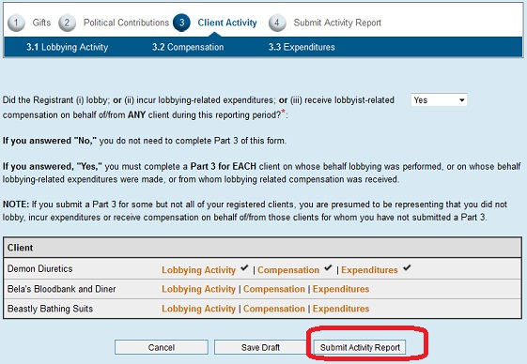

After hitting Submit Activity Report, you will be asked to provide your password, the answer to your secret question, click the box that said you have read the terms and conditions and then select Delete a client as the reason for the report. After providing all the requested information, click Submit Activity Report at the bottom of the screen.

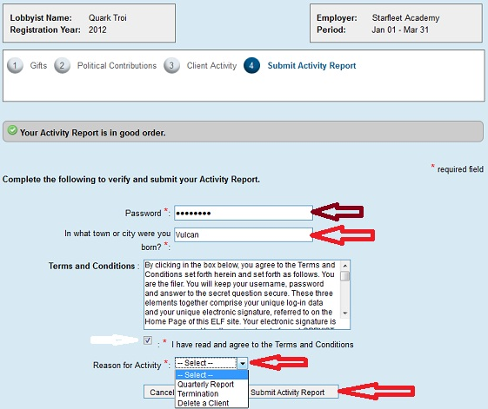

When you have properly submitted your report, an email will be sent to you and you will be taken to the screen below. You can either click the Home button, Logout or, if you want to see the status of your report, click View Activity Reports button in the left-hand menu.

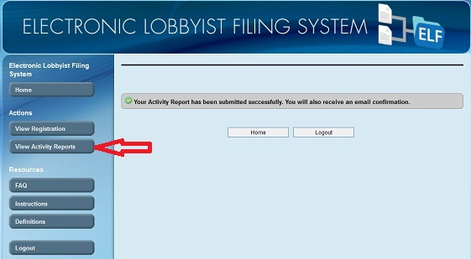

Until our staff has reviewed your report and accepted it as complete, your status will be Pending Review.

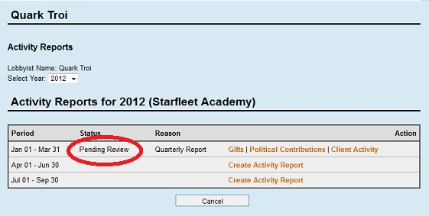

Once accepted your status will be changed to Filed, you will receive an email to that effect.
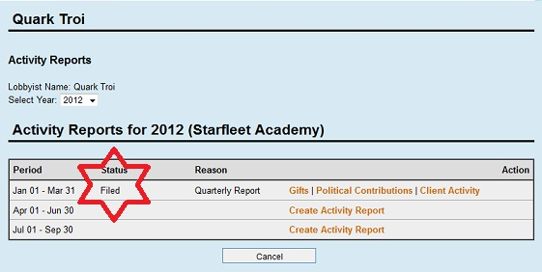

If your submission is rejected and needs correction, you will receive an email telling you why and your status will be changed to DRAFT. This will allow you to go back into the form to make any corrections necessary and re-submit. By clicking on Gifts, Political Contributions or Client Activity, you can then go back into the form and make your corrections.

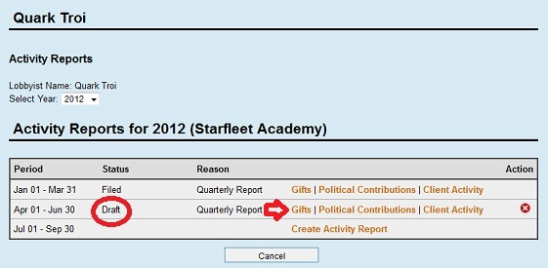

Once your activity report for the clients you wish to delete has been accepted and is in Filed Status, you can return to the system and do the following:
Click View Registration in the left-hand menu.
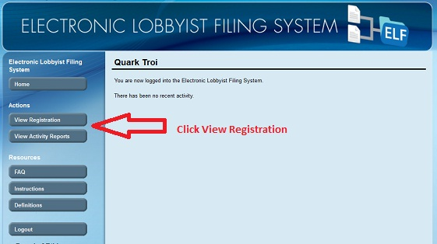

Click Employer Information in the proper year.
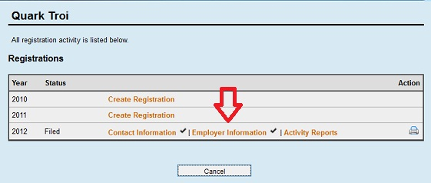

Click Clients for the proper employer. Your list of clients will then be shown.

NOTE: If at any time you think you might have made a mistake please use the Back button at the bottom of the screen. This will put your work into Draft mode. See the final screen shot below to see how to delete something in Draft.

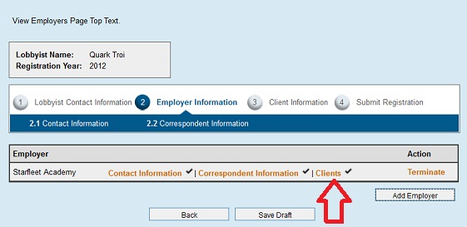

Click the red “X” under Action after each client you wish to delete and have submitted an activity report for. (Note: You can also add new clients if you so wish at the same time you are deleting clients. See the tutorial for registering and adding clients.)

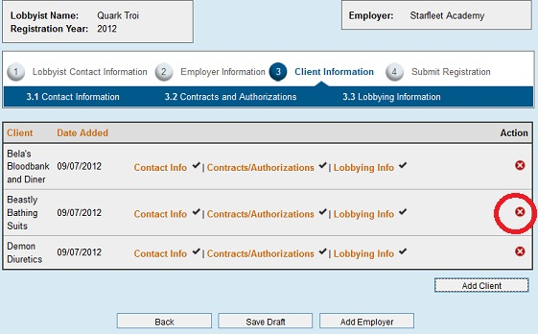

After you have clicked the red “X” you will notice that the bottom of the screen will change, offering you the necessary options you will need at this step. After “x”-ing out all the clients you wish to delete hit the Submit Registration button. This will send the revised registration to be reviewed by the board. You will receive emails of its acceptance or rejection. You can always review the status of your filing by logging in and clicking Review Registration from the left hand menu.

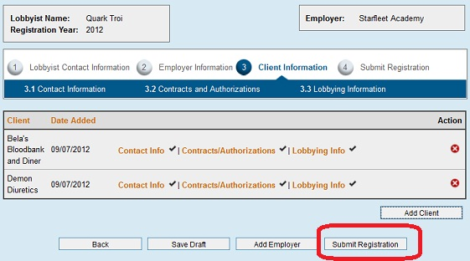

If you need to delete your draft because you must add a client prior to filing your report, or you mistakenly picked the wrong year or quarter, or you simply want to start all over again, you can click the red “X” under Action. As long as the form is in Draft status it will not become part of your lobbying record. Reports already filed, accepted and put into Filed status cannot be removed. They can, however be amended (see the tutorial for amending reports). Both the original and the amended form will be available to the public in the reporting section of the ELF system.

