TERMINATING AS A LOBBYIST
Terminating as a lobbyist means the lobbyist is terminating ALL activities for ALL clients and employers that require lobbyist registration. In essence, it means I am no longer going to lobby for anyone anymore. This is not the same as deleting a client wherein the lobbyist is no longer going to lobby for a particular client but keep lobbying for other clients.
There are several steps you must take in order to Terminate as a Lobbyist.
- File a final activity report.
- Have that activity report reviewed and approved by Board staff
- Terminating your registration.
- Having your termination approved by Board staff.

After logging into ELF, choose View Activity Reports from the left-hand menu.
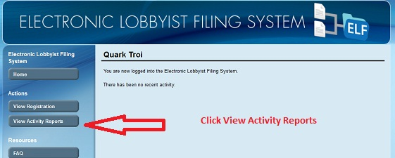

Confirm that you are in the proper year and that you are choosing the correct period for the reporting and then click Create Activity Report.

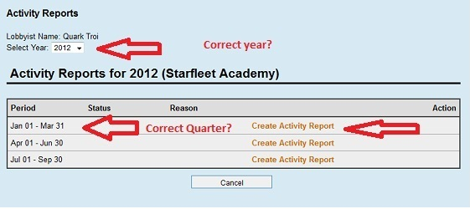

Report any Gifts that the lobbyist made by the lobbyist to any official or employee of the City.
Provide the requested information and click Add Gift to add more. If you did not make any gifts or when all gifts have been listed click Continue at the bottom of the screen.

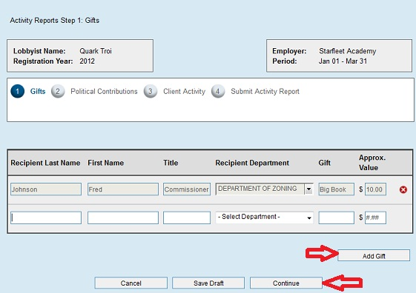

Report any political contributions made by the REGISTRANT (not the company or firm) to any candidate for City office, any elected official of City government and any official or employee of the City seeking election to an office other than a City office during the reporting period. Use the Add Political Contribution to add more contributions. If there were no contributions or when all contributions have been reported click Continue at the bottom of the screen

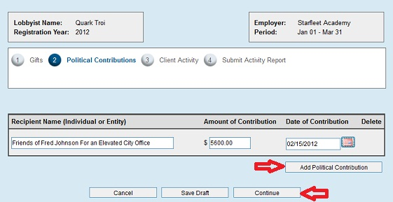

You must answer the question on top of this page. If you answer No, you are done and may then hit Submit Activity Report at the bottom of the page (see toward the bottom of this tutorial for the next steps). If you answer YES, you will be asked for further reporting information.

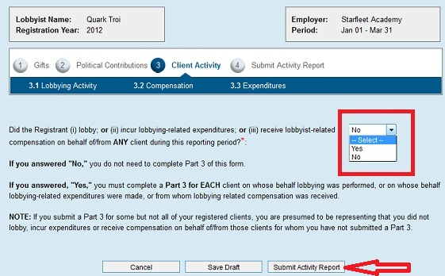

If you answer yes to the question regarding lobbying, a list of all your clients will pop up. You will then report on any client for whom you lobbied, received lobbying-related expenditures or compensation.

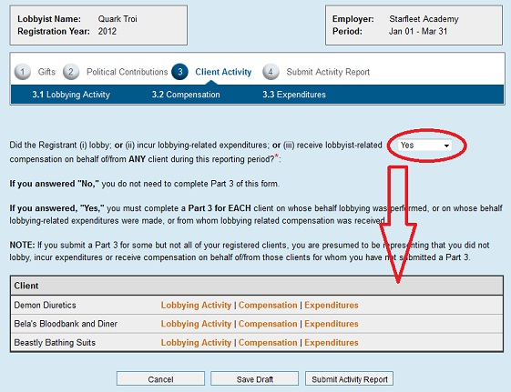

To report on your individual clients, choose Lobbying Activity after their name.

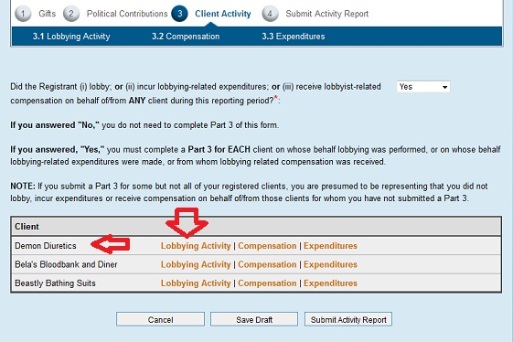

If you answer the top question (you must answer this question), you will be asked to provide the name and information of that client.
NOTE – if you say Yes, and the particular person or entity is not already registered to you, you will have to add this client to your registration. Because the ELF system only allows you one process at a time, you will have to delete the work you have done thus far (see toward the end of this tutorial about how to delete your activity report draft) and begin by adding the client, having that addition approved, and then pay for that client. You will then begin all over in submitting your activity report.

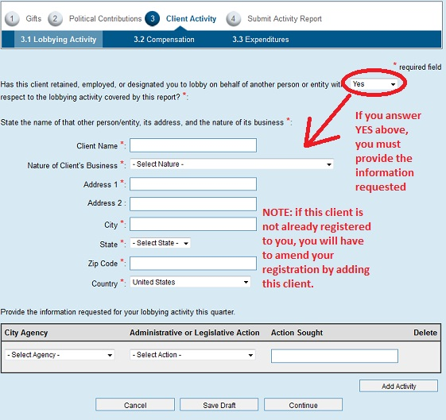

Provide the requested information for your lobbying activity for this client during this period.
Use the Add Activity button to continue adding other activities for this client.
When completed, of if there was NO activity, click the Continue button.

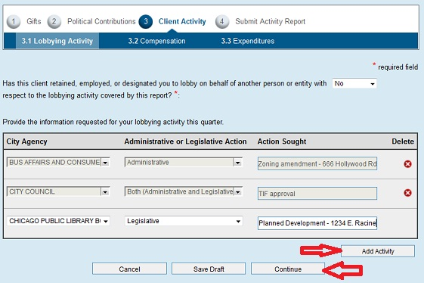

You must now answer the question regarding lobbying related compensation. If you answer NO, you may then click Continue. If you answer Yes, provide the amount of lobbying-related compensation received from this client and then click Continue.

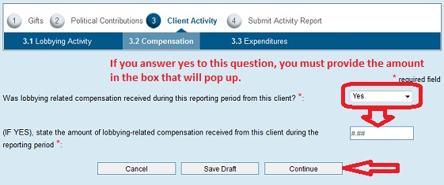

The next screen asks you to list your expenditures. The top box asks you to list each single expenditure of 250.00 or more. Please provide all the requested information for each of these expenditures. Use the Add Expenditures button to keep adding more. Other expenses are reported for each category asked for. If there were no expenses or when all expenses are reported, click the Continue button at the bottom of the screen.

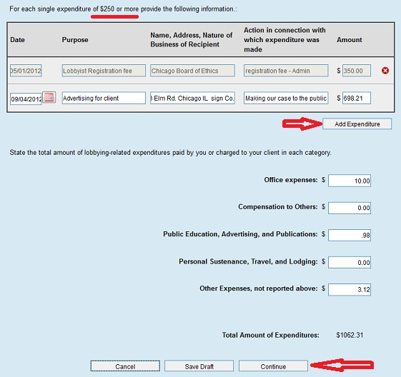

You may continue reporting on each of your clients as necessary. However, you only need to report on those clients on whose behalf lobbying was performed, or on whose behalf lobbying-related expenditures were made, or from whom lobbying related compensation was received. After completing your reporting, click the Submit Activity Report button on the bottom of the screen.

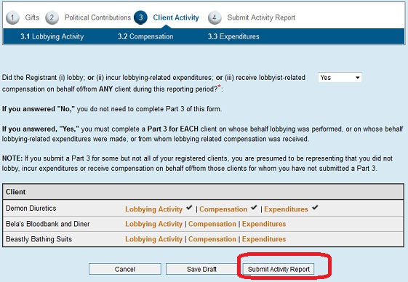

After hitting Submit Activity Report, you will be asked to provide your password, the answer to your secret question, click the box that said you have read the terms and conditions and then select Termination as the reason for the report. After providing all the requested information, click Submit Activity Report at the bottom of the screen.

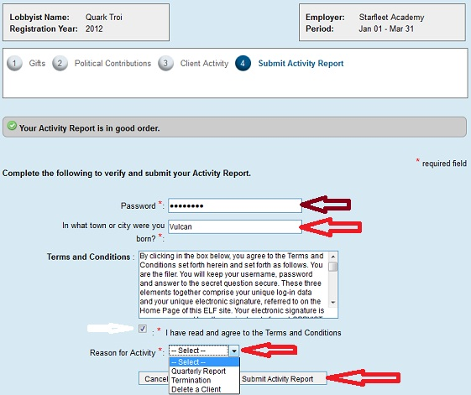

When you have properly submitted your report, an email will be sent to you and you will be taken to the screen below. You can either click the Home button, Logout or, if you want to see the status of your report, click View Activity Reports button in the left-hand menu.

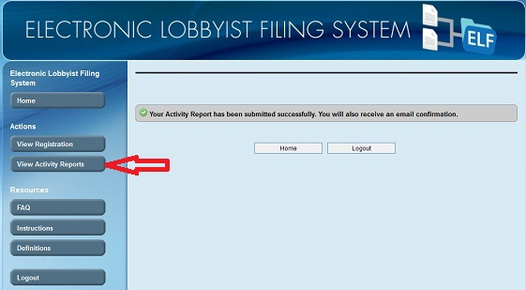

Until our staff has reviewed your report and accepted it as complete, your status will be Pending Review.

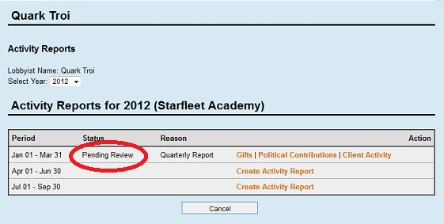

Once accepted your status will be changed to Filed, you will receive an email to that effect.
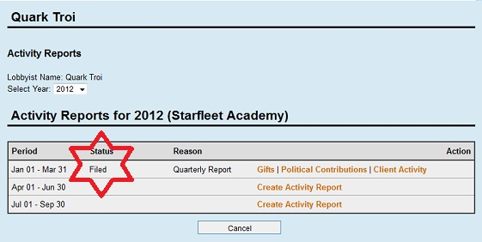

If your submission is rejected and needs correction, you will receive an email telling you why and your status will be changed to DRAFT. This will allow you to go back into the form to make any corrections necessary and re-submit. By clicking on Gifts, Political Contributions or Client Activity, you can then go back into the form and make your corrections.

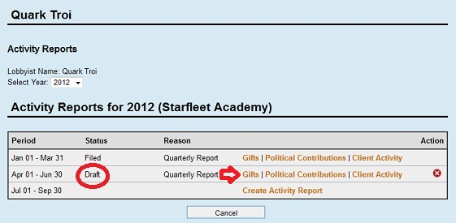

If you need to delete your draft because you must add a client prior to filing your report, or you mistakenly picked the wrong year or quarter, or you simply want to start all over again, you can click the red “X” under Action. As long as the form is in Draft status it will not become part of your lobbying record. Reports already filed, accepted and put into Filed status cannot be removed. They can, however be amended (see the tutorial for amending reports). Both the original and the amended form will be available to the public in the reporting section of the ELF system.

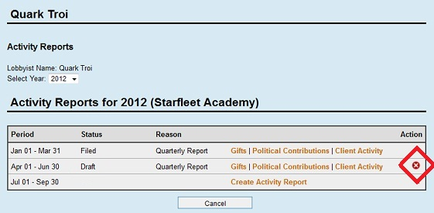

Once your final activity report has been accepted and is in Filed Status, you can return to the system and do the following:
Click View Registration in the left-hand menu.
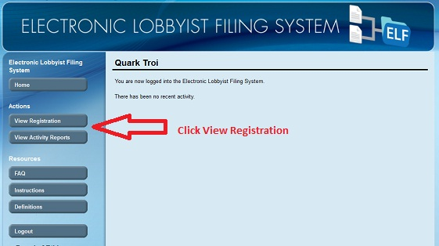

Click Employer Information in the proper year.
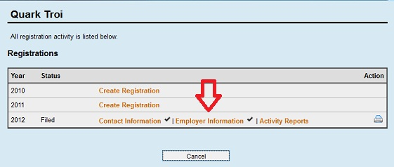

Click Terminate under Action
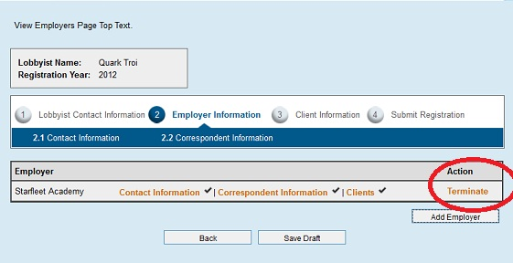

You will be asked to confirm that you do indeed want to terminate. Click Yes.
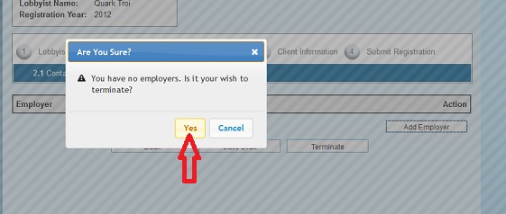

You will then have to provide you password, the answer to your secret question and confirm that you have read and agree to the terms and conditions. Then click Submit Final Registration
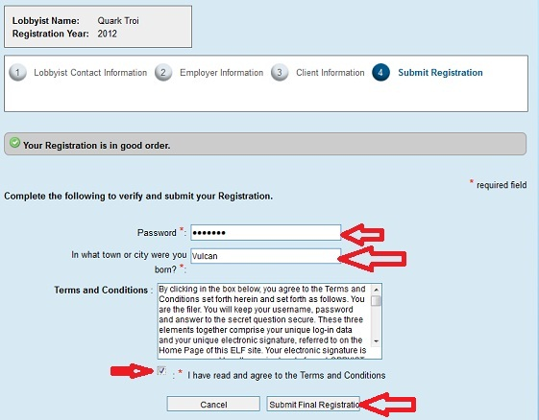
After you have clicked the Submit button, your termination will be reviewed by the board. You will receive emails of its acceptance or rejection. You can always review the status of your filing by logging in and clicking Review Registration from the left hand menu.

